User Manual

Group 37

Contents

Welcome 2

Login 3

Register as New User 4

Email Verification 7

Login with Details 9

Reset Password 11

Remember Me 16

Dashboard 17

Start an Enrolled Course 18

Complete a Course (Quiz) 20

Review a Completed Course 24

Courses 27

Enroll in a Course 28

Filter Courses 30

View Ratings/Comments 34

Profile 35

Achievements 38

Friends 40

Add Friends 41

View Friends Profile 43

View Friend Requests 46

Remove Friend 49

Search to Add Friends 51

Leaderboard 53

Leagues 55

Notifications 57

Logout 61

FAQ’s & Contact Us 62

FAQs - Frequently Asked Questions 64

# Welcome

To access the welcome page, use this link: <https://localhost:8443/welcome>

On the welcome page, you will see the button to Login/Register, a quote, and the current trending courses.

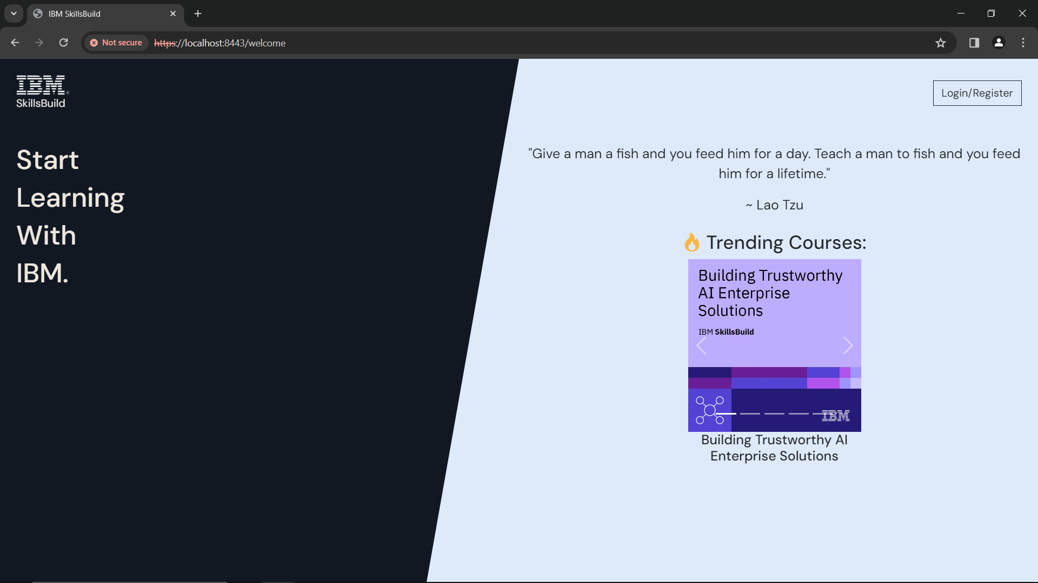

Figure 1: Welcome Page

If you help with Login, head to the **Login** section in the user manual.

# Login

To access the login page, use this link: <https://localhost:8443/login>

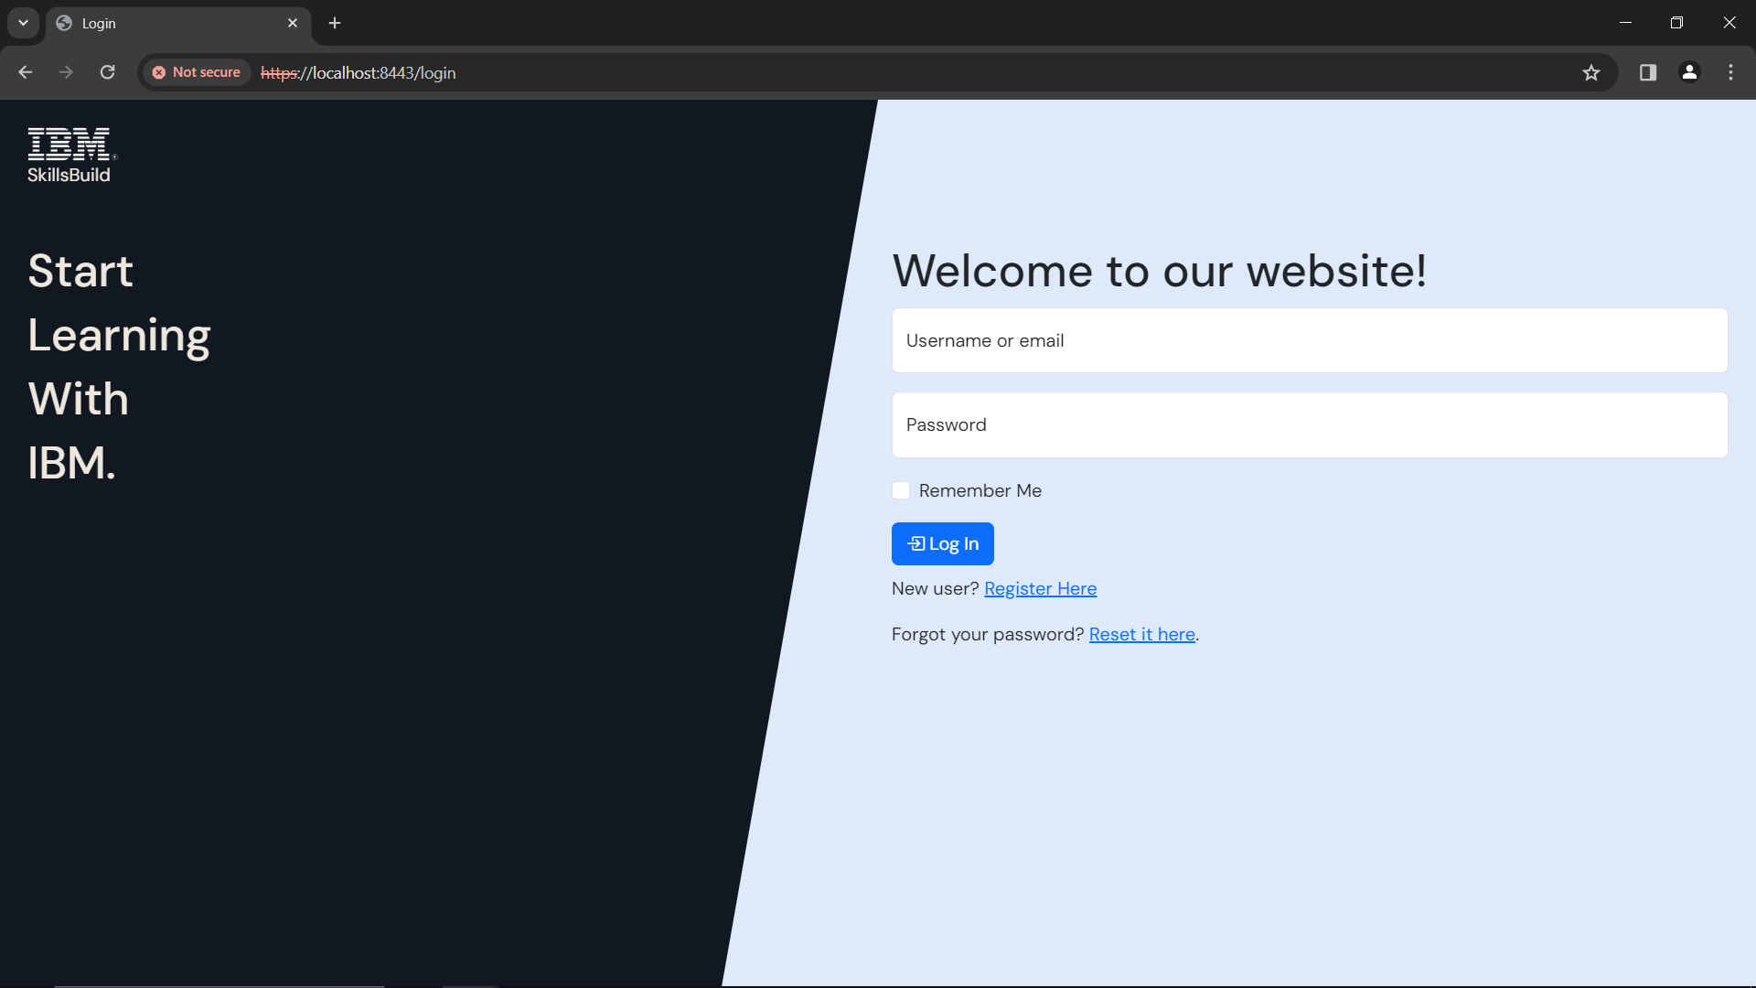

Figure 2: Login Page

If you already have an account, head to **Login with Details** section under **Login** section of the user manual.

If you don’t have an account, head to **Register as New User** section under **Login** section of the user manual.

## Register as New User

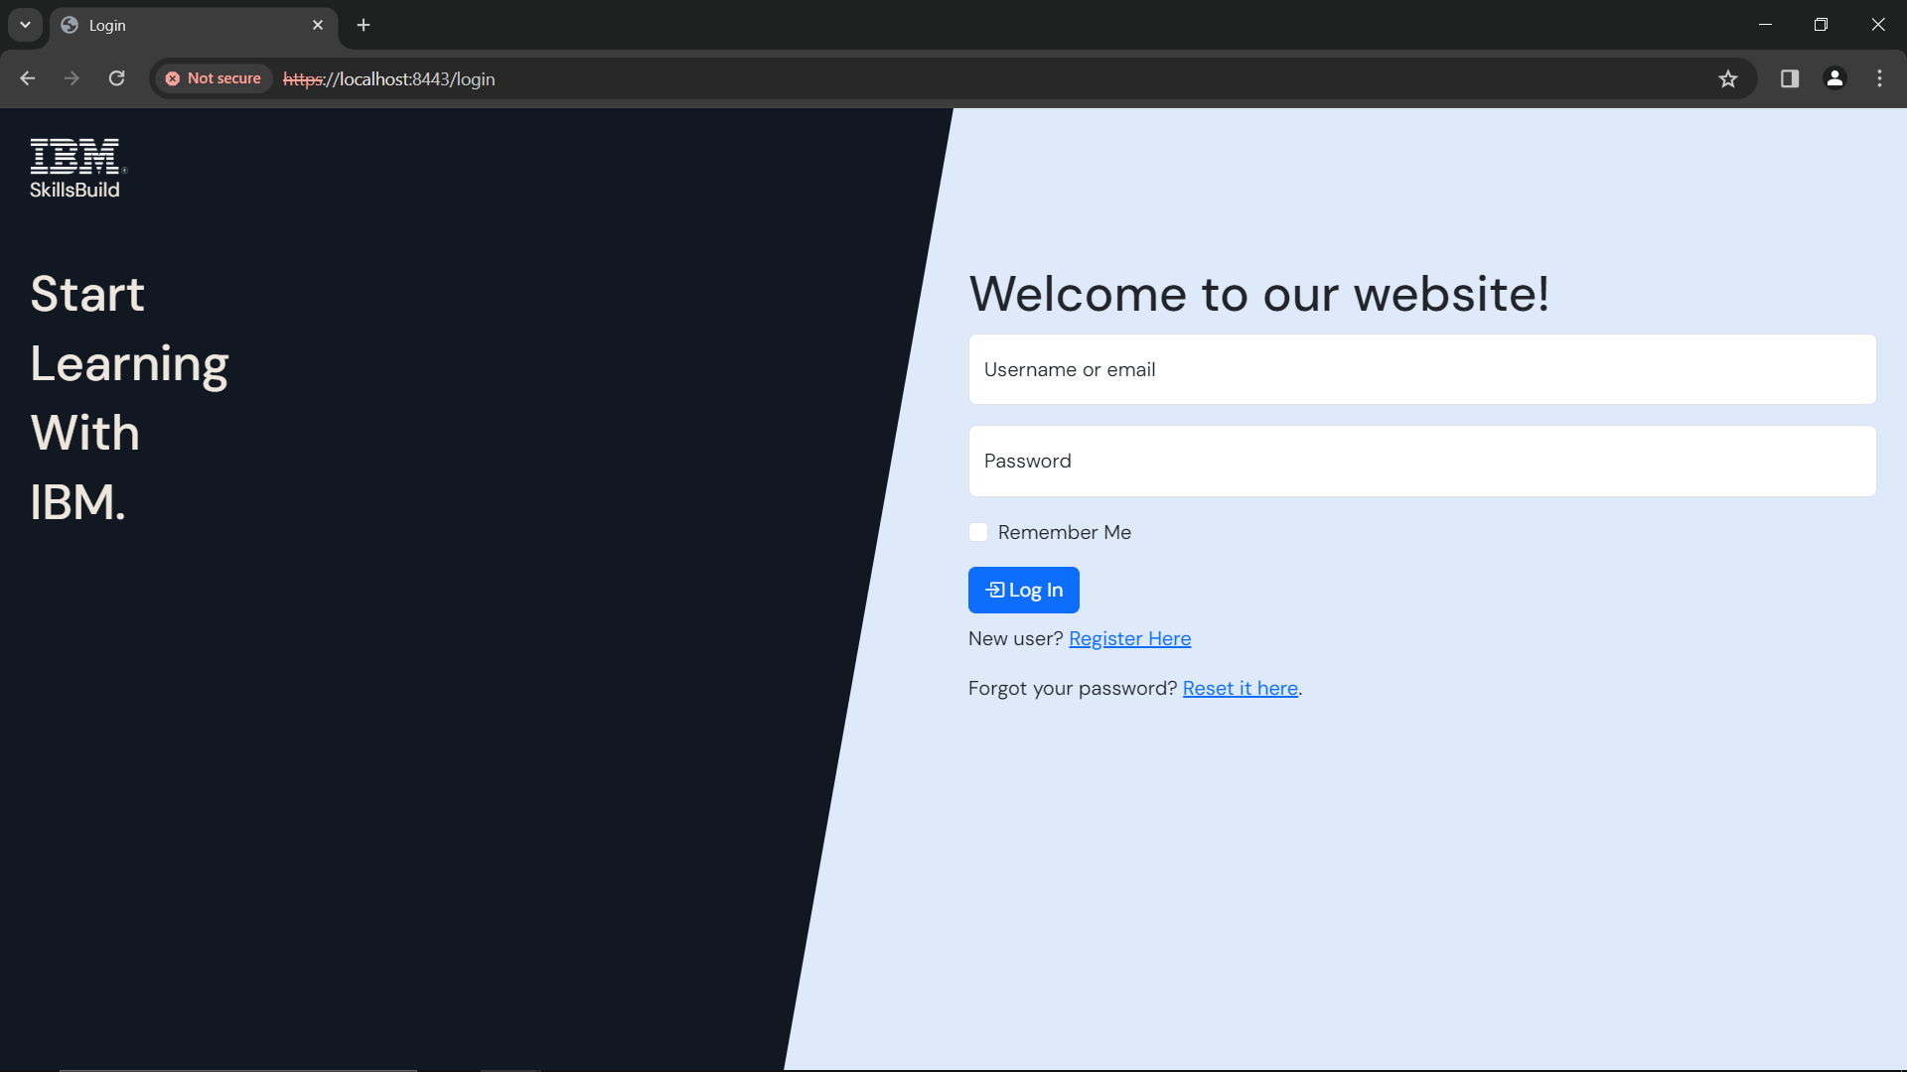

Click here to register as new user

Figure 3: Login - Register Here

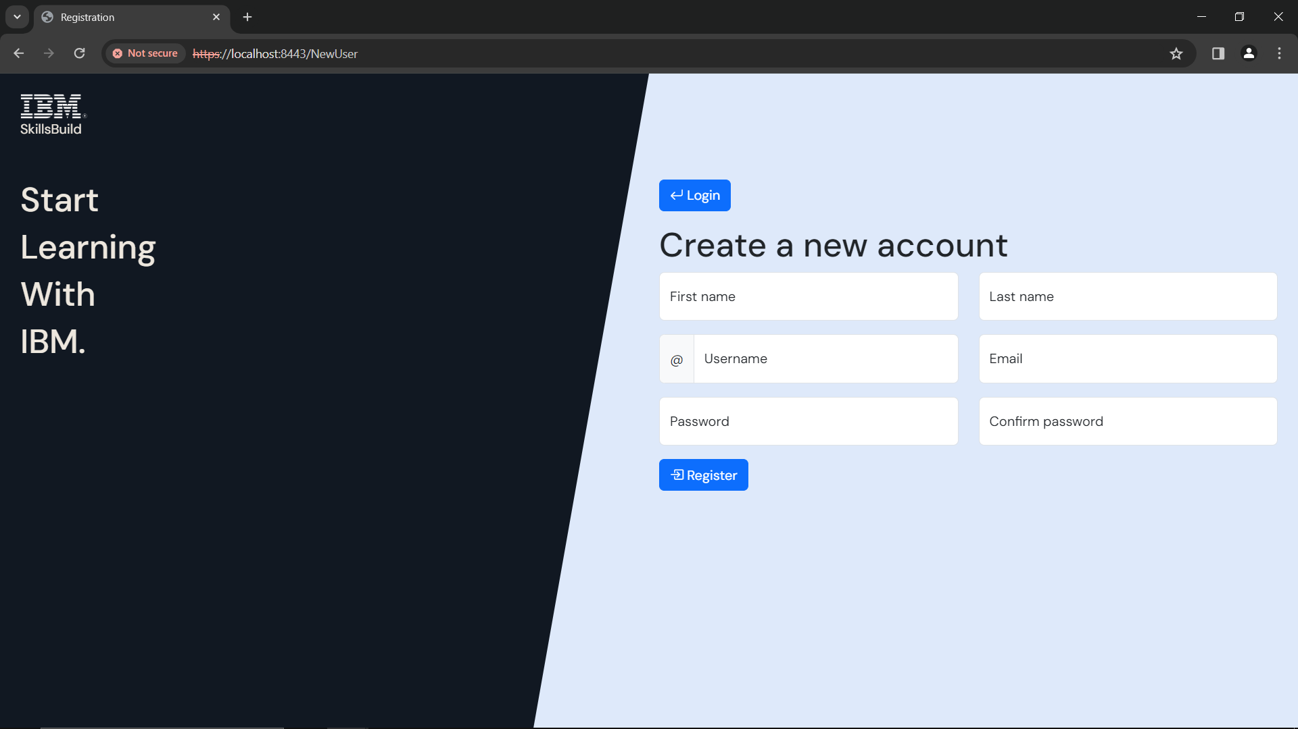

Once you have filled in your details, click ‘***Register***’

Your Email

Repeat your password

Your Last Name

A password of your choice

A username of your choice

Your First Name

Figure 4: Register new user

Fill in your details in each box

* Make sure **not** to leave any of the boxes **blank**
* Your first name must be **between 3-15 characters**
* Your last name must be **between 3-20 characters**
* Your username must be **between 4-20 characters**
* Your email address must be a valid email address
* Username must be **unique**
* Your password must follow these rules:
  + **Between 8-32 characters**
  + **An uppercase letter**
  + **A lowercase letter**
  + **A number**
  + **A special character** from any of the below
    - ! @ # £ $ % ^ & * ( ) _ + { } : ; < > , . ? ~ = ' / -
  + e.g. *Password1!*
* Make sure both passwords match

Make a note of your username and password - as you will need this to login to the website

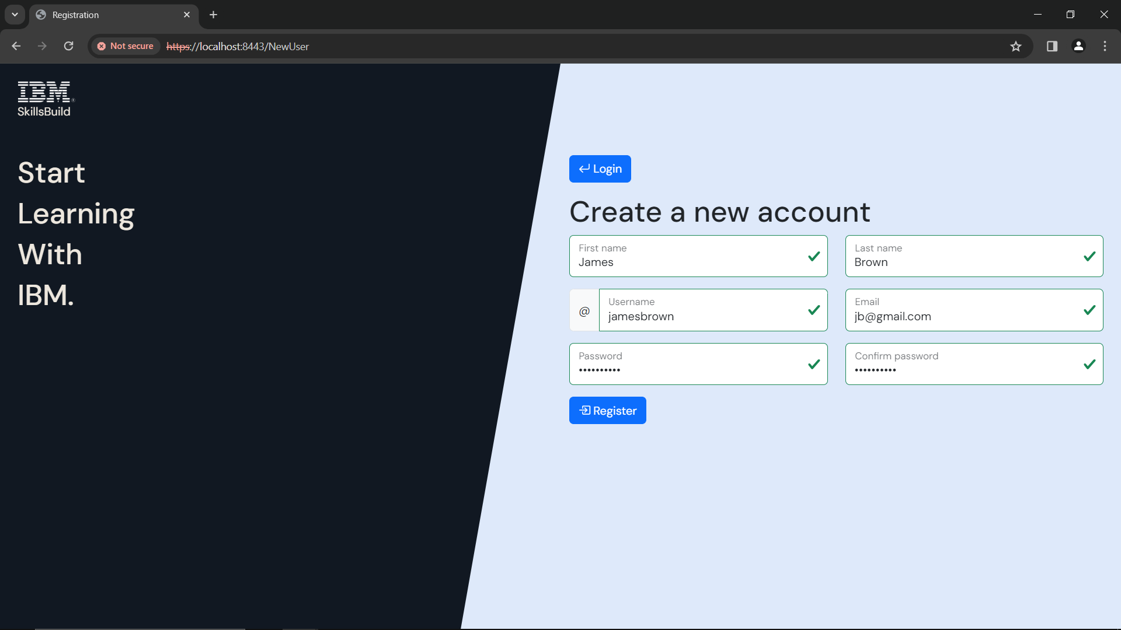

Figure 5: Register - Valid Example

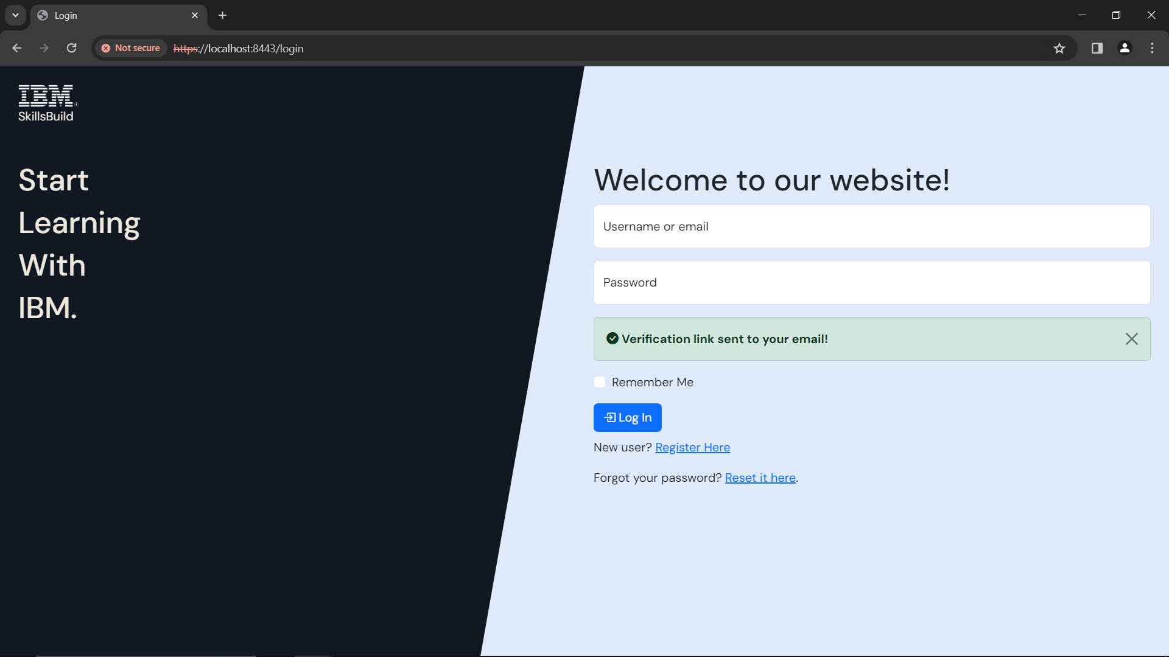

Figure 6: After Registration - Verification

After you click **‘*Register’***  you will go back to the login page, where you will see a message saying *‘Verification link sent to your email!’*.

Head to the **Email Verification** section under the **Login** section of the user manual.

## Email Verification

Once you have registered, you will receive a verification email to the email you registered with.

You **must** verify your email before you can login to the website.

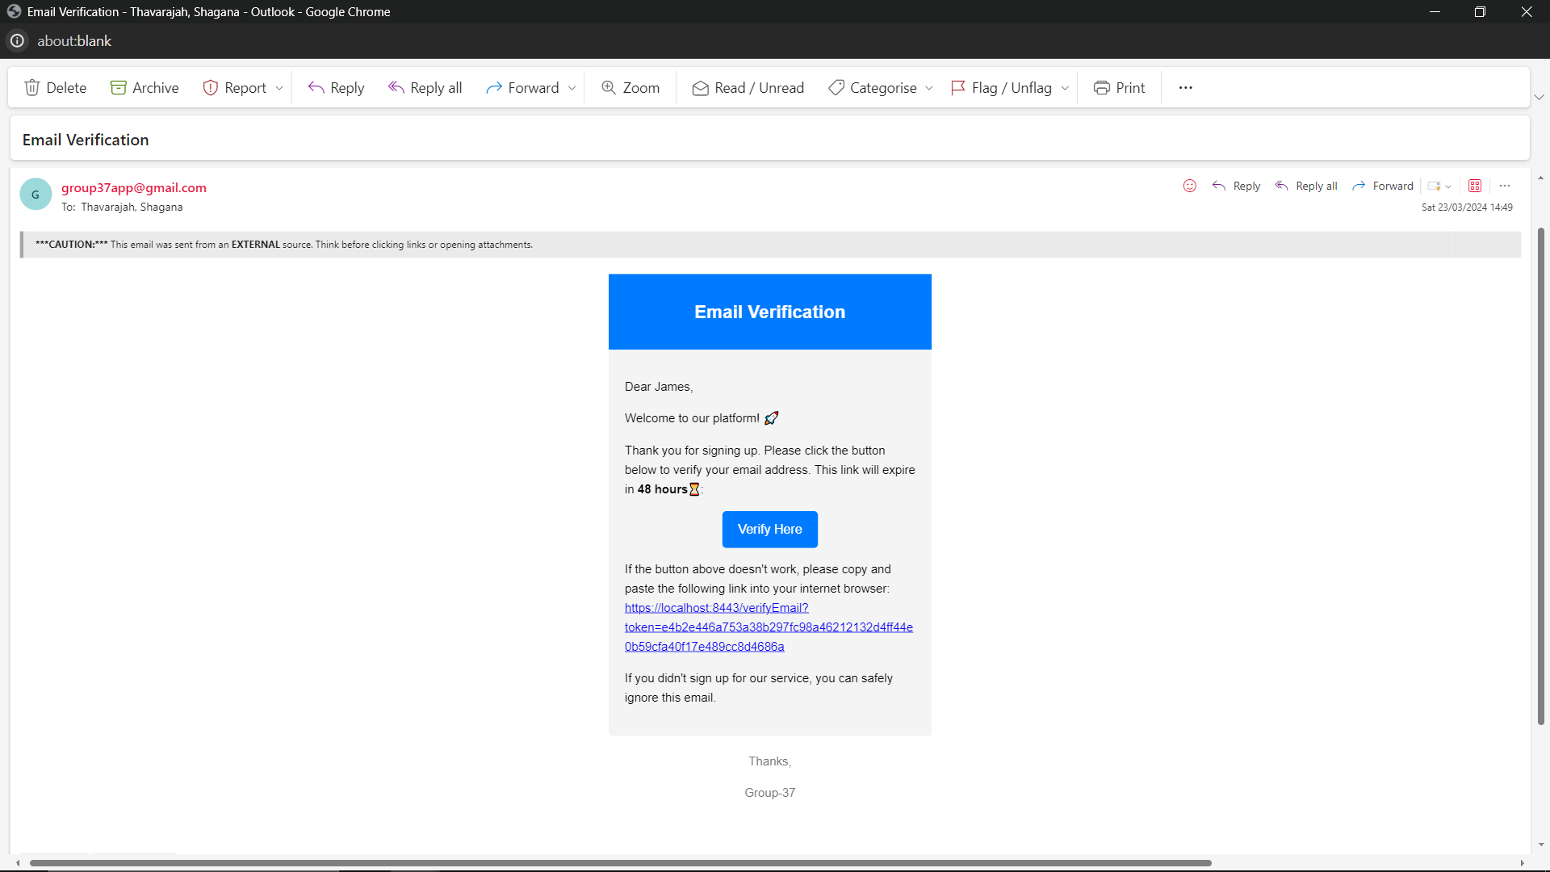

OR Copy and paste link

Click Verify Here

James Brown

Figure 7: Verification Email

* Click ***‘Verify Here’*** or copy and paste the link into your browser
  + You will be taken to the login page
* The link expires in 48 hours
  + If your link has expired, try to login in with your email and password, and you will receive another link
  + If you have any issues, please contact the team at [group37app@gmail.com](mailto:group37app@gmail.com)

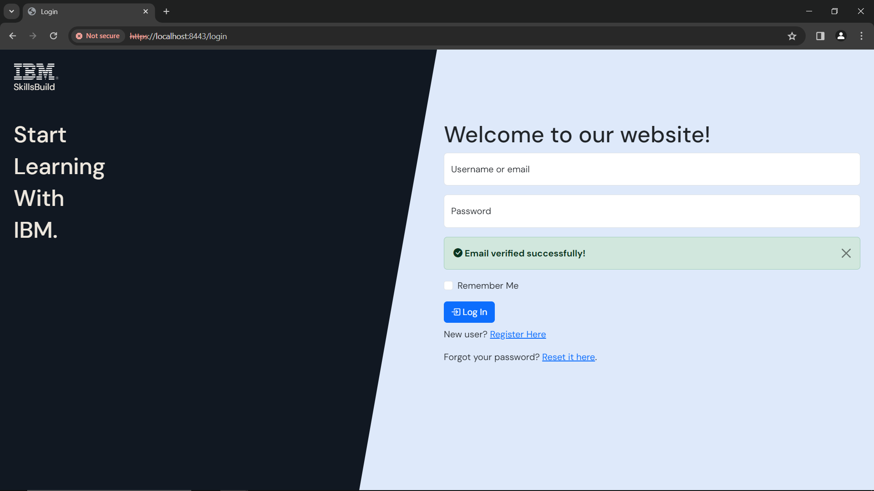

Figure 8: Login - Email Verified Successfully

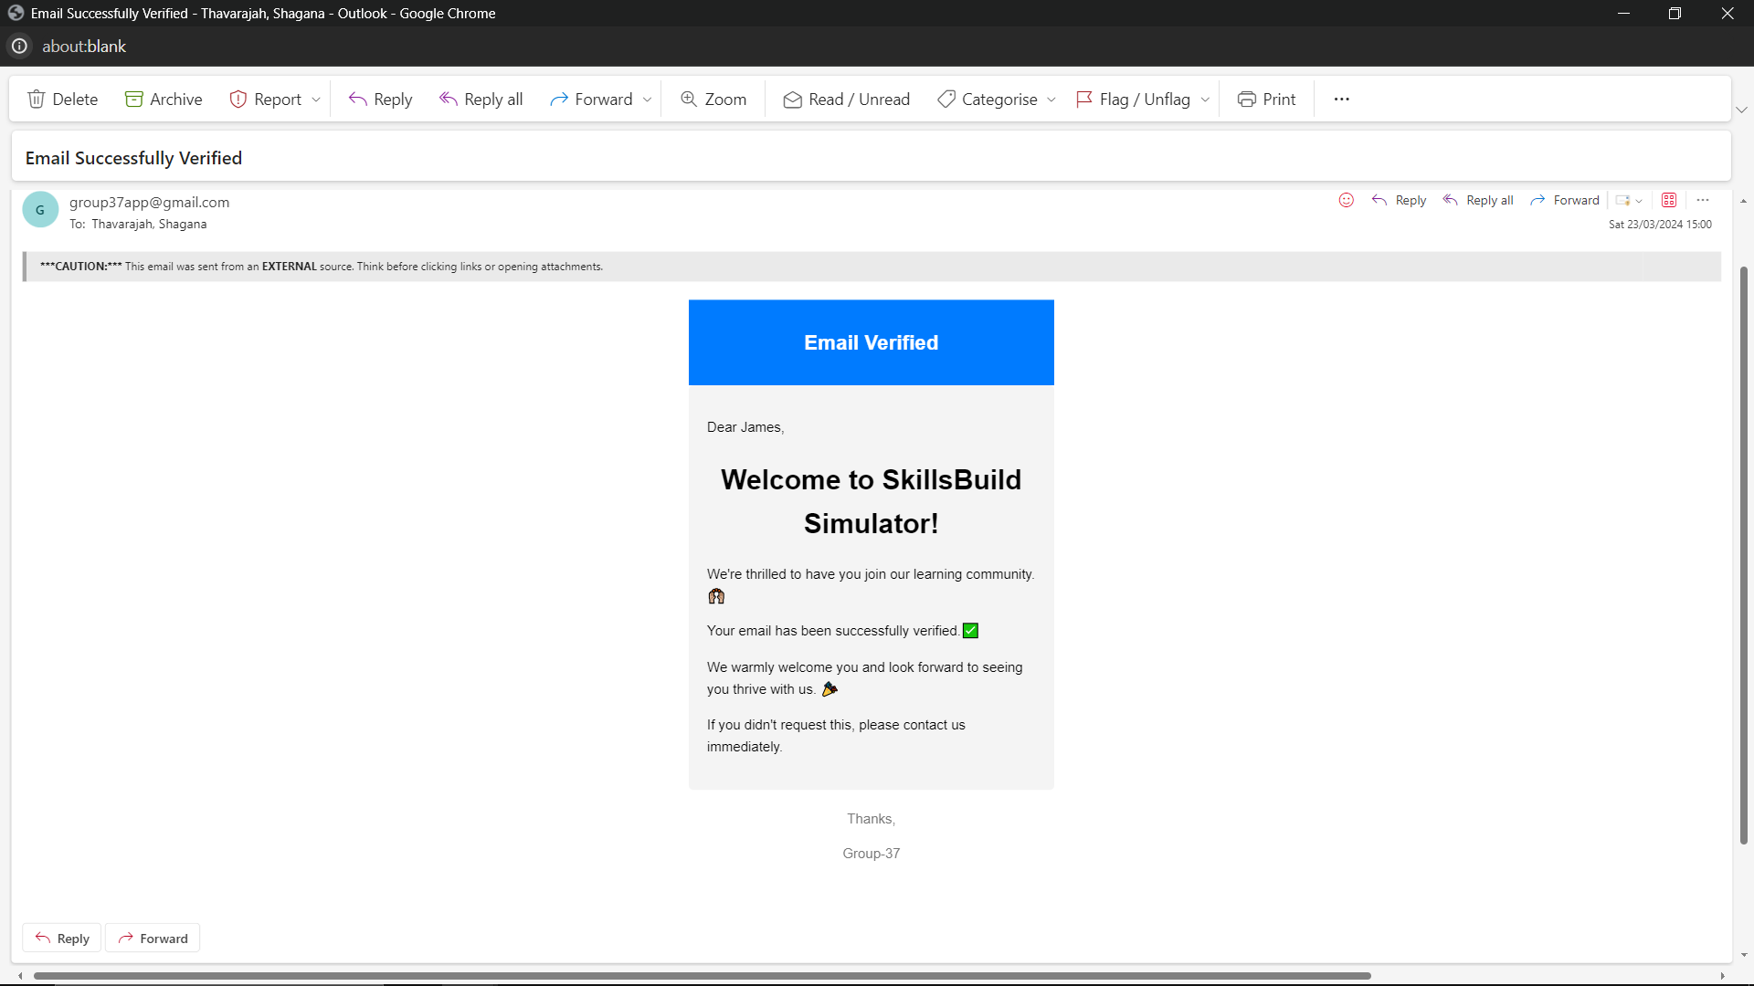

James Brown

Figure 9: Email Successfully Verified

You will also receive an email saying that you have successfully verified your email.

Once you have verified your email, head to the **Login with Details** section under the **Login** section of the user manual.

## Login with Details

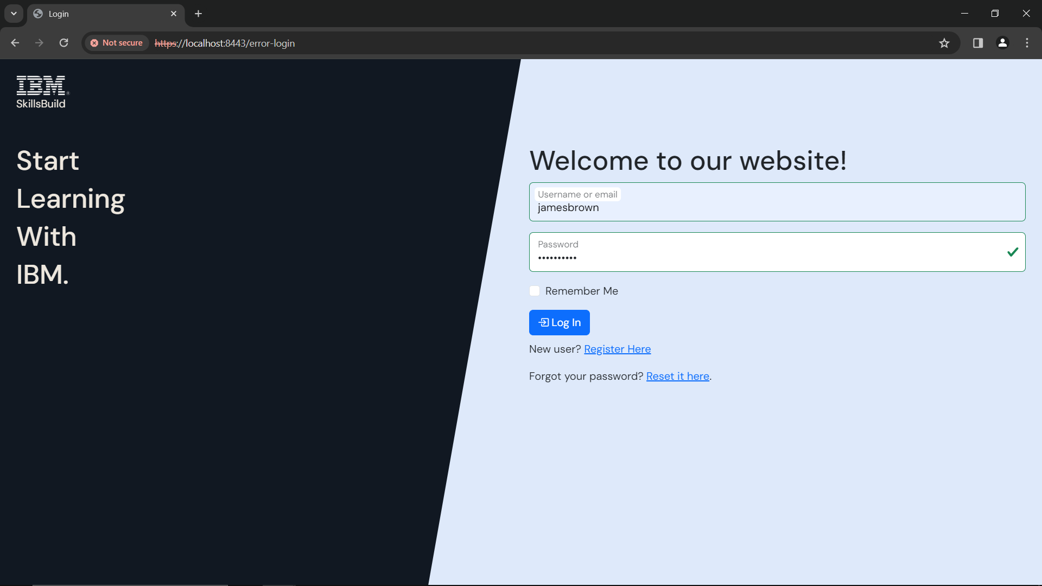

Once you are done, click **‘*Log In*’**

Enter your username or email

Enter your password

Figure 10: Login – Sign In

Enter the details that you registered with and click **‘*Log In’***

If your username or password is **incorrect**, you will see a **message that says, ‘Invalid Credentials!’**.

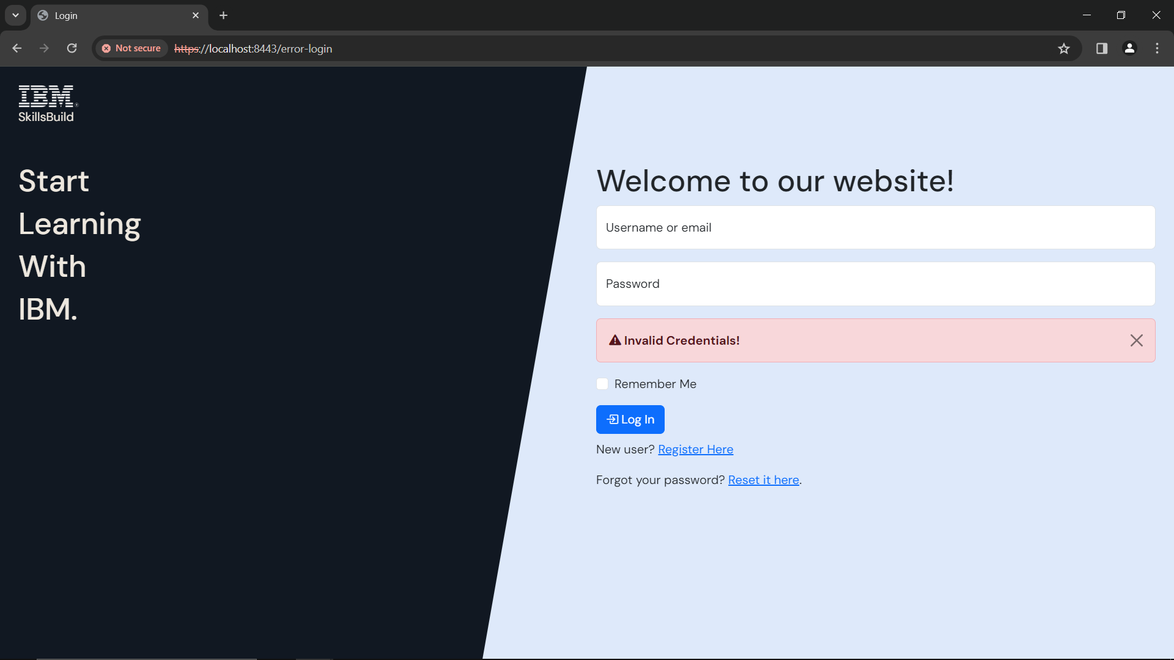

Figure 11: Login - 'Invalid Credentials'

* Enter your correct username and password

If your username and password are **correct**, you will see one of 2 pages:

* **Courses page** - if you are **NOT** enrolled in any courses

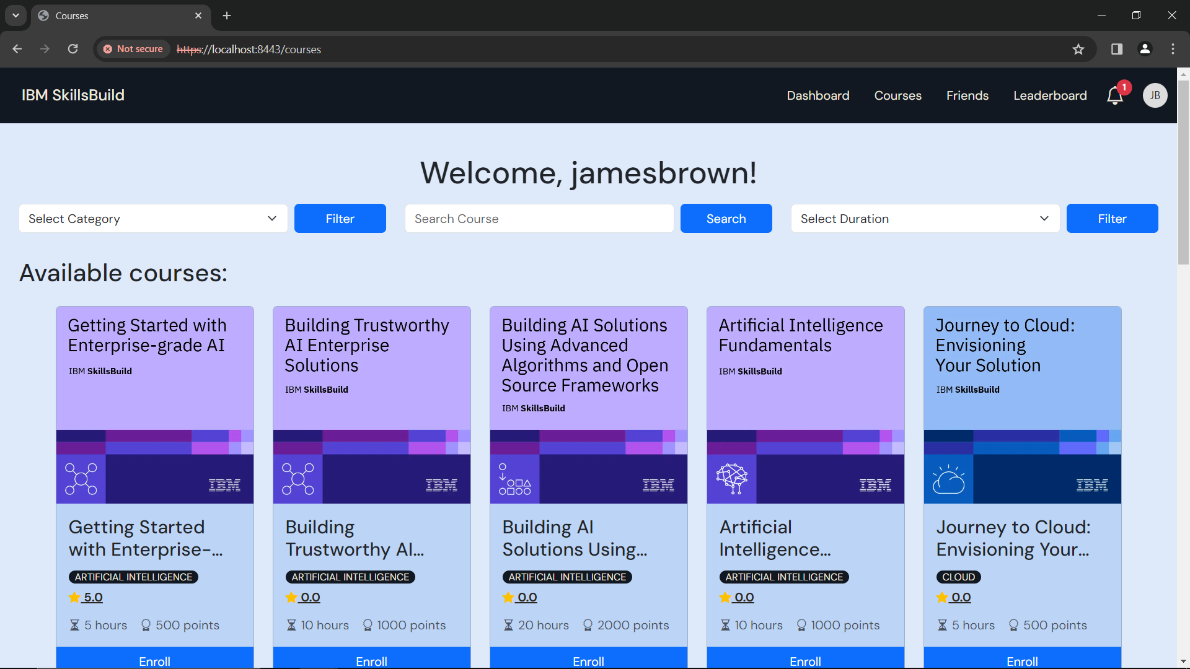

Figure 12: Courses

* **Dashboard** - if you are enrolled in any courses

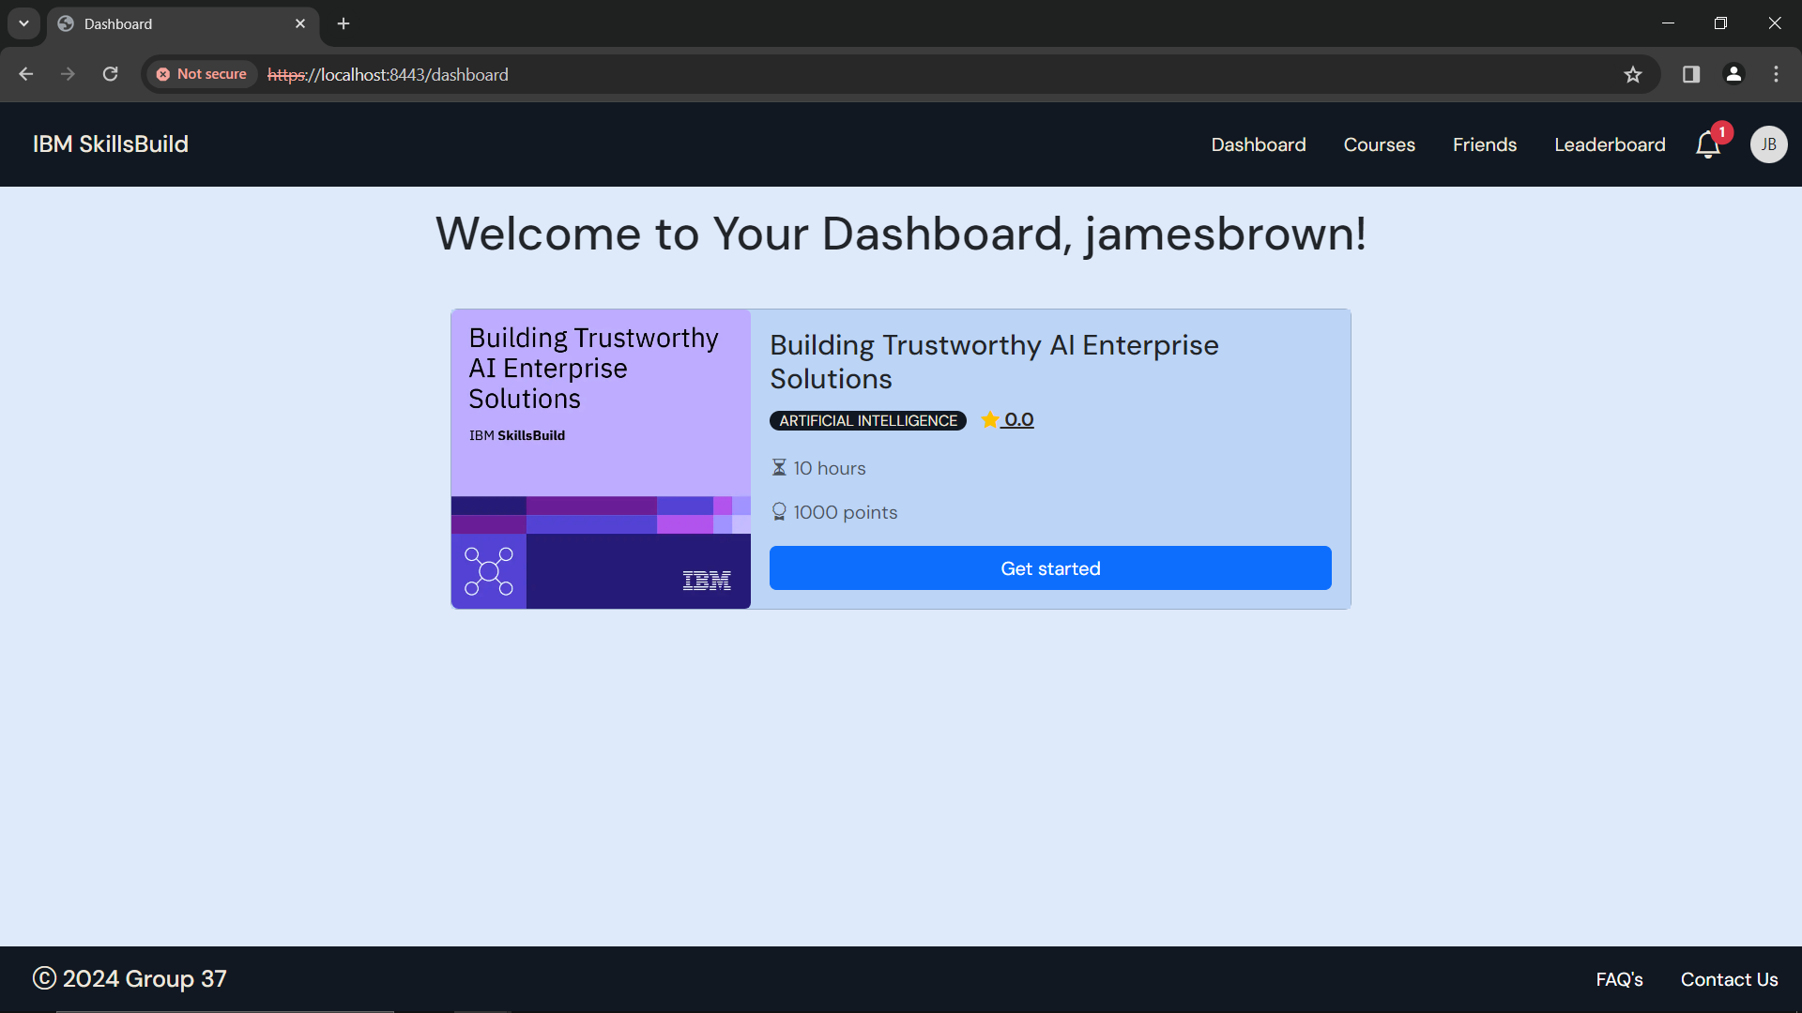

Figure 13: Dashboard

If you want help with logging out, head to the **Logout** section in the user manual.

## Reset Password

If you have forgotten your password, head to the login page at: <https://localhost:8443/login>

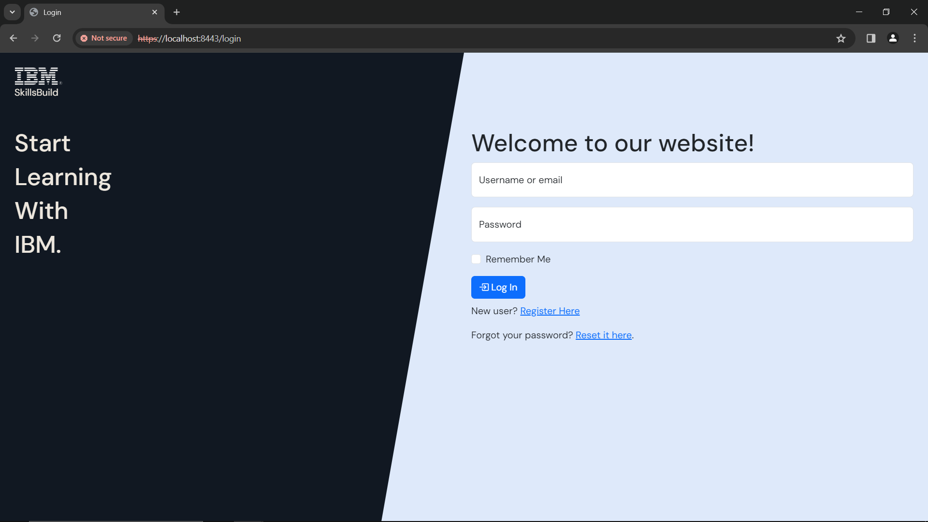

Click **‘*Reset it here*’**

Figure 14: Login - Reset Password

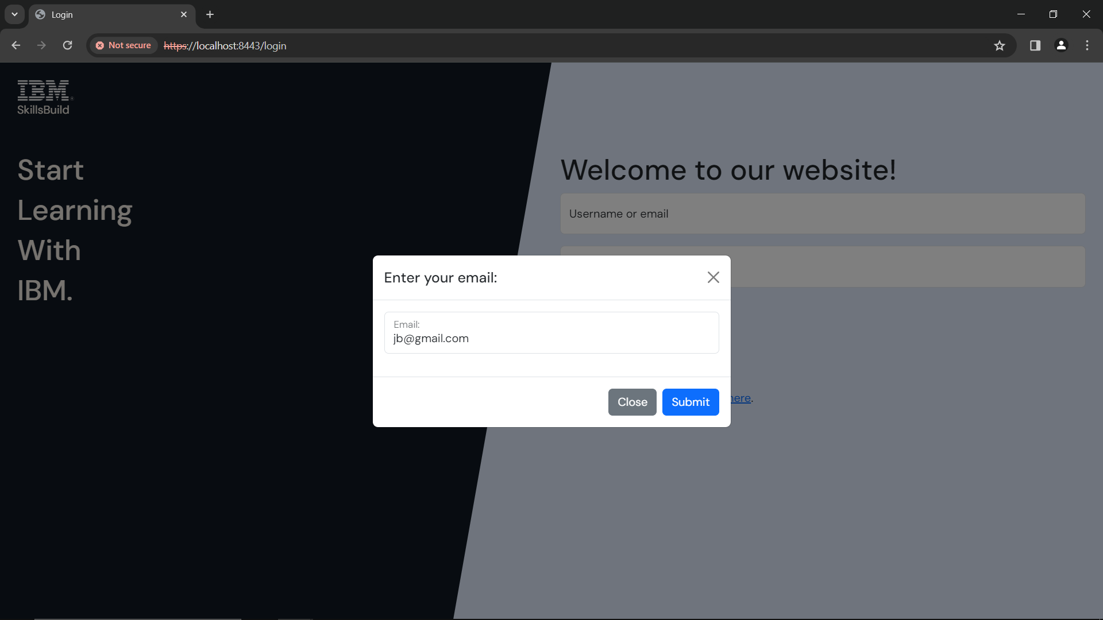

Click **‘*Submit*’**

Figure 15: Reset Password - Enter Email

* Enter in the email address that you registered your account with.
  + If you have forgotten the email address that you registered with, please contact the team at [group37app@gmail.com](mailto:group37app@gmail.com)
* Make sure **not** to leave any of the boxes **blank**
* Enter the email address you **registered with**

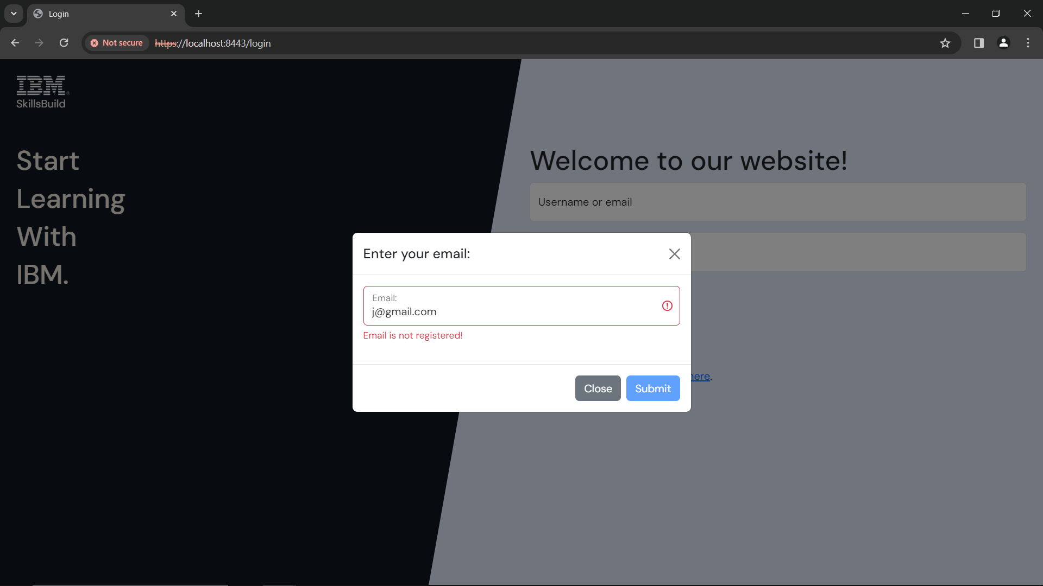

Figure 16: Reset Password - Email not registered

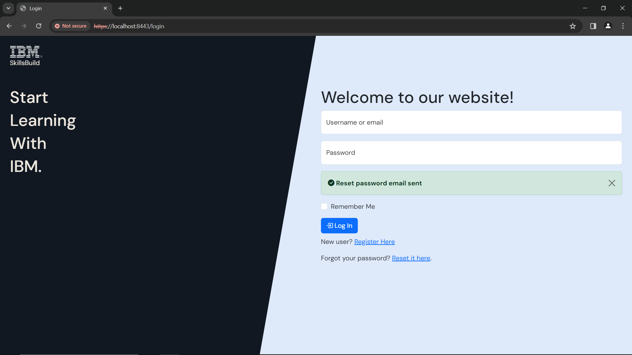

Figure 17: Login - Reset password email sent

Once you have clicked ***‘Submit’***, you will receive a password reset email to the email you registered with.

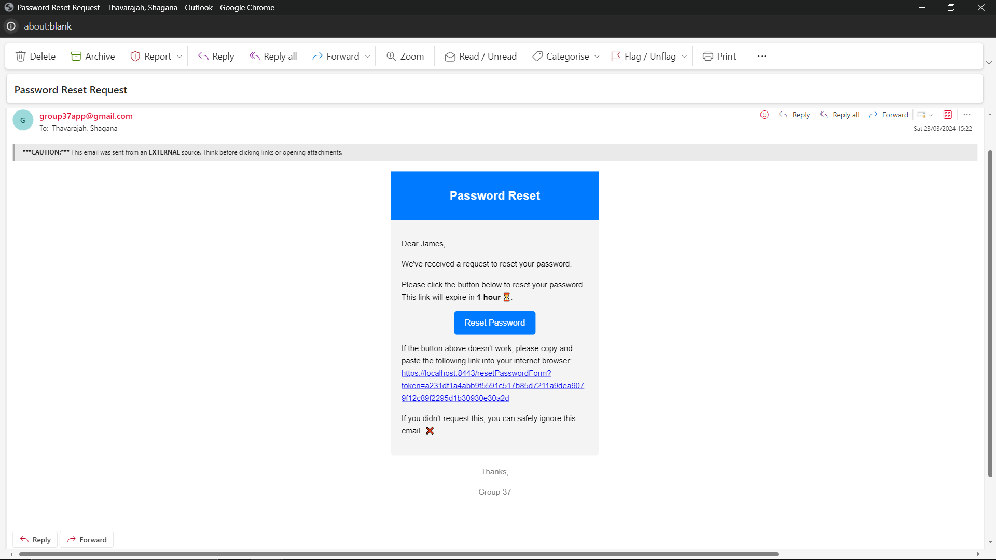

James Brown

Click ***‘Reset Password’***

OR Copy and paste link

Figure 18: Password Reset Request email

* Click ***‘Reset Password’*** or copy and paste the link into your browser
  + You will be taken to the login page of the page
* The link expires in 1 hour
  + If your link has expired, go to the login page, and reset your password again
  + If you have any issues, please contact the team at [group37app@gmail.com](mailto:group37app@gmail.com)

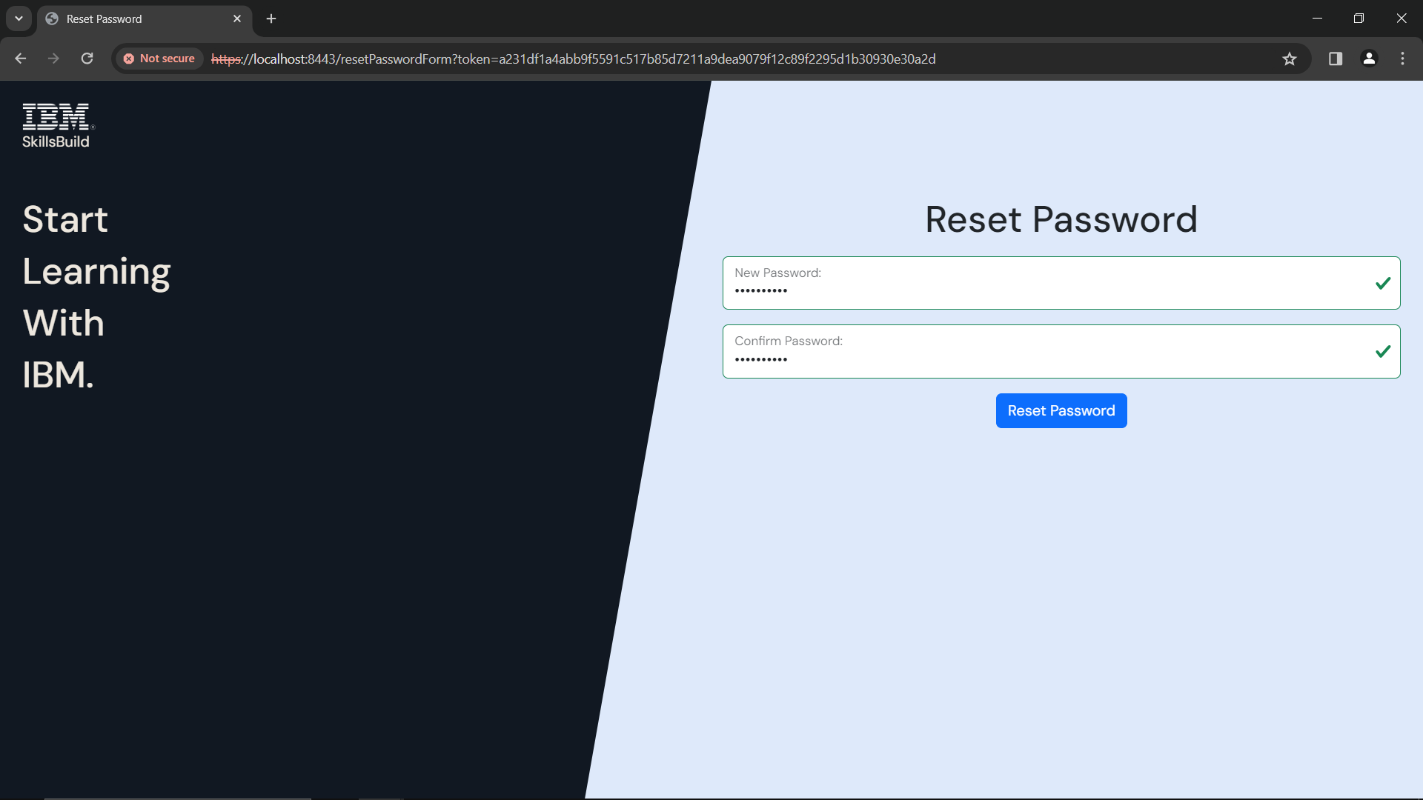

Click ***‘Reset Password’***

Figure 19: Reset Password

* Your password must follow these rules:
  + **Between 8-32 characters**
  + **An uppercase letter**
  + **A lowercase letter**
  + **A number**
  + **A special character** from any of the below
    - ! @ # £ $ % ^ & * ( ) _ + { } : ; < > , . ? ~ = ' / -
  + e.g. *Password1!*
* Make sure both passwords match

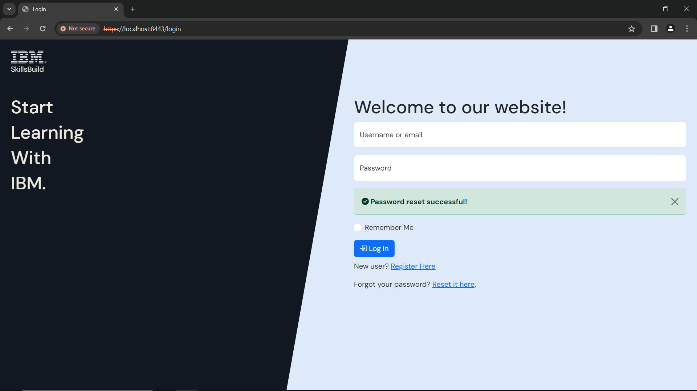

Figure 20: Login - Password reset successful!

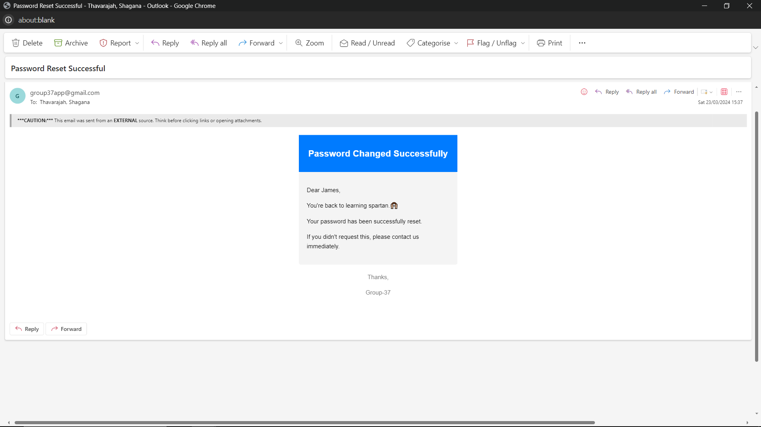

James Brown

Figure 21: Password Changed Successfully email

You will also receive an email saying that you have changed your password successfully.

If you need help with logging in, head to the **Login with Details** section under the **Login** section of the user manual.

## Remember Me

If you select remember me, you can come back to the website to where you last left off, without logging in again.

* Only works if you **do not** logout

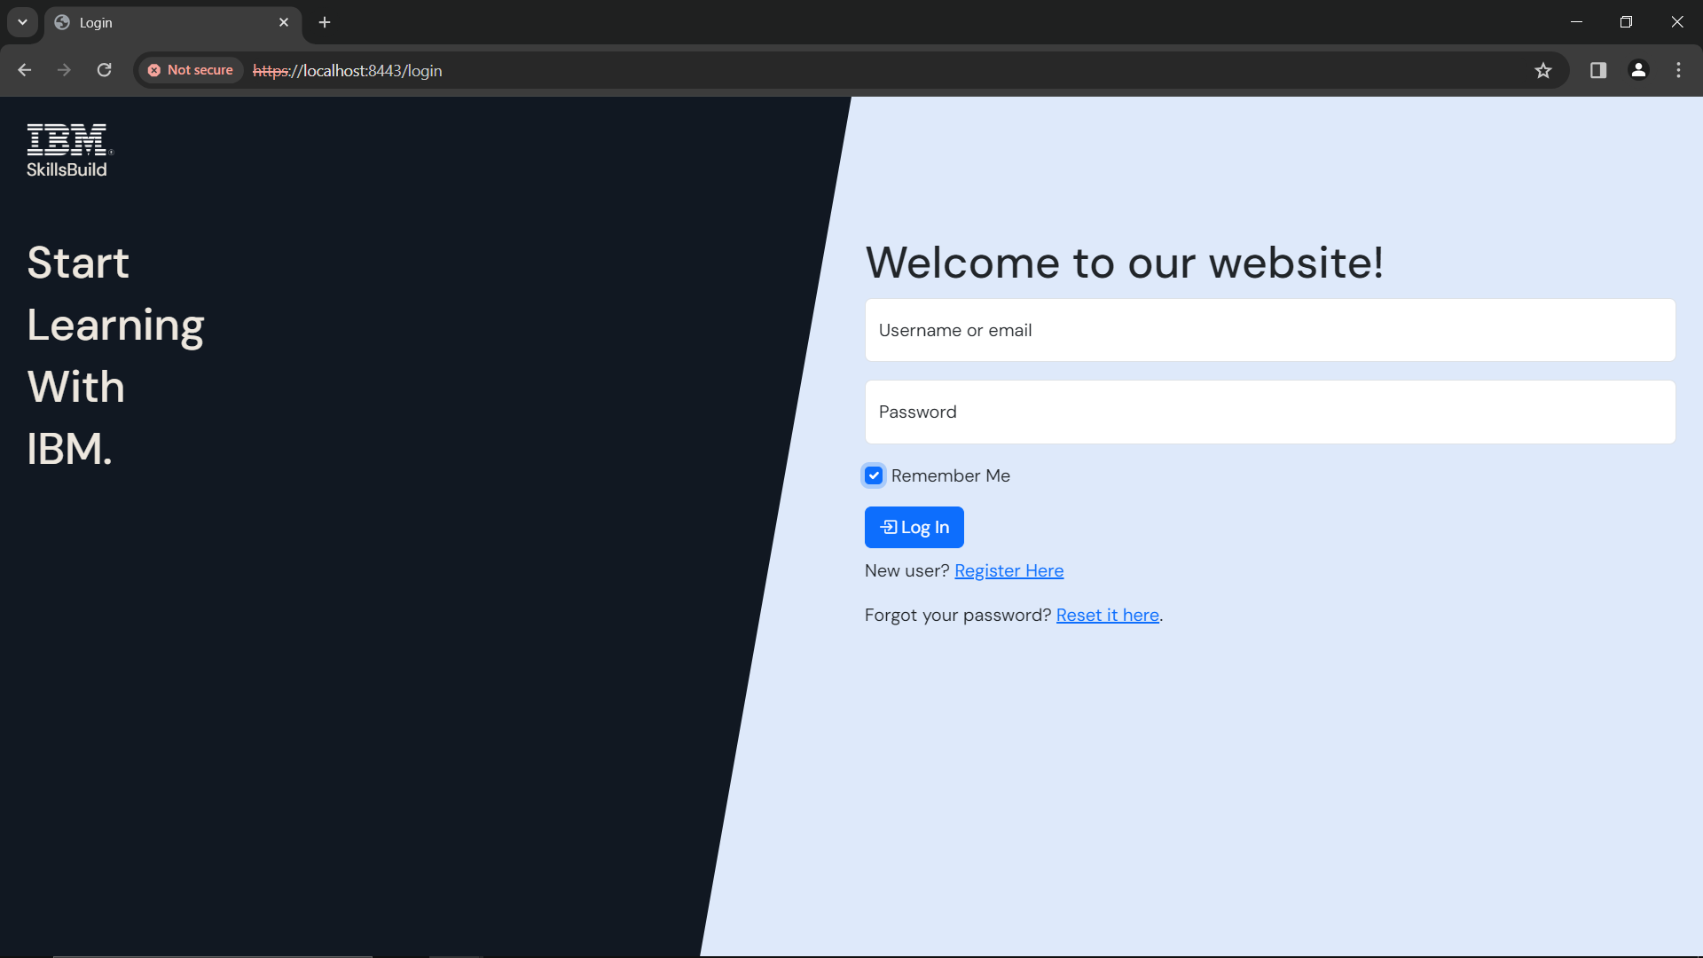

Click ***‘Remember Me’***

Figure 22: Login - Remember Me

If you need help with logging in, head to the **Login with Details** under the **Login** section of the user manual.

# Dashboard

To access your dashboard, use this link: <https://localhost:8443/dashboard>

On your dashboard, you will see a Welcome message, with the courses you have enrolled in.

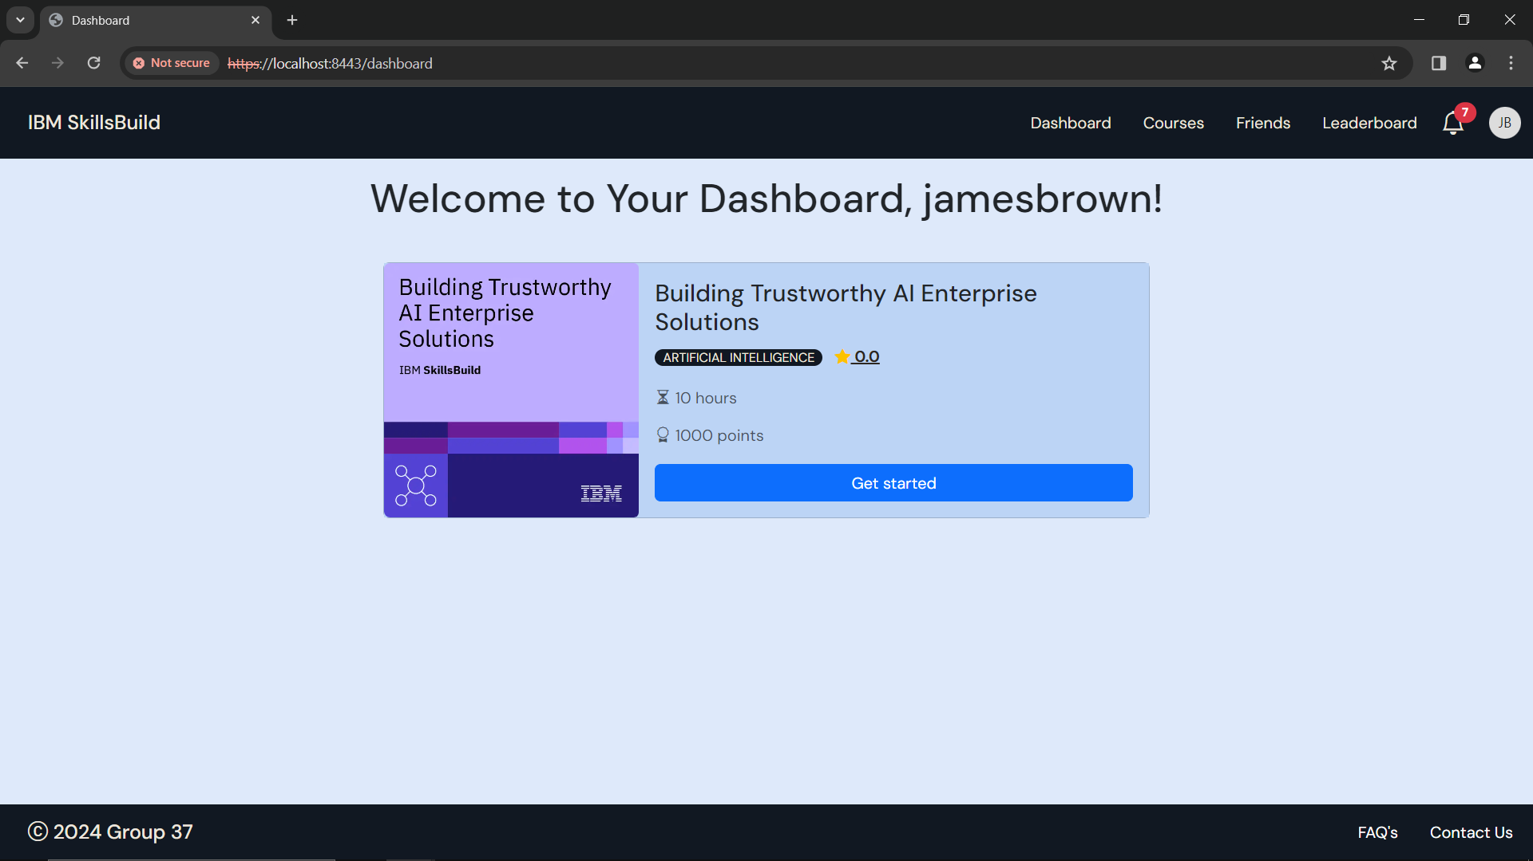

Figure 23: Dashboard

If you have not enrolled in any courses, you will see this.

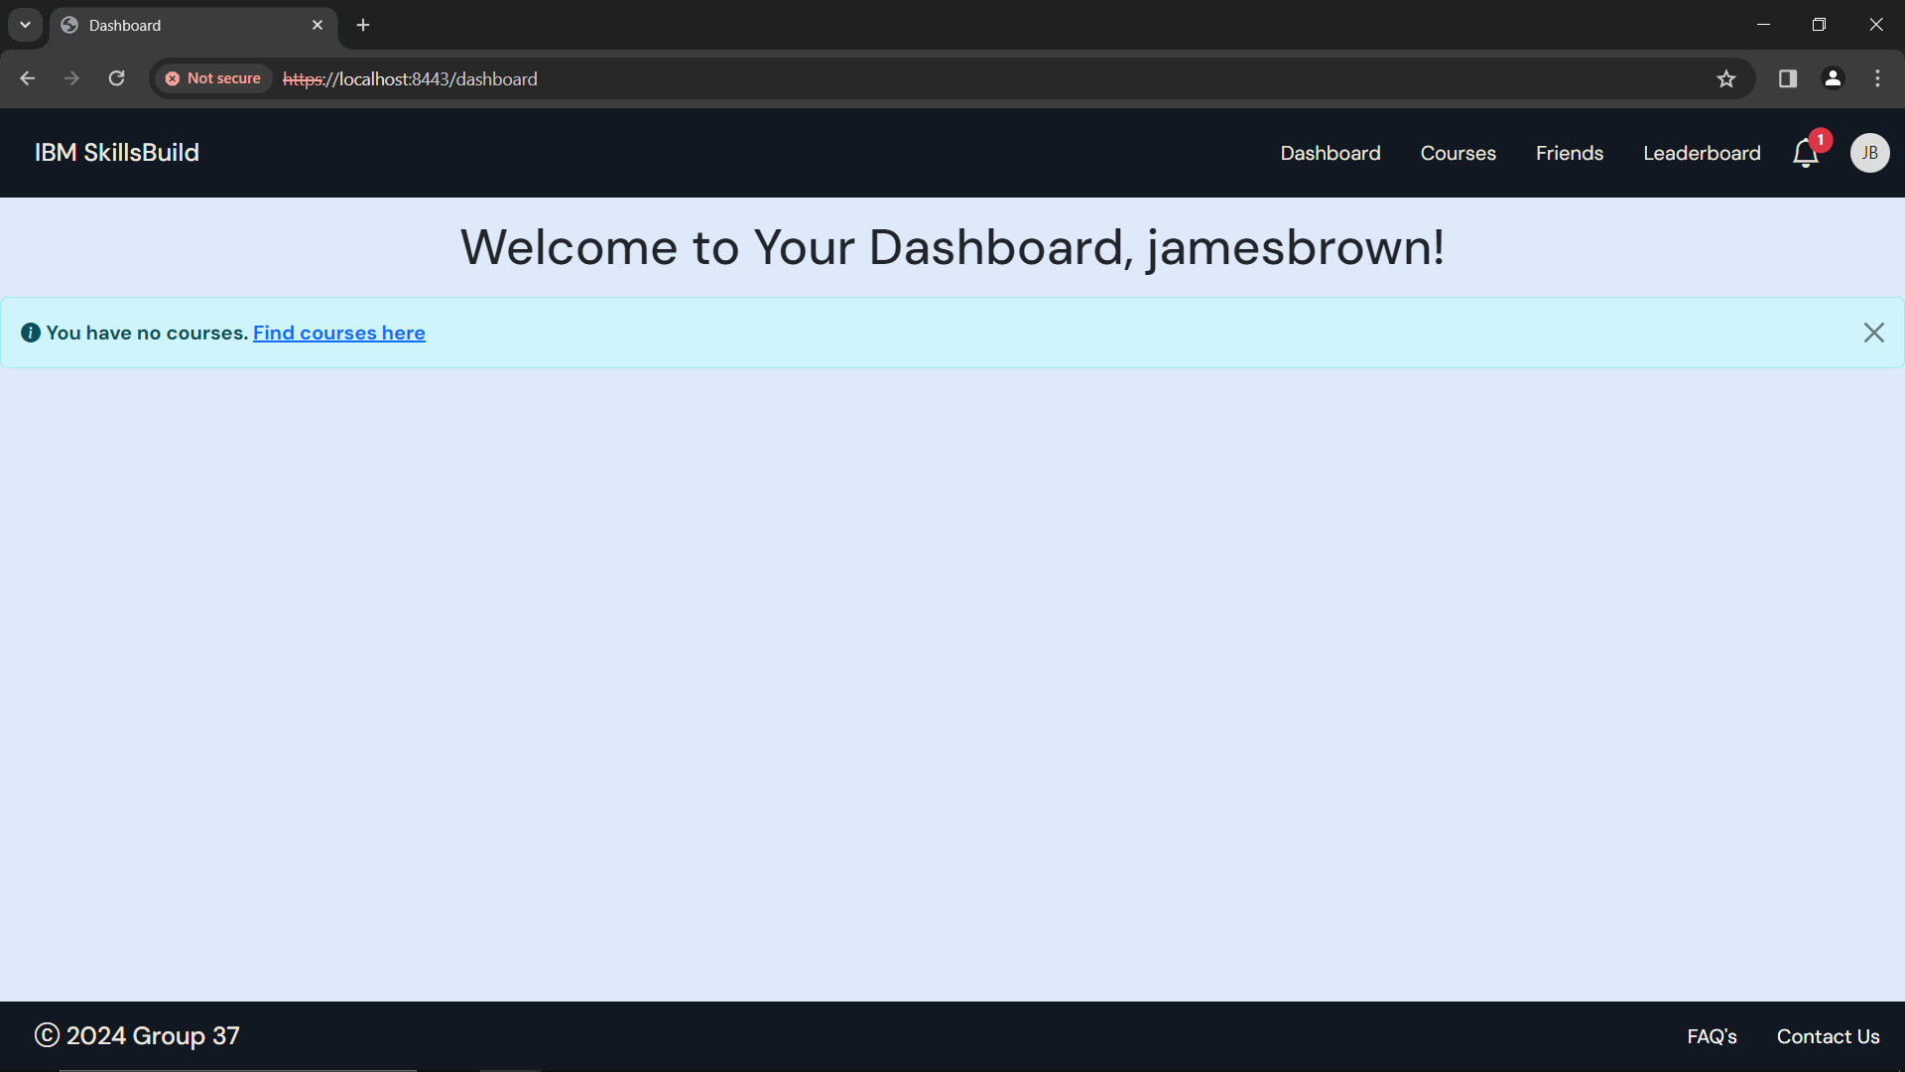

Figure 24: Dashboard – Not enrolled in any courses

## Start an Enrolled Course



To start a course, click **‘*Get Started’***

Figure 25: Dashboard

In your dashboard, you will see the courses you have enrolled in.

To start a course, click the ***’Get Started’*** button under the course

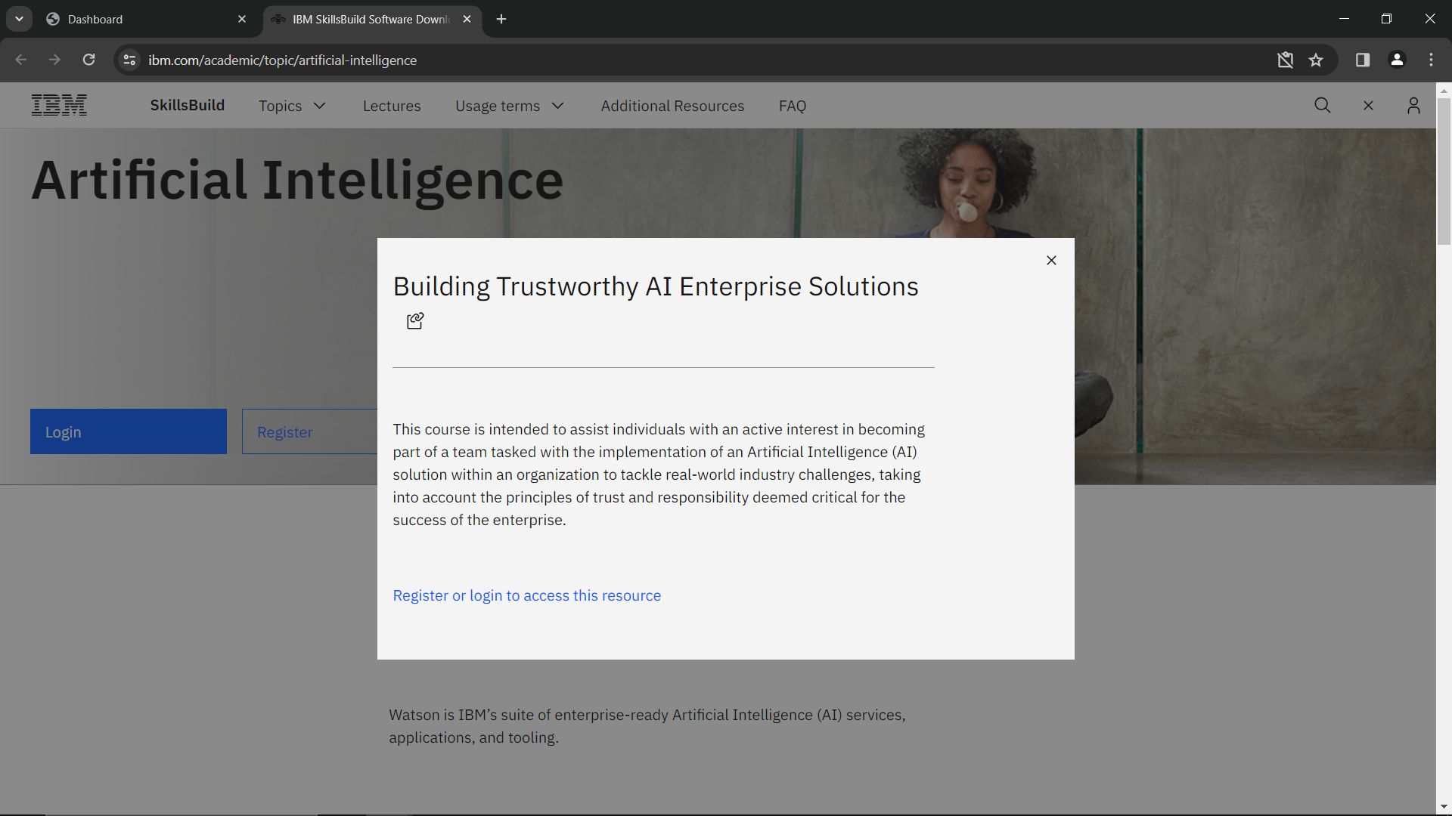

Figure 26: IBM Skillsbuild to begin course

You will be redirected to the IBM Skillsbuild website for that course.

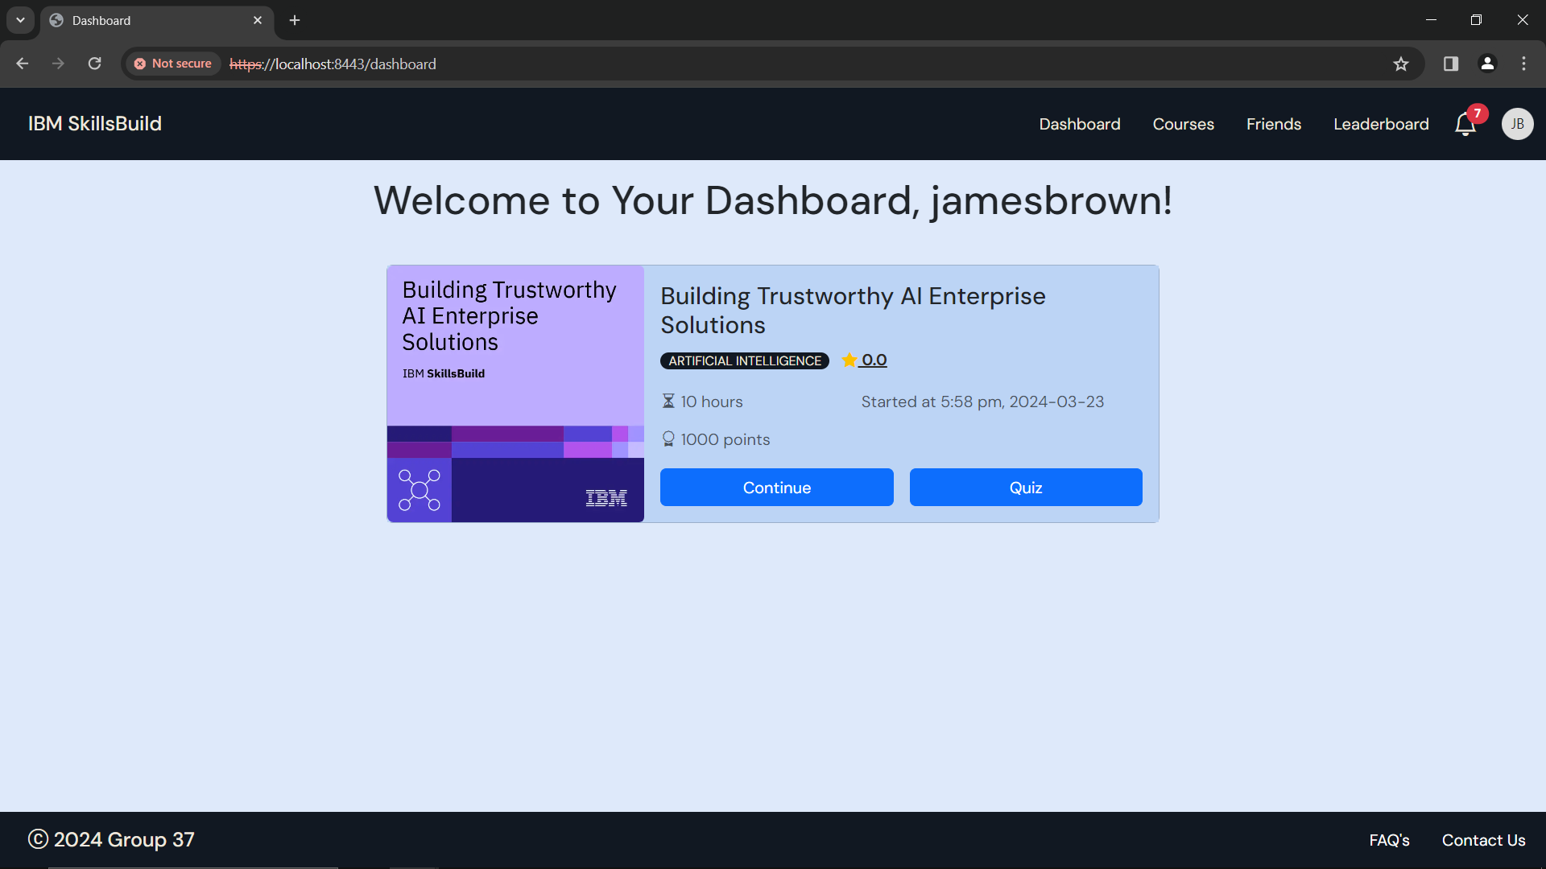

Figure 27: Dashboard - Course Start Time

In your dashboard, you will also be able to see the time and date of when you started the course.



To continue a course, click **‘*Continue’***

Figure 28: Dashboard - Continue Course

To continue a course, click the ***‘Continue’*** button under the course

## Complete a Course (Quiz)

Once you have completed a course on IBM SkillsBuild, you will have to take a quiz to test your understanding.



Click ***‘Quiz’***, to test your understanding

Figure 29: Dashboard - Course Completion Quiz

Once you click on ***‘Quiz’***, you will see a quiz with 5 questions.

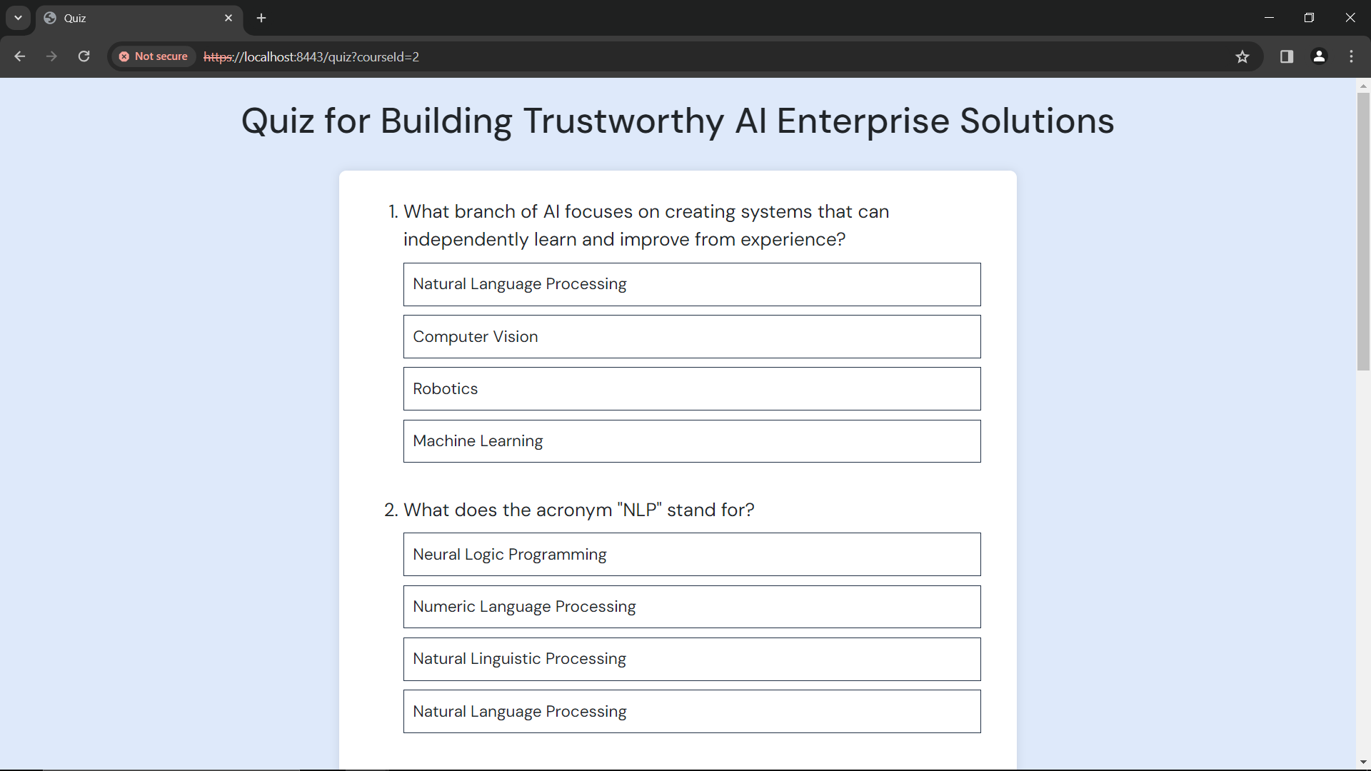

Figure 30: Quiz

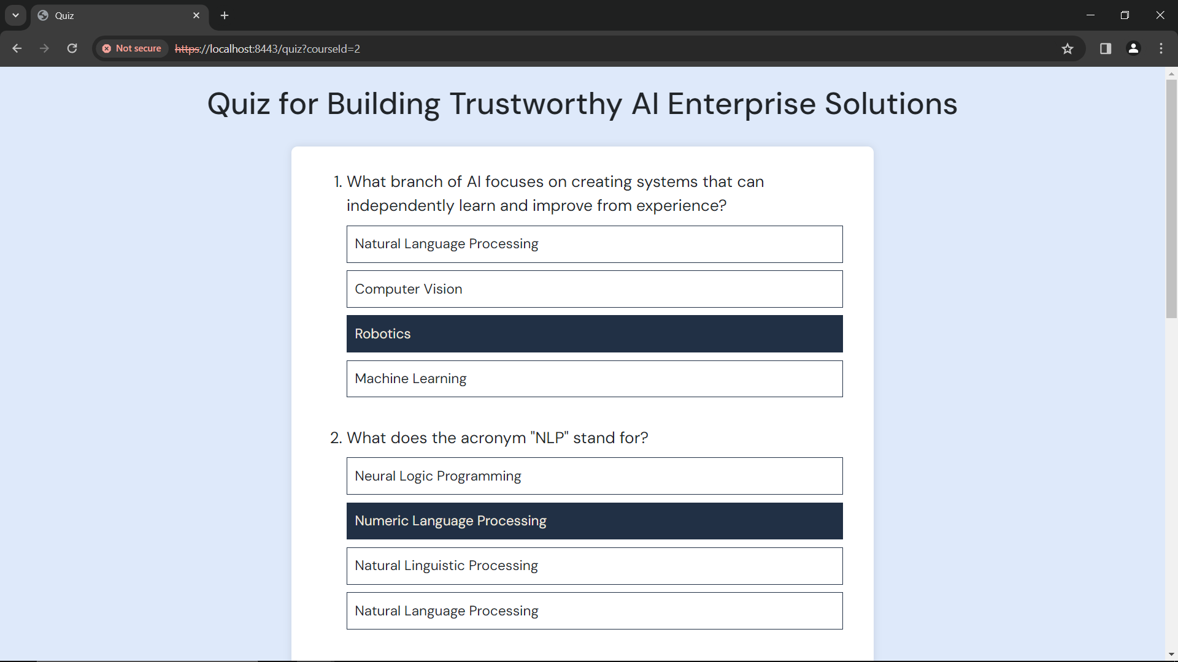

Figure 31: Quiz - Select answers

Select the correct option for each of the 5 questions

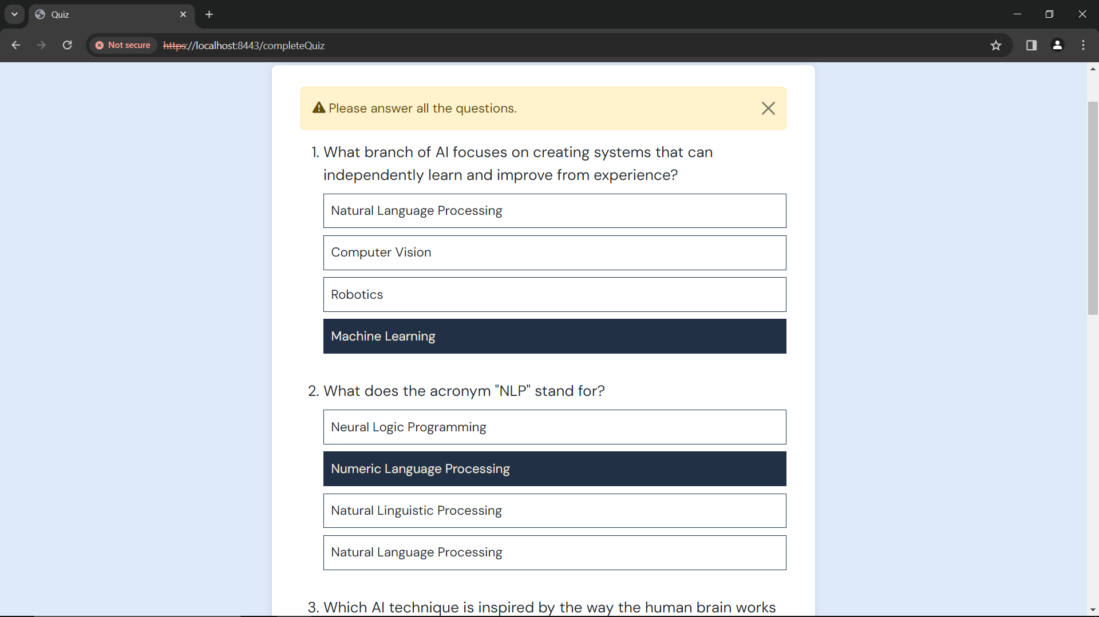

Figure 32: Quiz - Please answer all the questions

You must answer **ALL** the questions

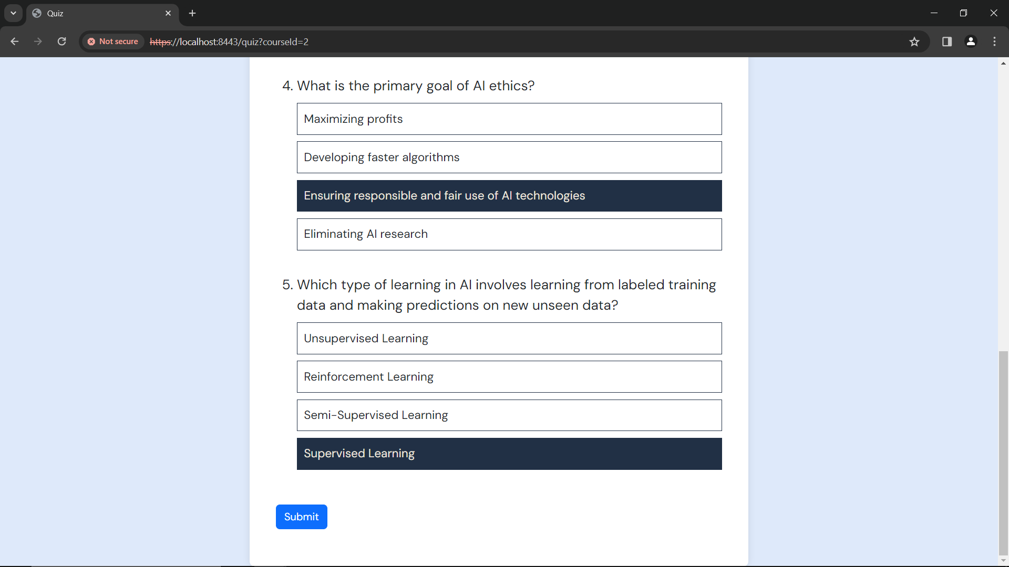

Click ***‘Submit’***, once you are done

Figure 33: Quiz - Submit

Once you are done, click ***‘Submit’***

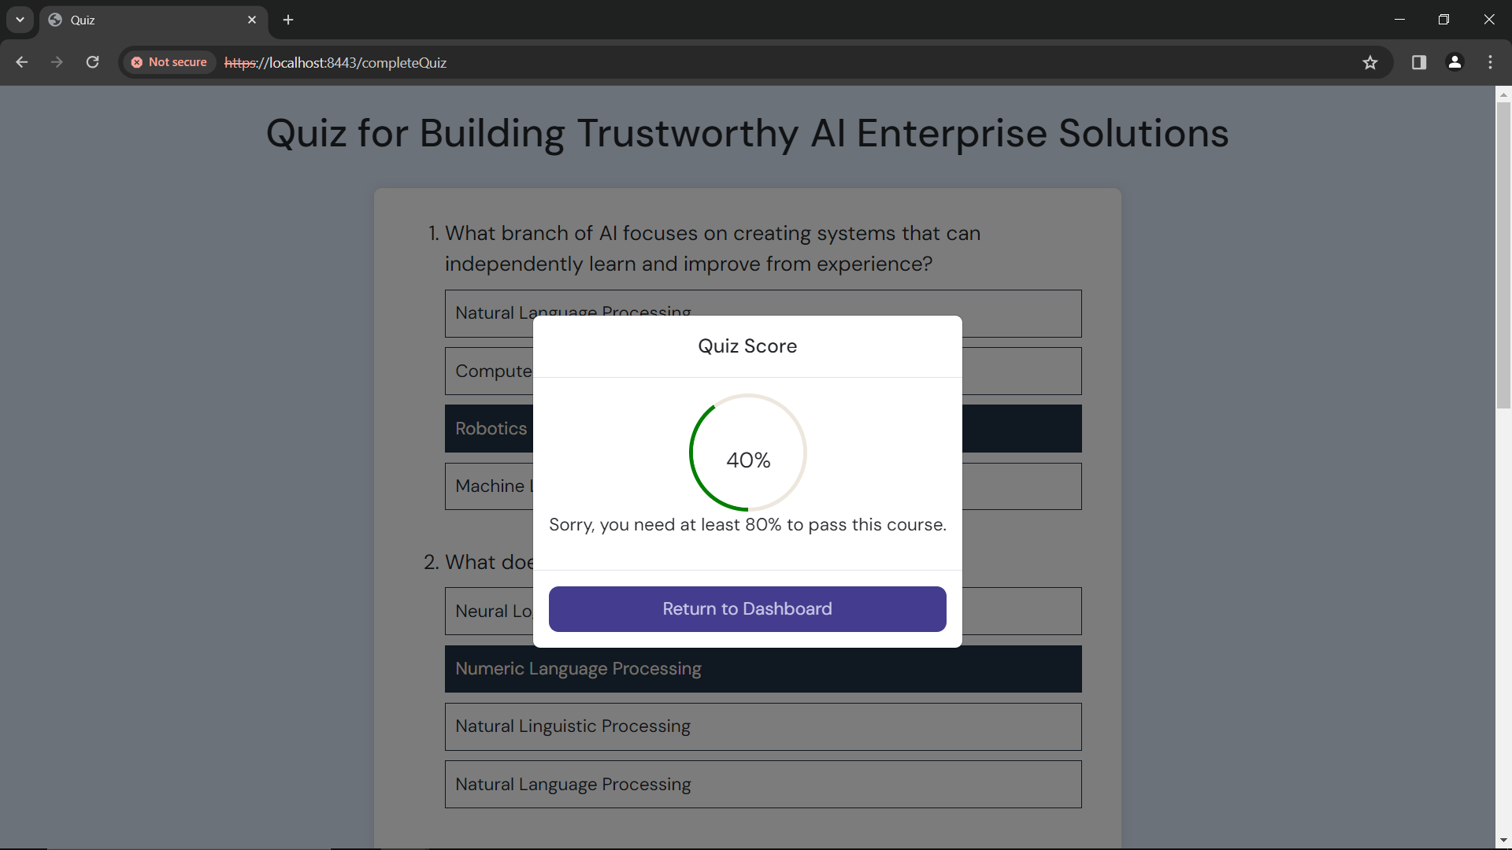

Figure 34: Quiz - Score

You will see your score

* You need **at least 80%** in the quiz to pass a course, and complete it

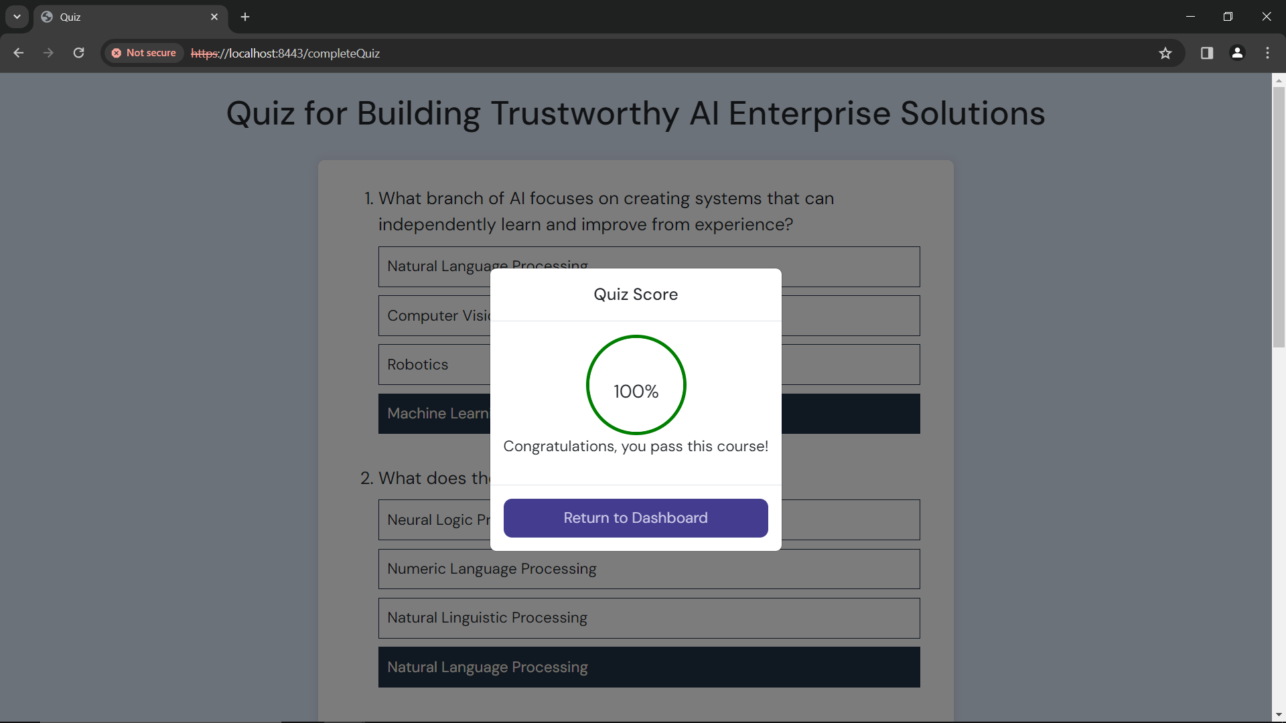

Click ***‘Return to Dashboard’***

Figure 35: Quiz - Passed

Once you have passed the quiz you will see the screen shown above

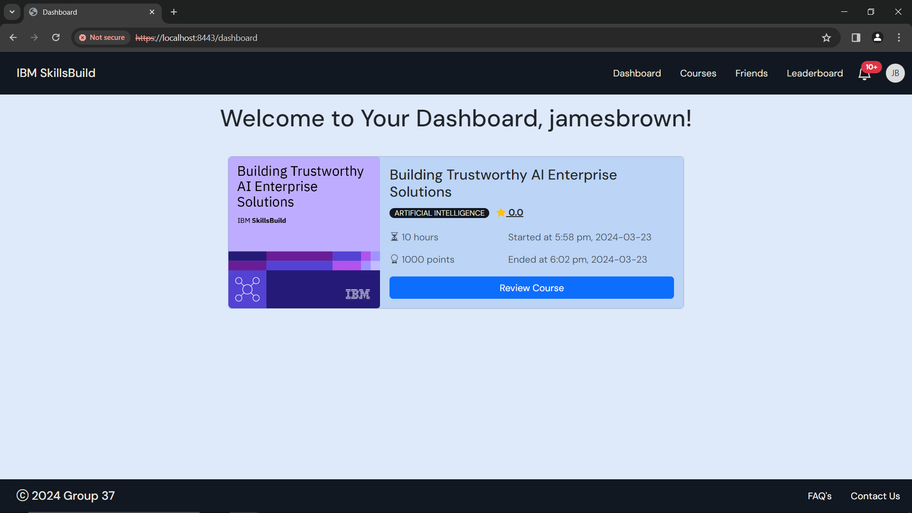

Figure 36: Dashboard - Completed Course

After you click ***‘Return to Dashboard’***, you will see the time and date when you passed the quiz and completed the course.

If you help with enrolling in more courses, head to the **Enroll in a Course** section under the **Courses** section in the user manual

## Review a Completed Course

Once you have completed a course, you can review it, by adding a rating and a comment.



Click ***‘Review Course’***

Figure 37: Dashboard - Review Course

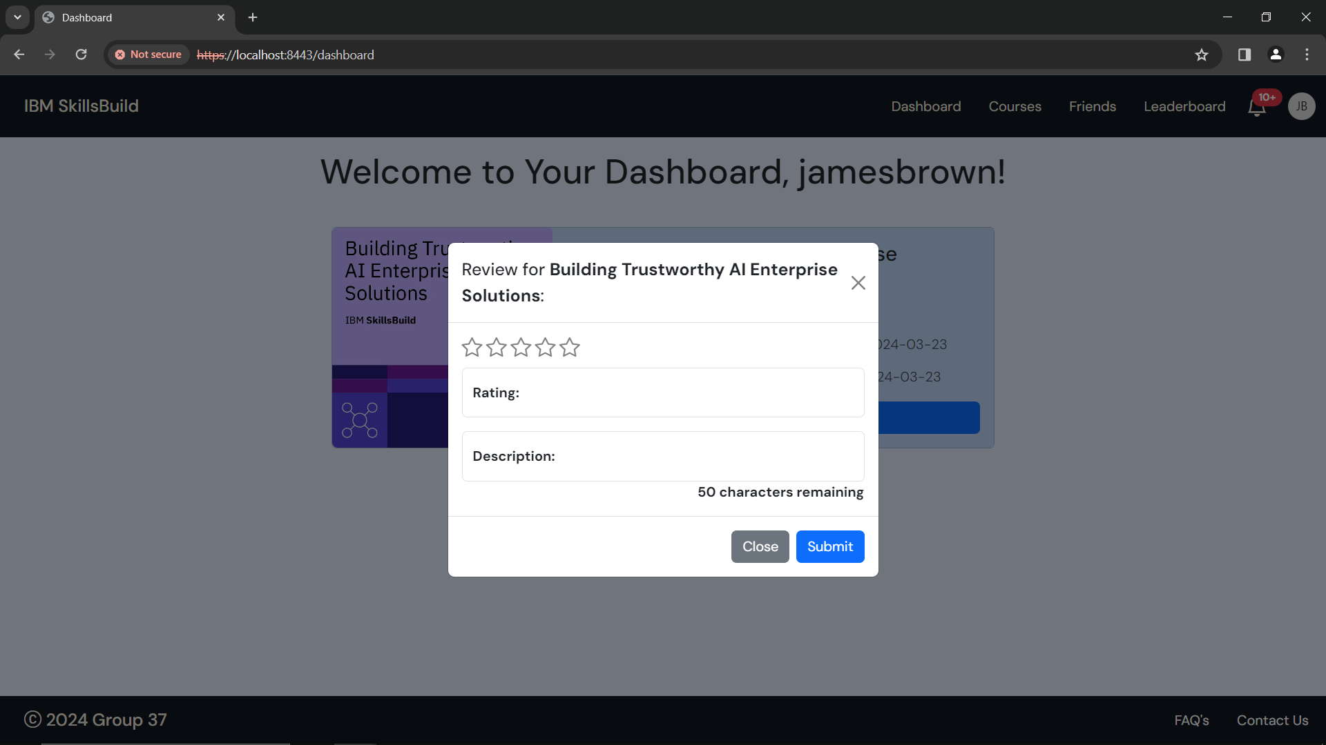

Figure 38: Review Course

Here you select the rating, and provide a description

* Rating must be 0-5 **inclusive** (e.g. 0 or 3.5 or 5)
* Description must have **minimum** 20 characters
* Description can have **maximum** 50 characters
* Description must **not** have any profanities

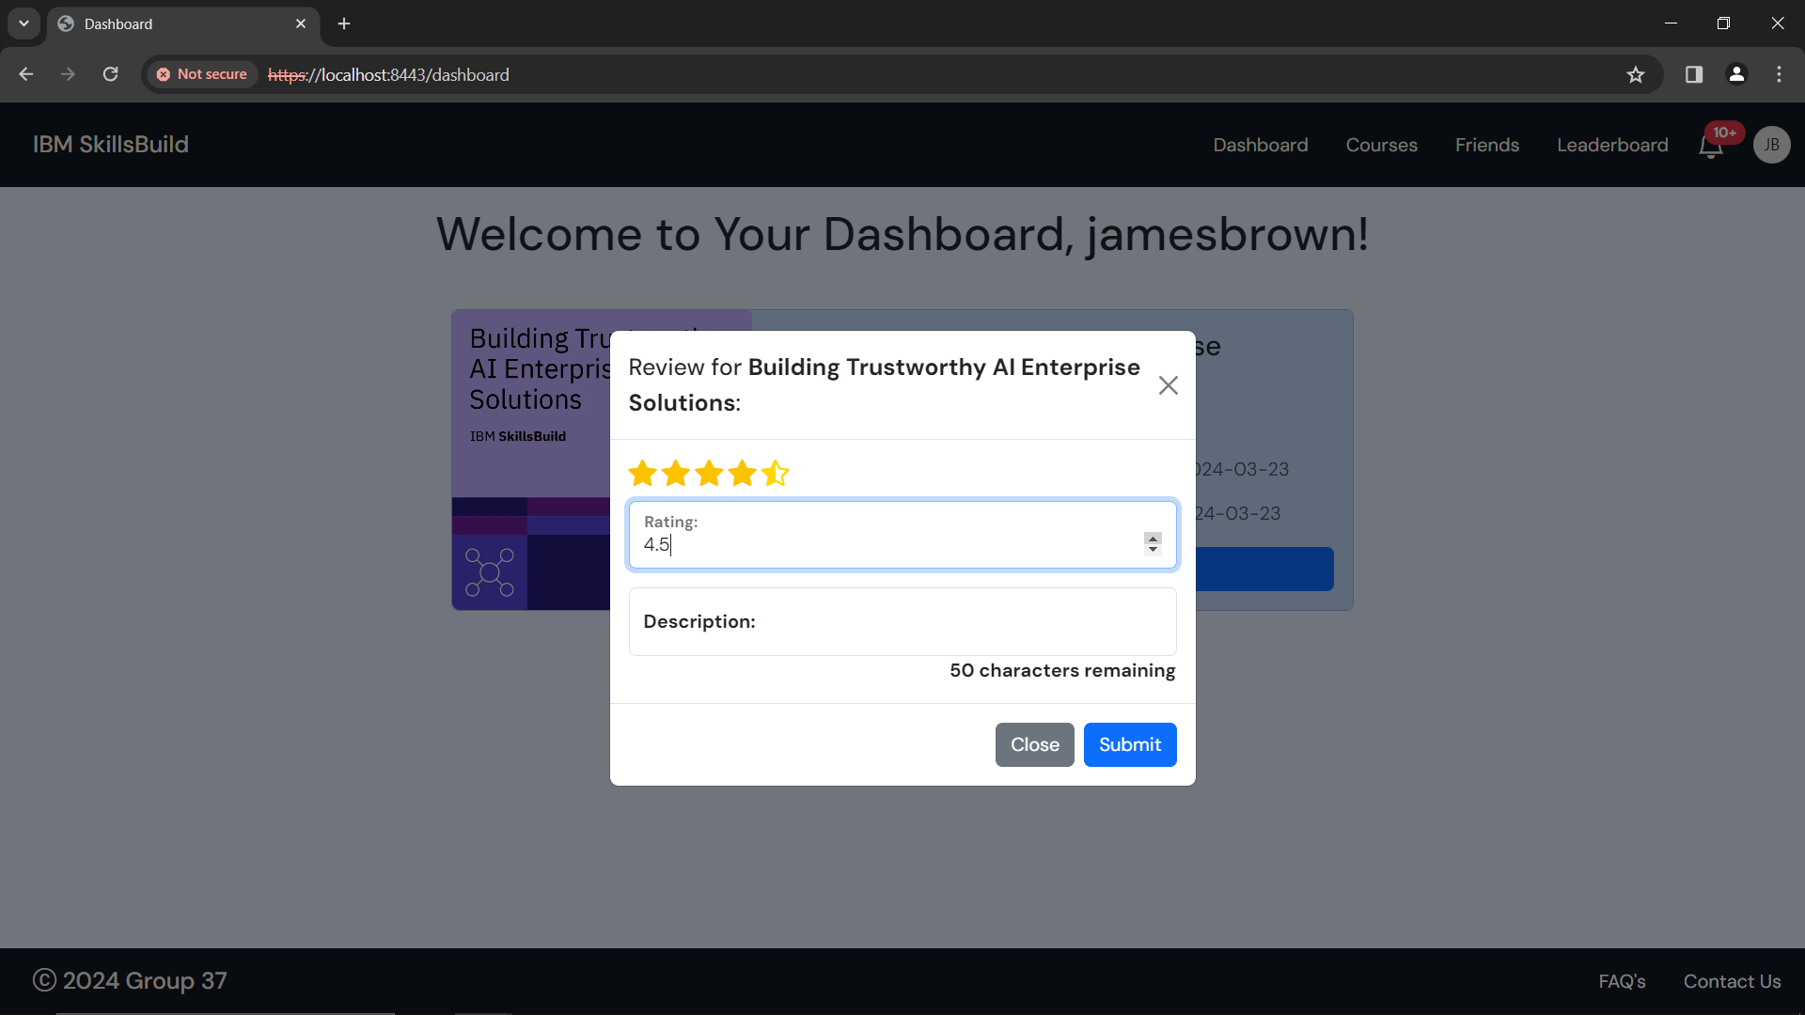

Shows your rating in terms of stars

Click the up/down arrows to increase/decrease rating by 0.5

Figure 39: Increase/Decrease Rating

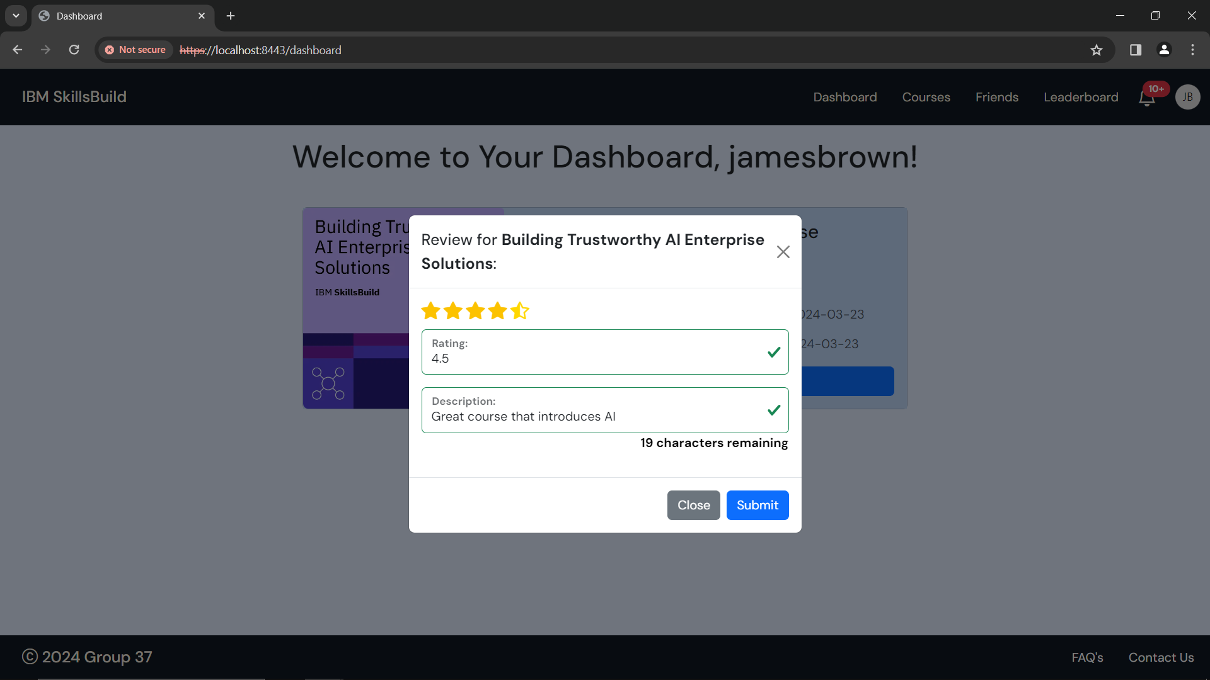

Click ***‘Submit’***

Once you are happy with your review, click ***‘Submit’***

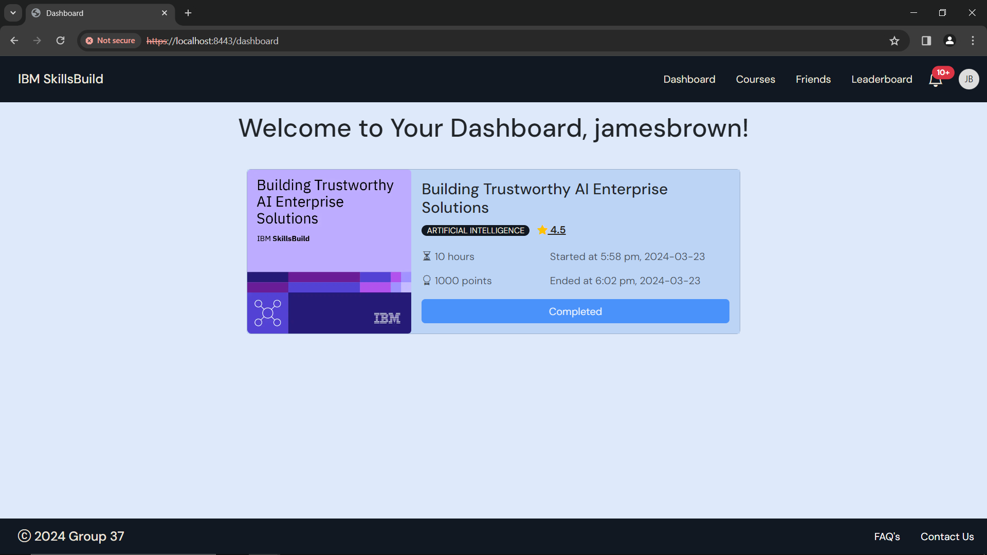

Figure 40: Dashboard - Review Submitted

Once you have submitted your review, you will be taken back to the dashboard where you can see your updates rating.

To see your review, click on the rating.

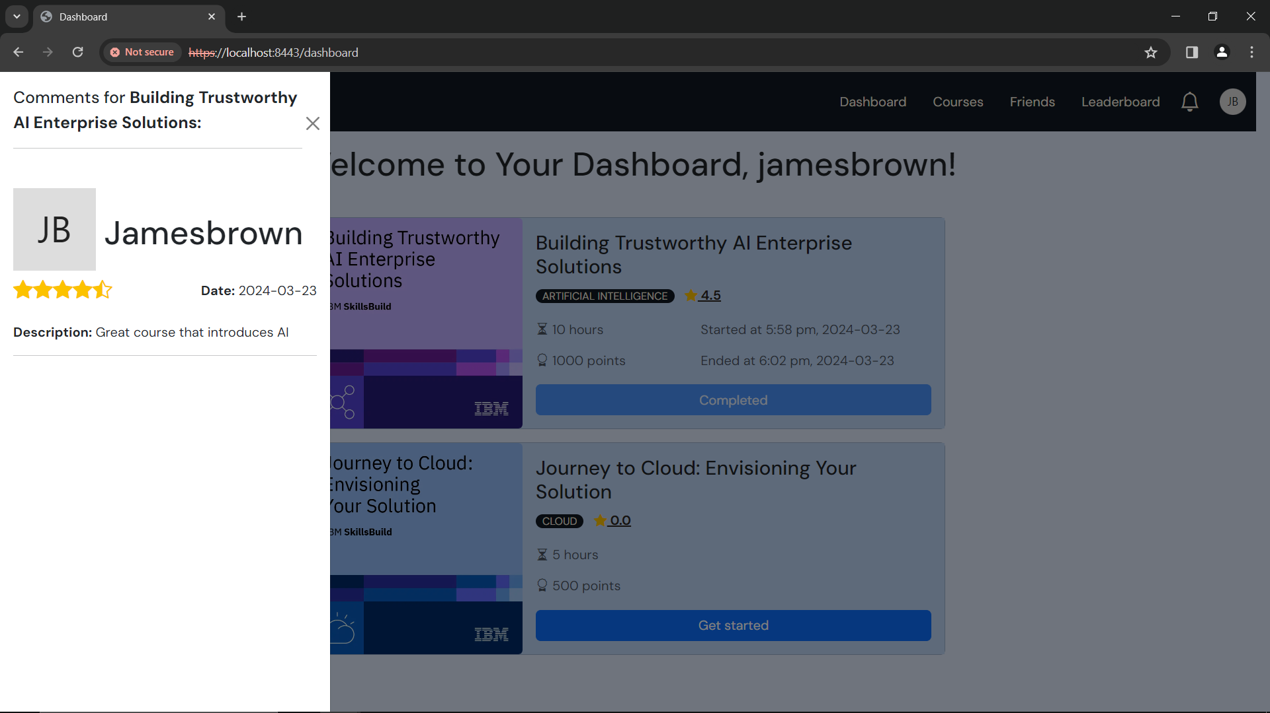

Figure 41: Updated review

If you help with enrolling in more courses, head to the **Enroll in a Course** section under the **Courses** section in the user manual

# Courses

To access the courses page, use this link: <https://localhost:8443/courses>

On the courses page, you will see a Welcome message, with available courses that you can enroll in.



Figure 42: Courses

If you want to view courses you have already enrolled in, head to the ***‘Dashboard’***



To go to your Dashboard, click **‘*Dashboard’***

Figure 43: Courses - Dashboard

If you want help with your dashboard, head to the **Dashboard** section in the user manual.

## Enroll in a Course

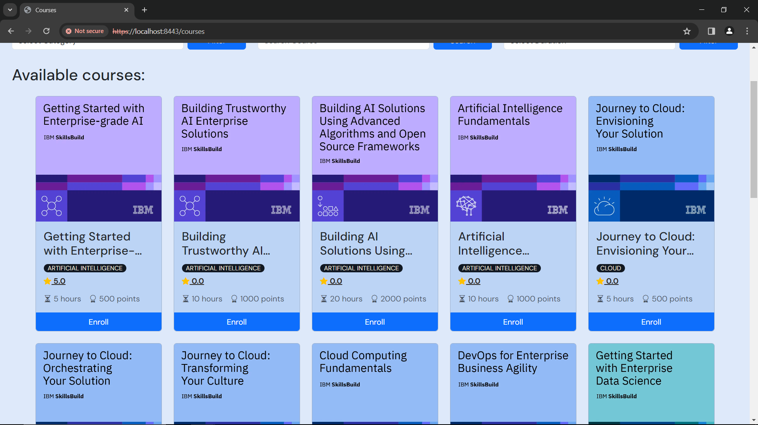

To enroll in course, click **‘*Enroll’***

Figure 44: Courses - Enroll in a Course

To enroll in a course of your choice, click **‘*Enroll’***

*Example: Course – Building Trustworthy AI Enterprise Solutions (shown in Figure 41 above)*

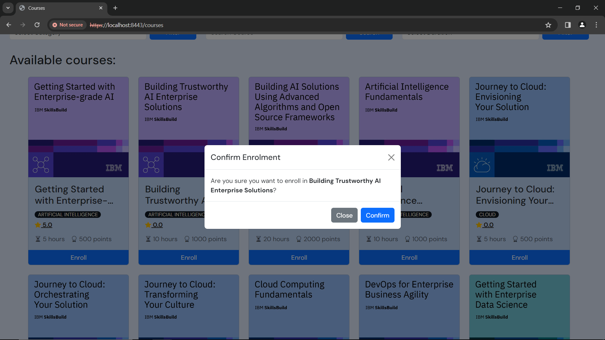

Figure 45: Courses - Enroll

After you click ***‘Enroll’***, you will see a popup that asks if you want to enroll in that course.

* If no, click ***‘Cancel’ –*** you will see the courses page again



Figure 46: Courses

* If yes, click ***‘Confirm’*** – you will see your dashboard with the course you enrolled in



Figure 47: Dashboard

If you want help with your dashboard, head to the **Dashboard** section in the user manual.

## Filter Courses

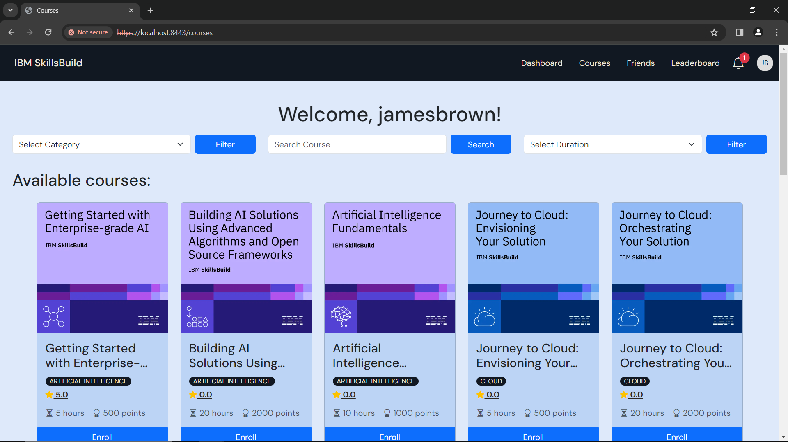

Filters

Figure 48: Courses - Filters

At the top of the courses page, you will see filters where you can filter available courses in 3 ways

1. **Category**

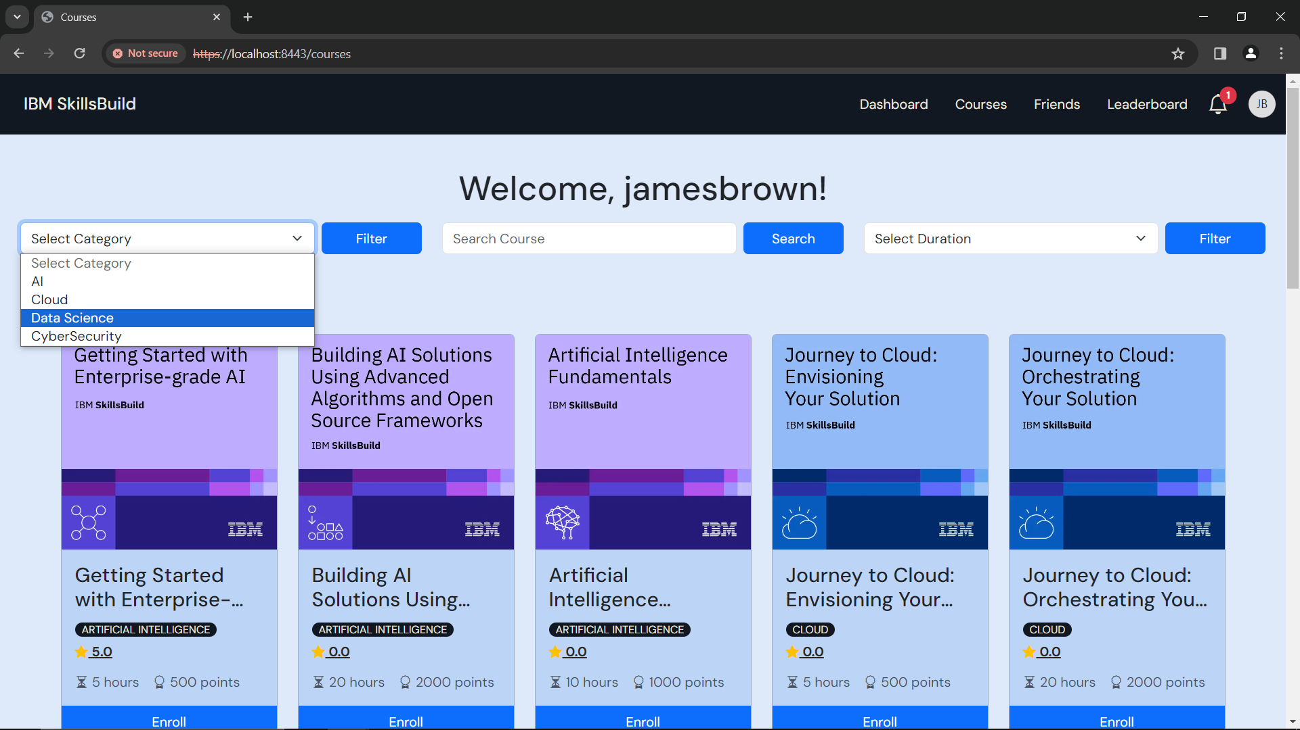

Figure 49: Courses - Filter by Category

Select your preferred category *(e.g. Data Science)* and it will display all Data Science courses.

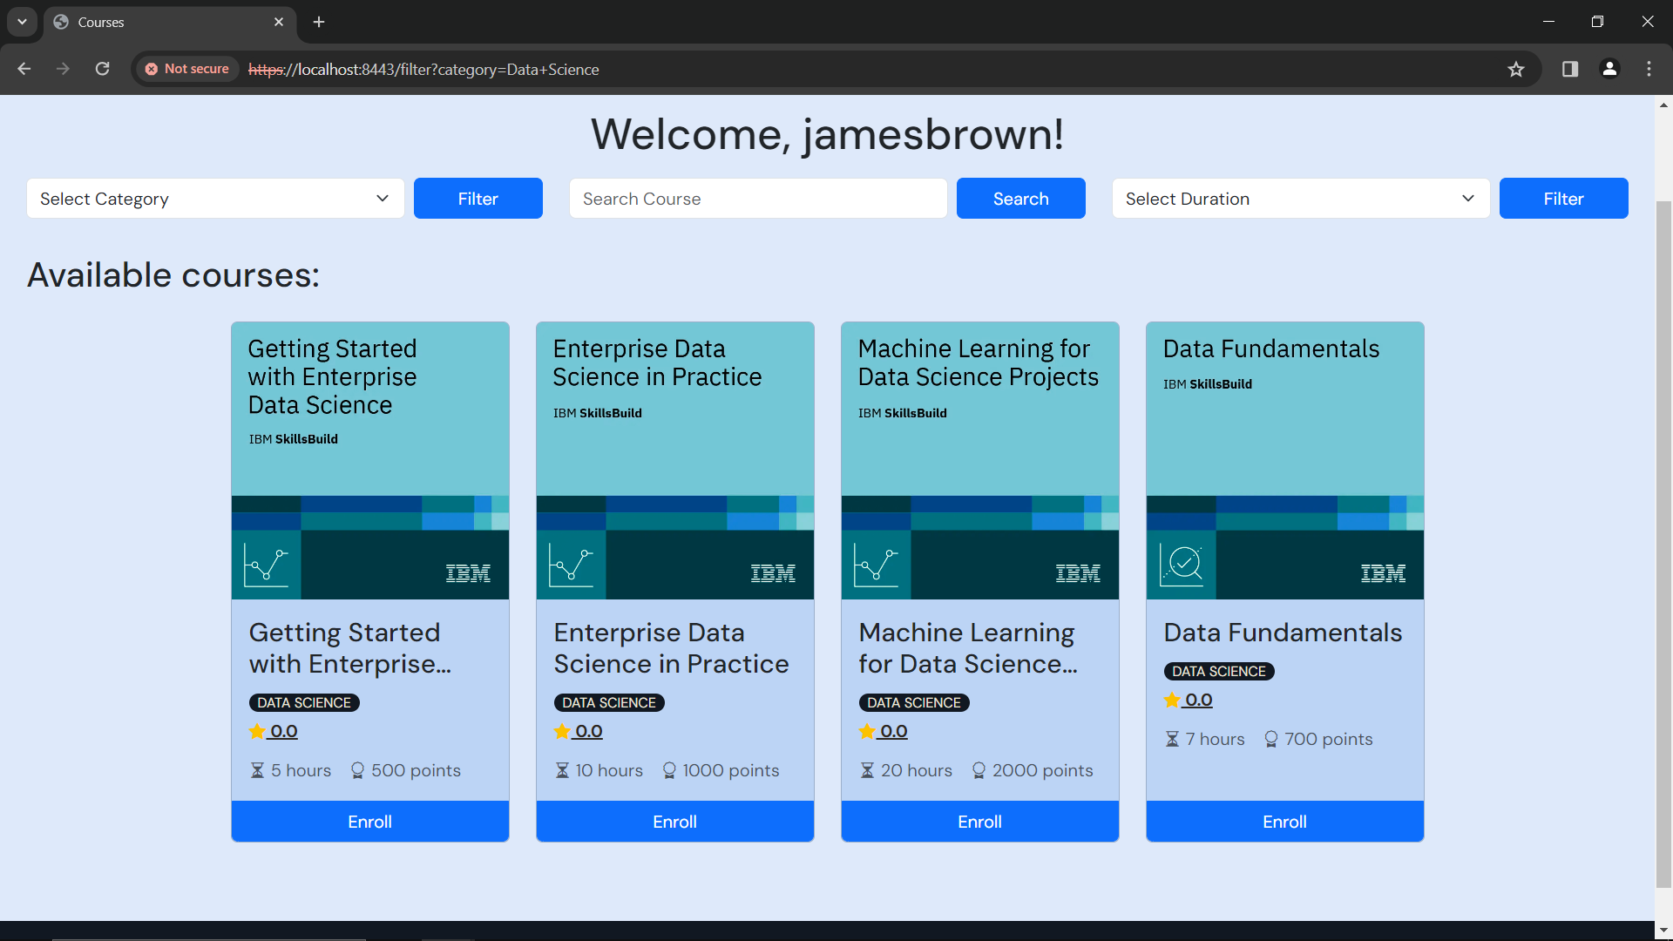

Figure 50: Courses - Filtered Data Science Category

You can now see the results of your filter by course category.

1. **Name**

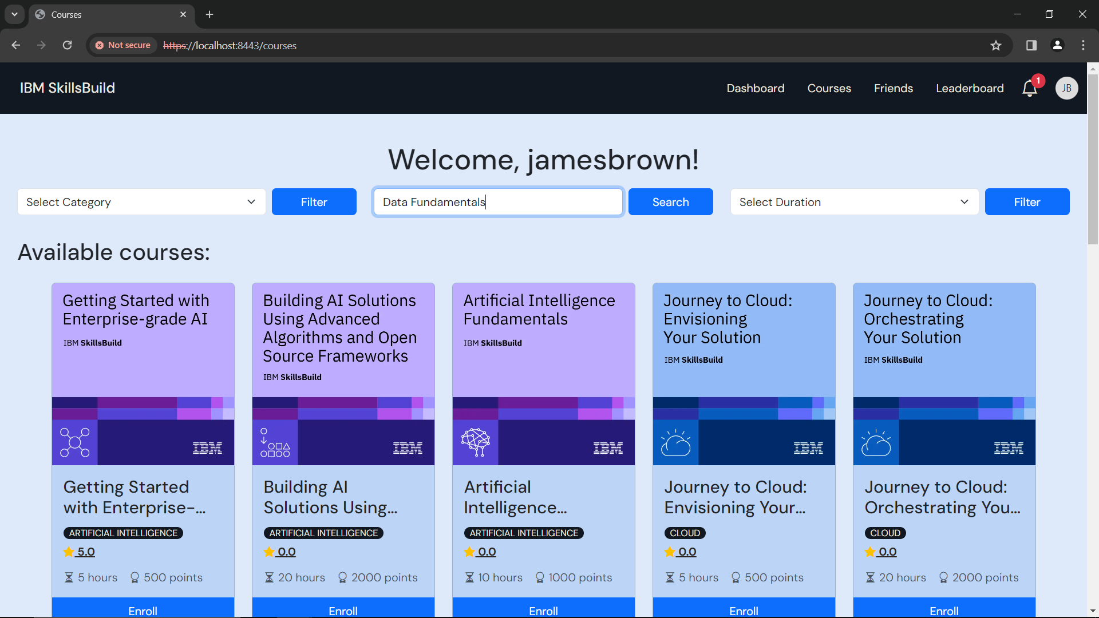

Figure 51: Courses - Filter by Name

You can search by course name, or keyword

Type in the search box *(e.g. ‘Data Fundamentals’)*

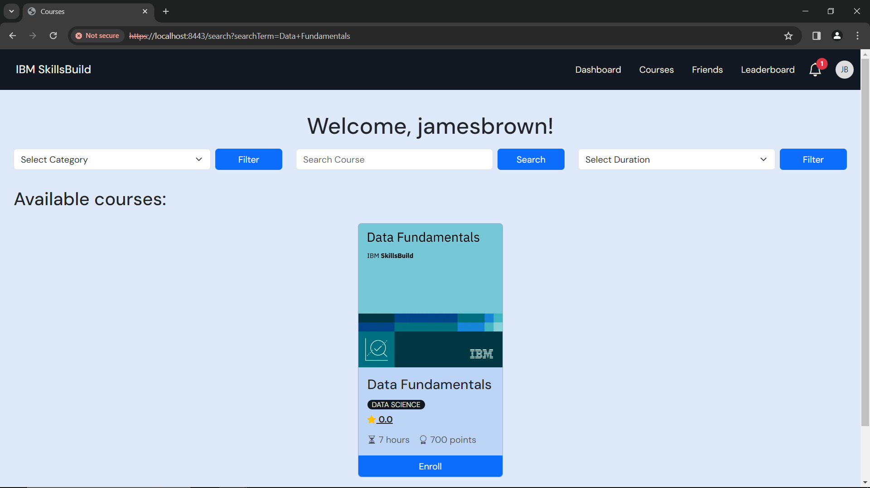

Figure 52: Courses - Filtered by 'Data Fundamentals'

You can now see the results of your search.

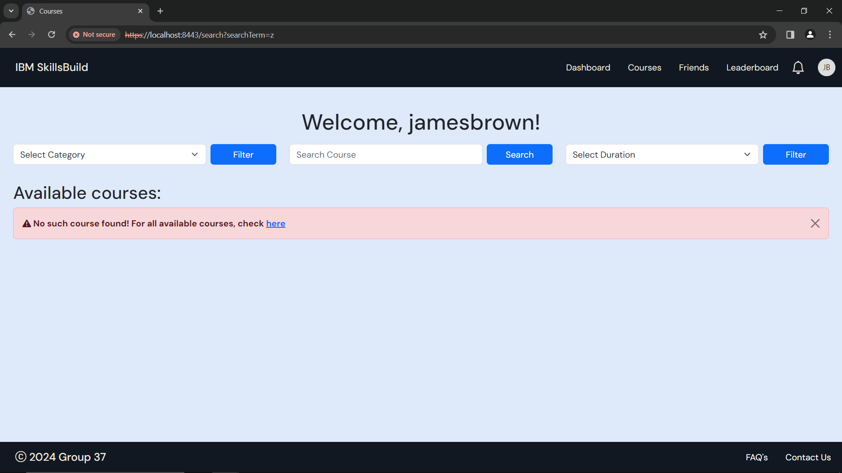

Figure 53: Courses - 'No such course found'

If your search returns the ‘No such course found!’ message (as shown above), try another keyword or phrase.

Or click ***‘here’***  to see all available courses.

1. **Duration**

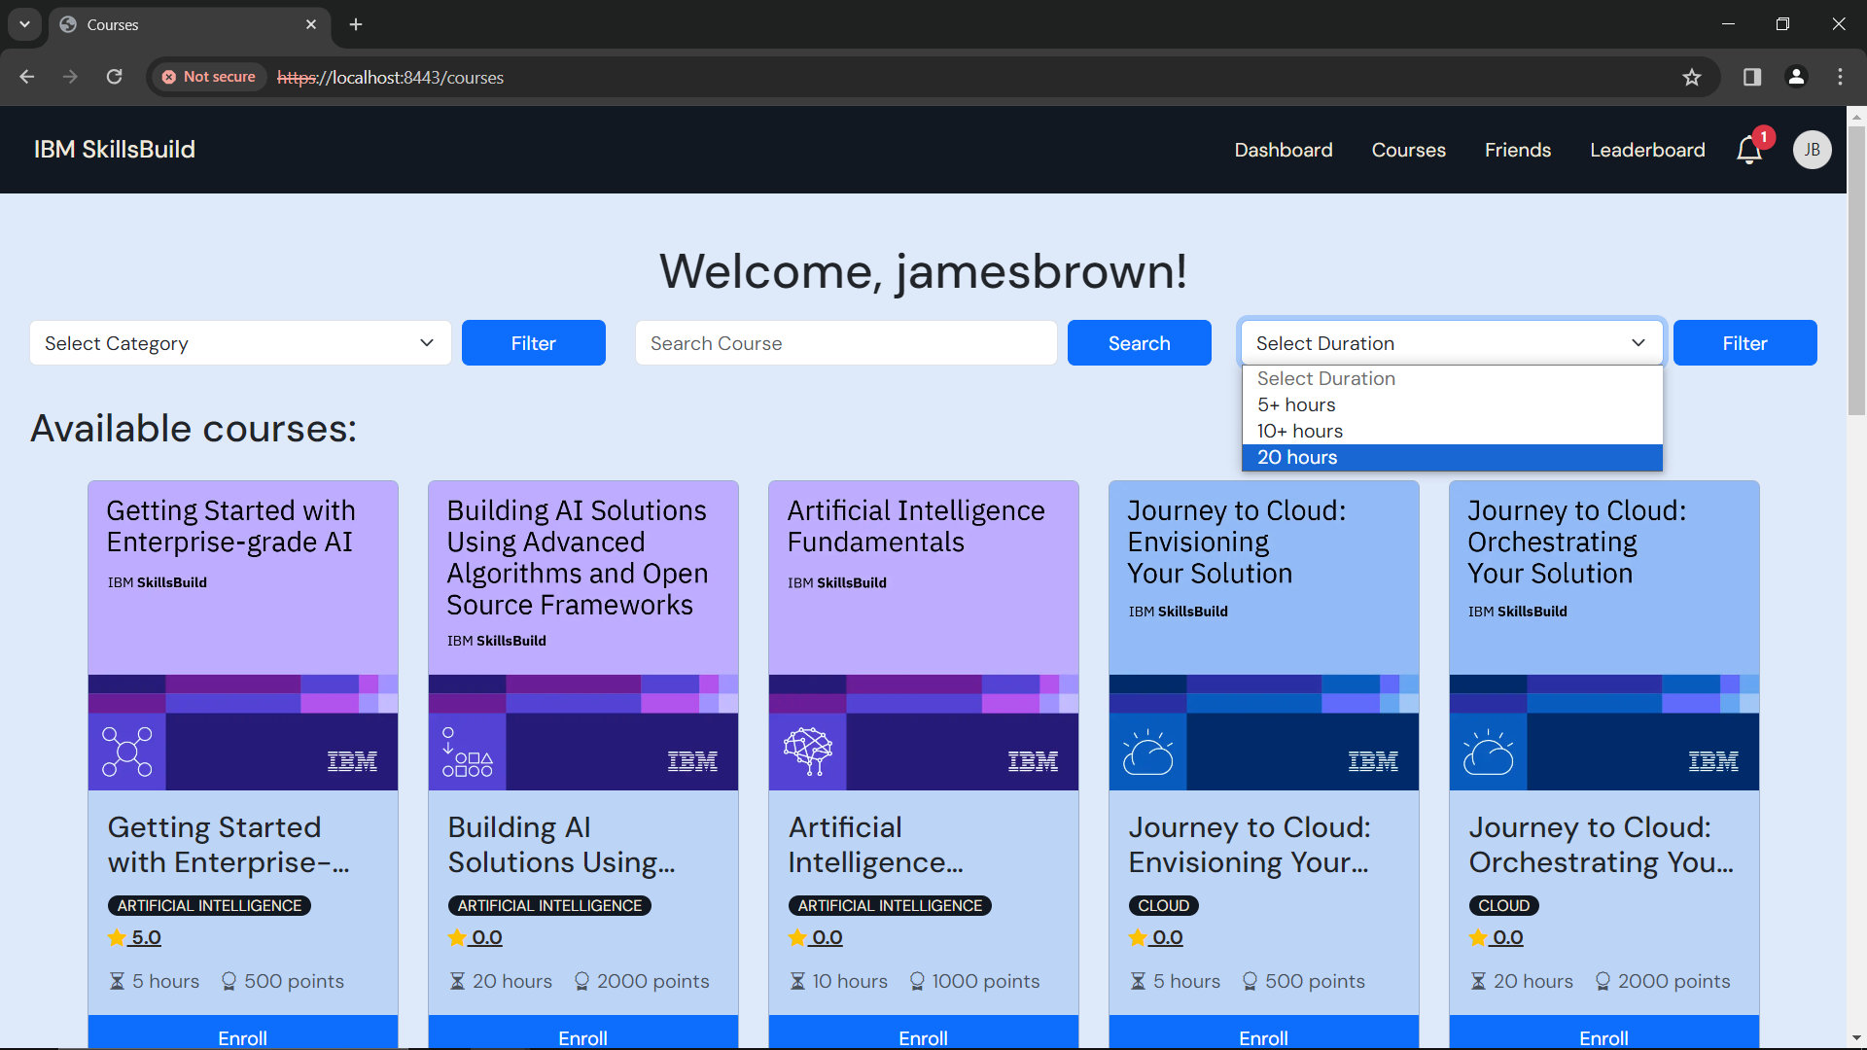

Figure 54: Courses - Filter by Course Duration

Select your preferred category *(e.g. 20 hours)* and it will display all courses with a duration of 20 hours.

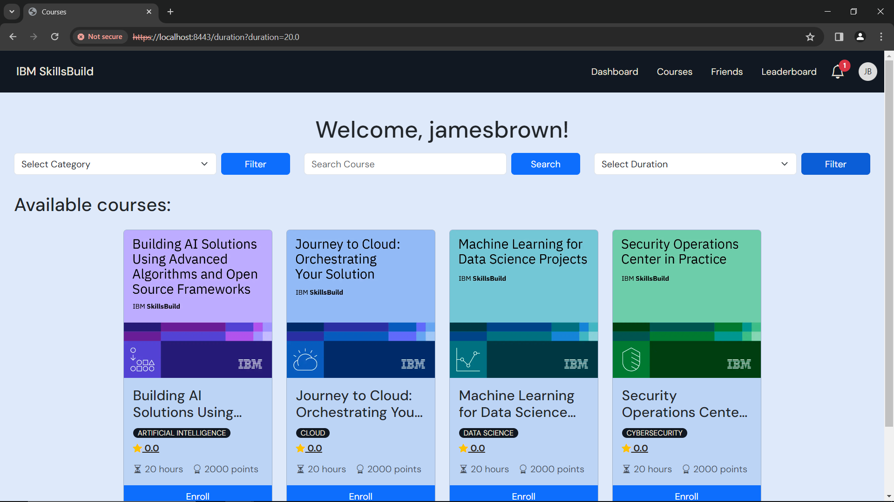

Figure 55: Courses - Filtered by Duration 20 hours

You can now see the results of your filter by duration.

You can now enroll in a course of your choice.

If you want help with enrolling in a course, head to the **Enroll in a Course** section under the **Courses** section in the user manual.

## View Ratings/Comments

You can view the rating and comments for any course before you enroll.

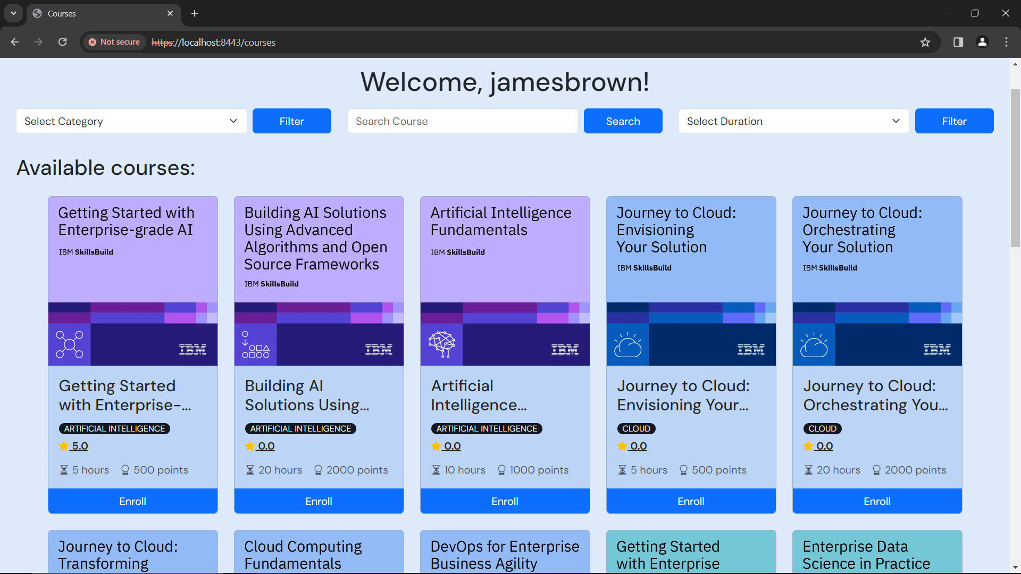

Click here, to view reviews

Figure 56: Courses

You will be able to see the average rating of every course, under the title and category of a course.

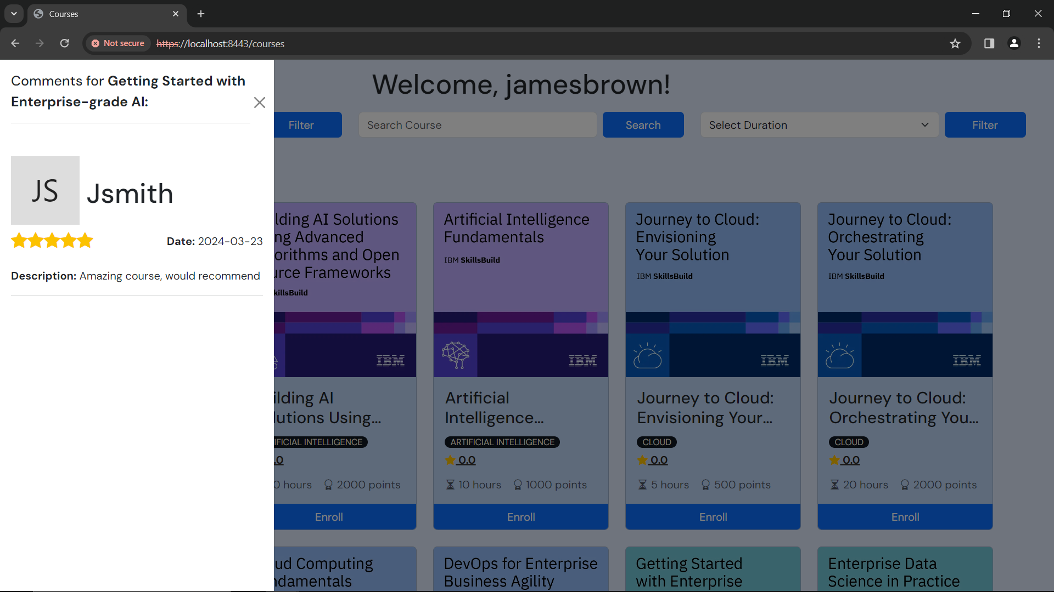

Figure 57: Courses - View Comments

To add a review, head to the **Review a Completed Course** section under **Dashboard** of the user manual.

# Profile

To access your profile page, use this link: <https://localhost:8443/profile>

In your profile, you will see your details, current statistics, achievements, and a quote.

You can also access your profile from the navigation bar (shown below)

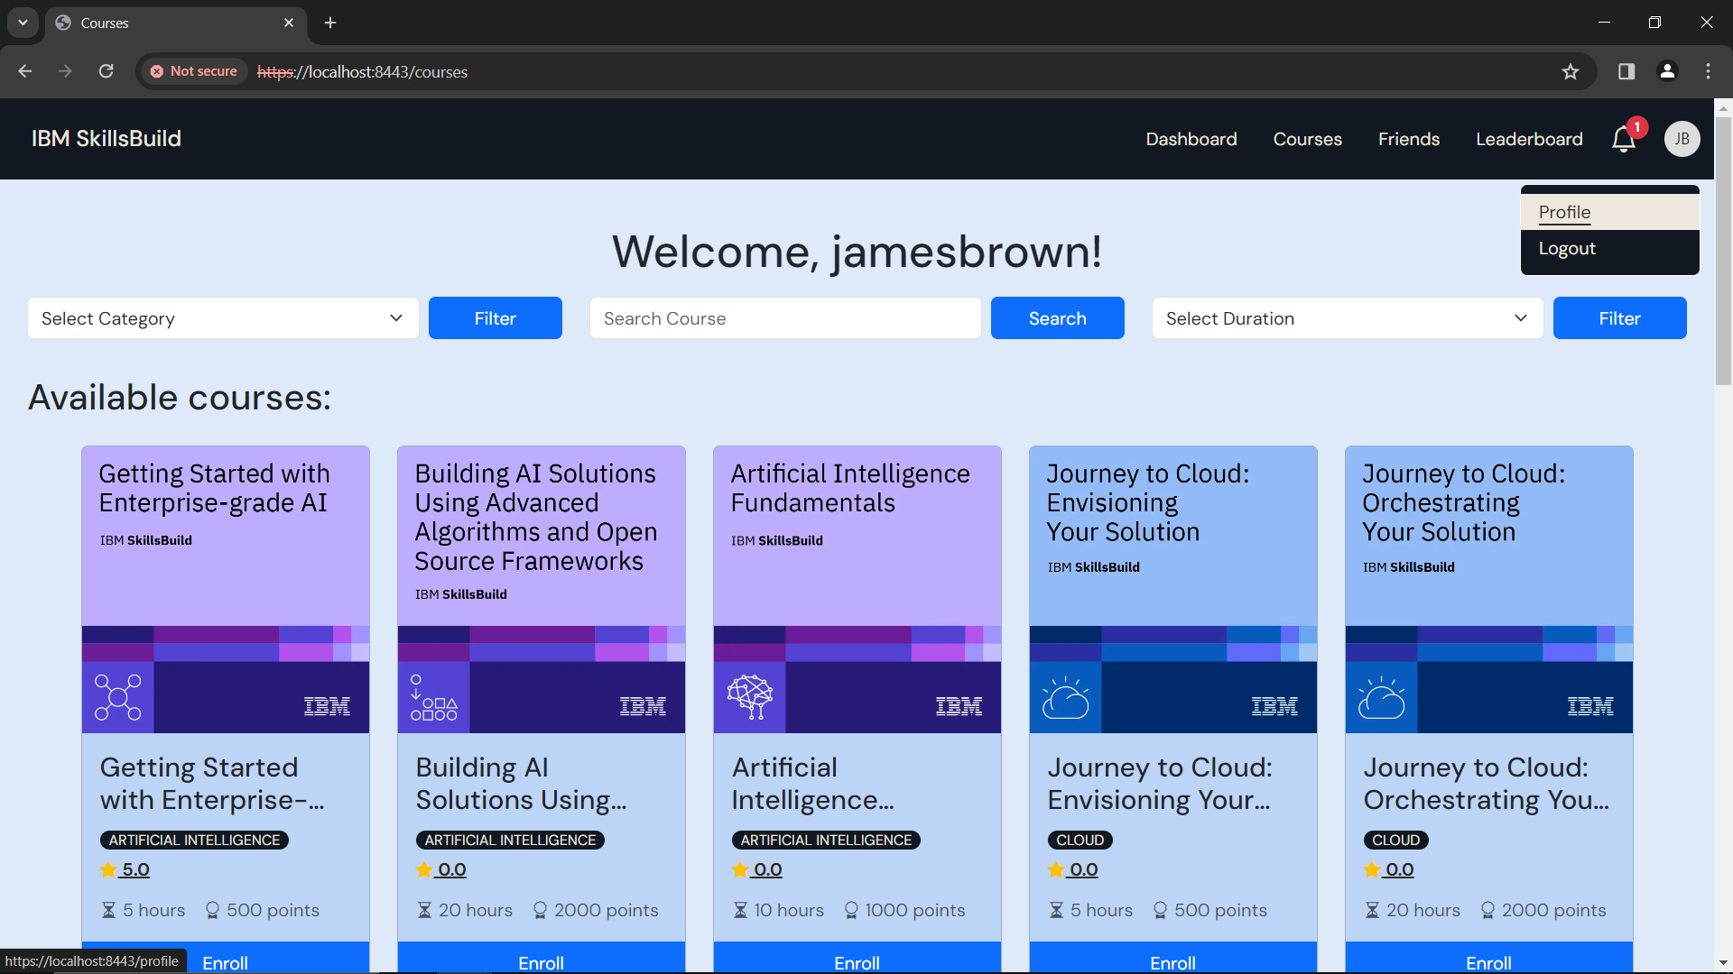

Figure 58: Courses

* First click your profile picture, in the top right
* Then click ***‘Profile’***

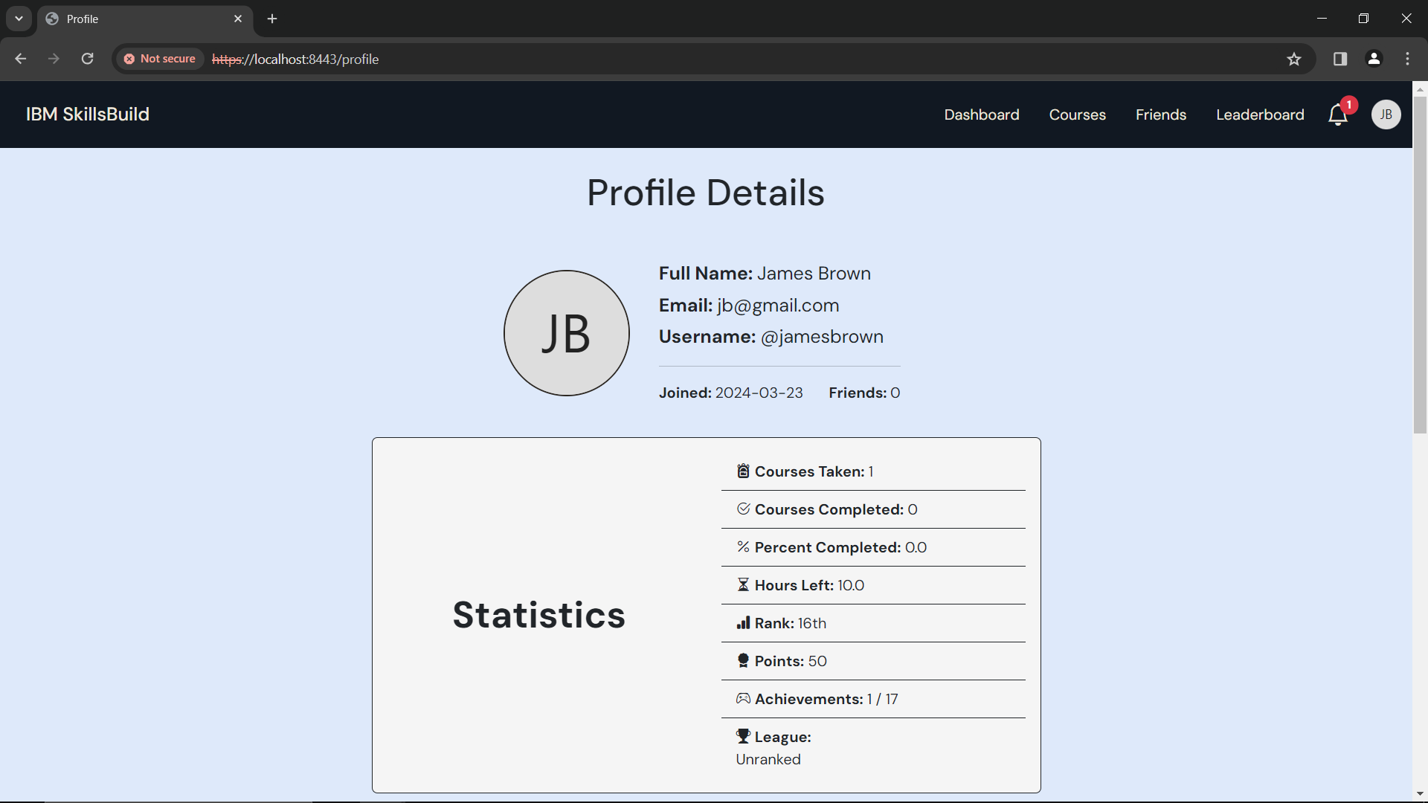

Figure 59: Profile



Figure 60: Profile – Details

At the top of the profile page, you will be able to your details

* Full name
* Email
* Username
* Date you joined
* Number of friends – (This will update as you add/remove friends)

Next you will see your statistics

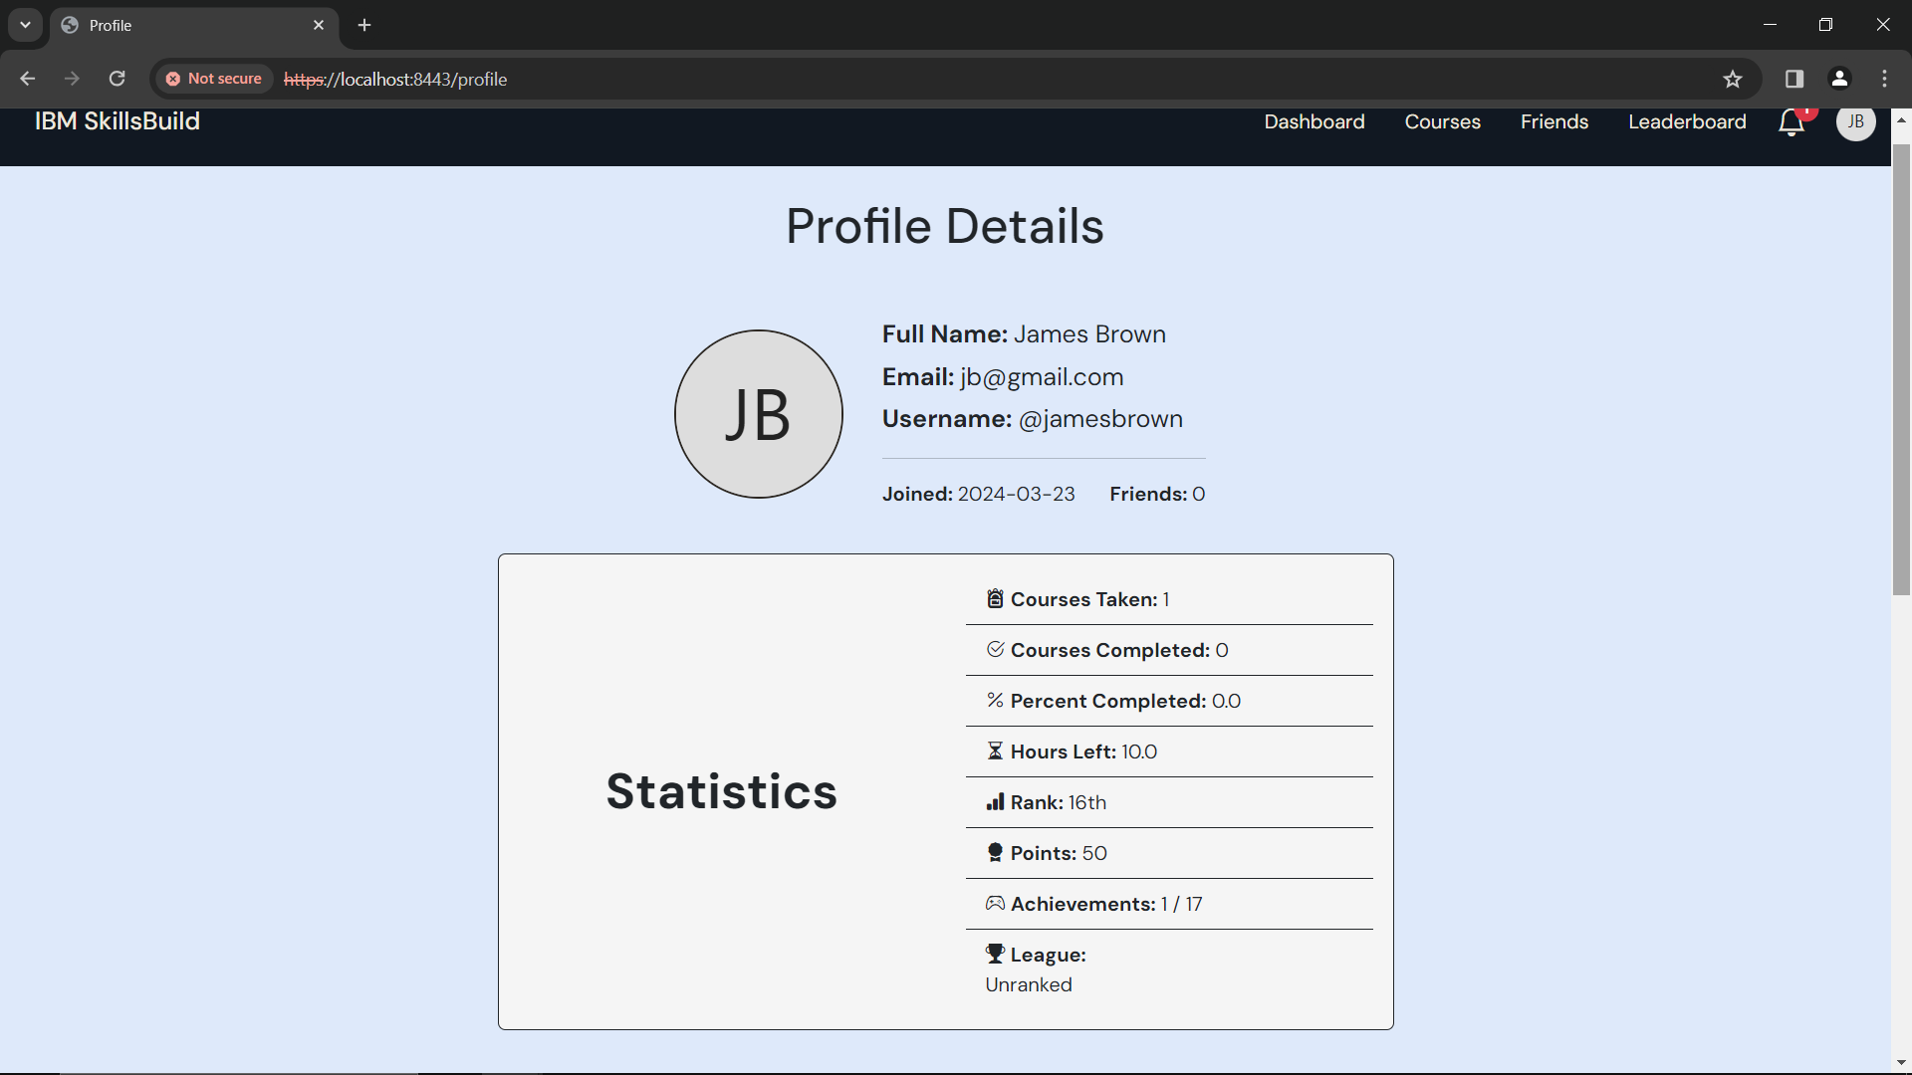

Figure 61: Profile - Statistics

* Number of course taken
* Number of courses completed
* Percentage of courses completed
* Hours of learning left
* Current rank in the global leaderboard
* Your current total of points
* How many achievements you have achieved
* You current League

The statistics will update as you enroll in, and complete courses.

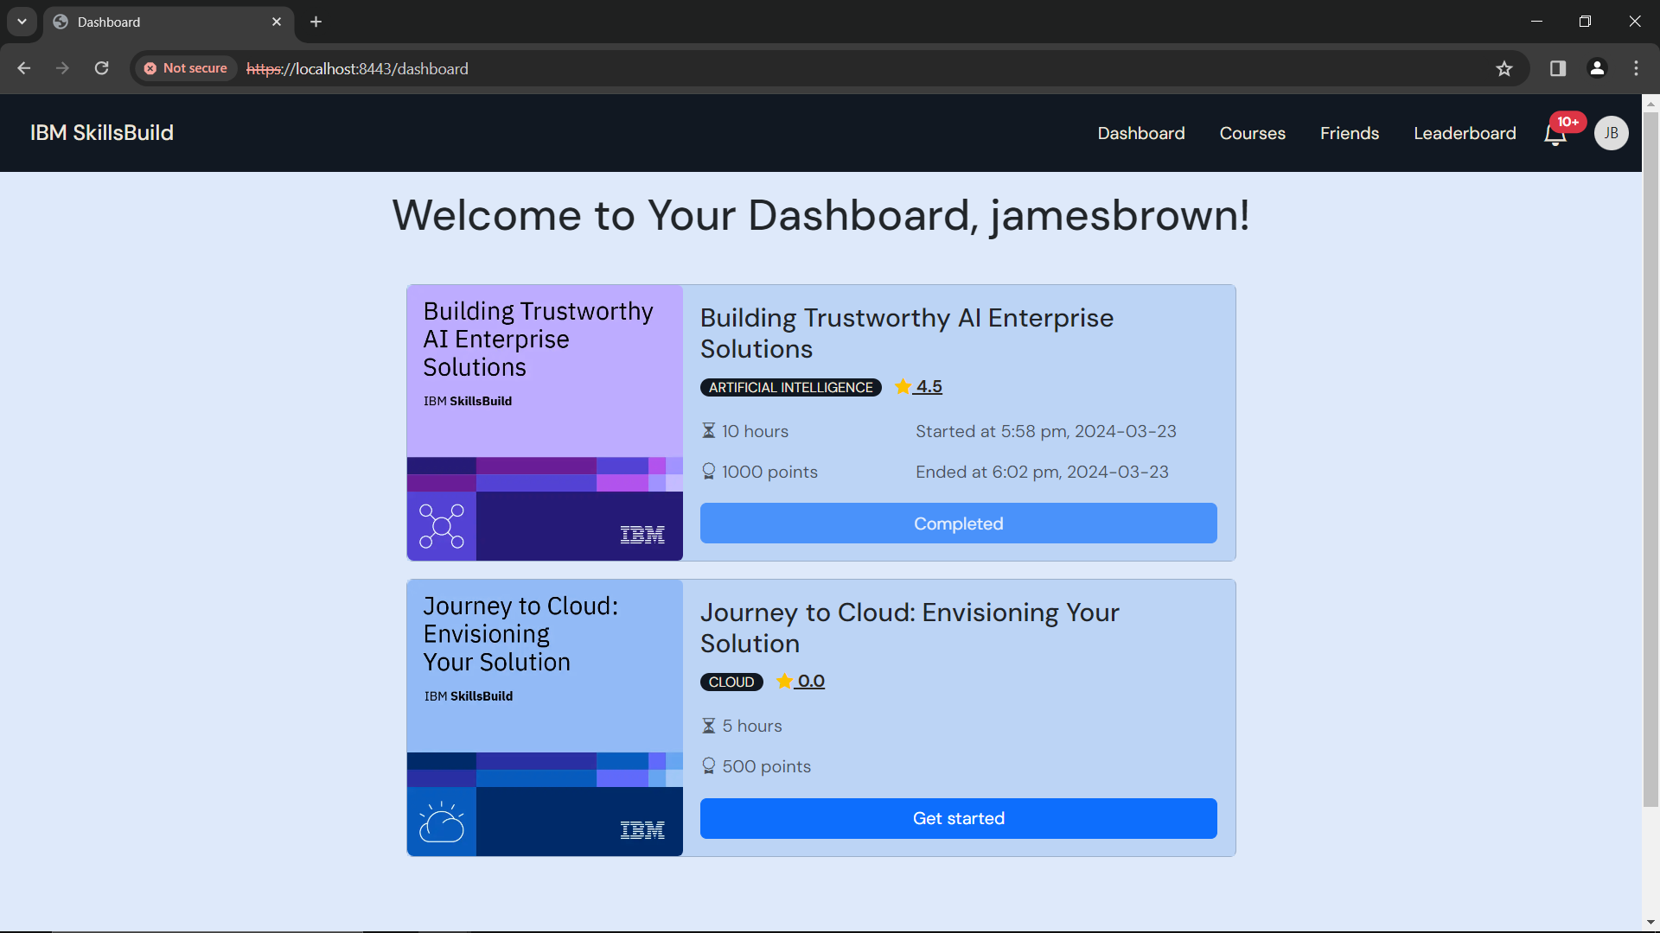

Figure 62: Dashboard - 2 courses

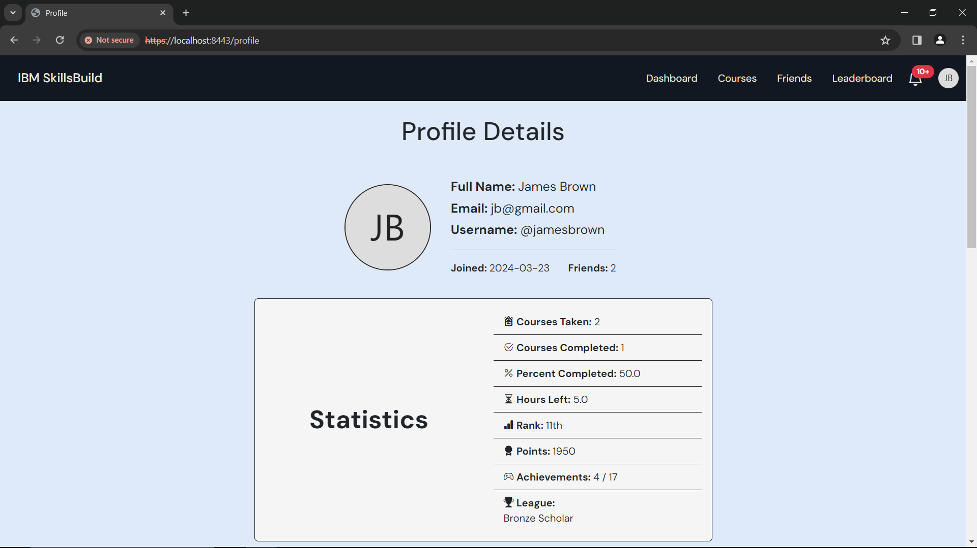

Figure 63: Profile reflecting 2 courses information

## Achievements

Next you will see your achievements

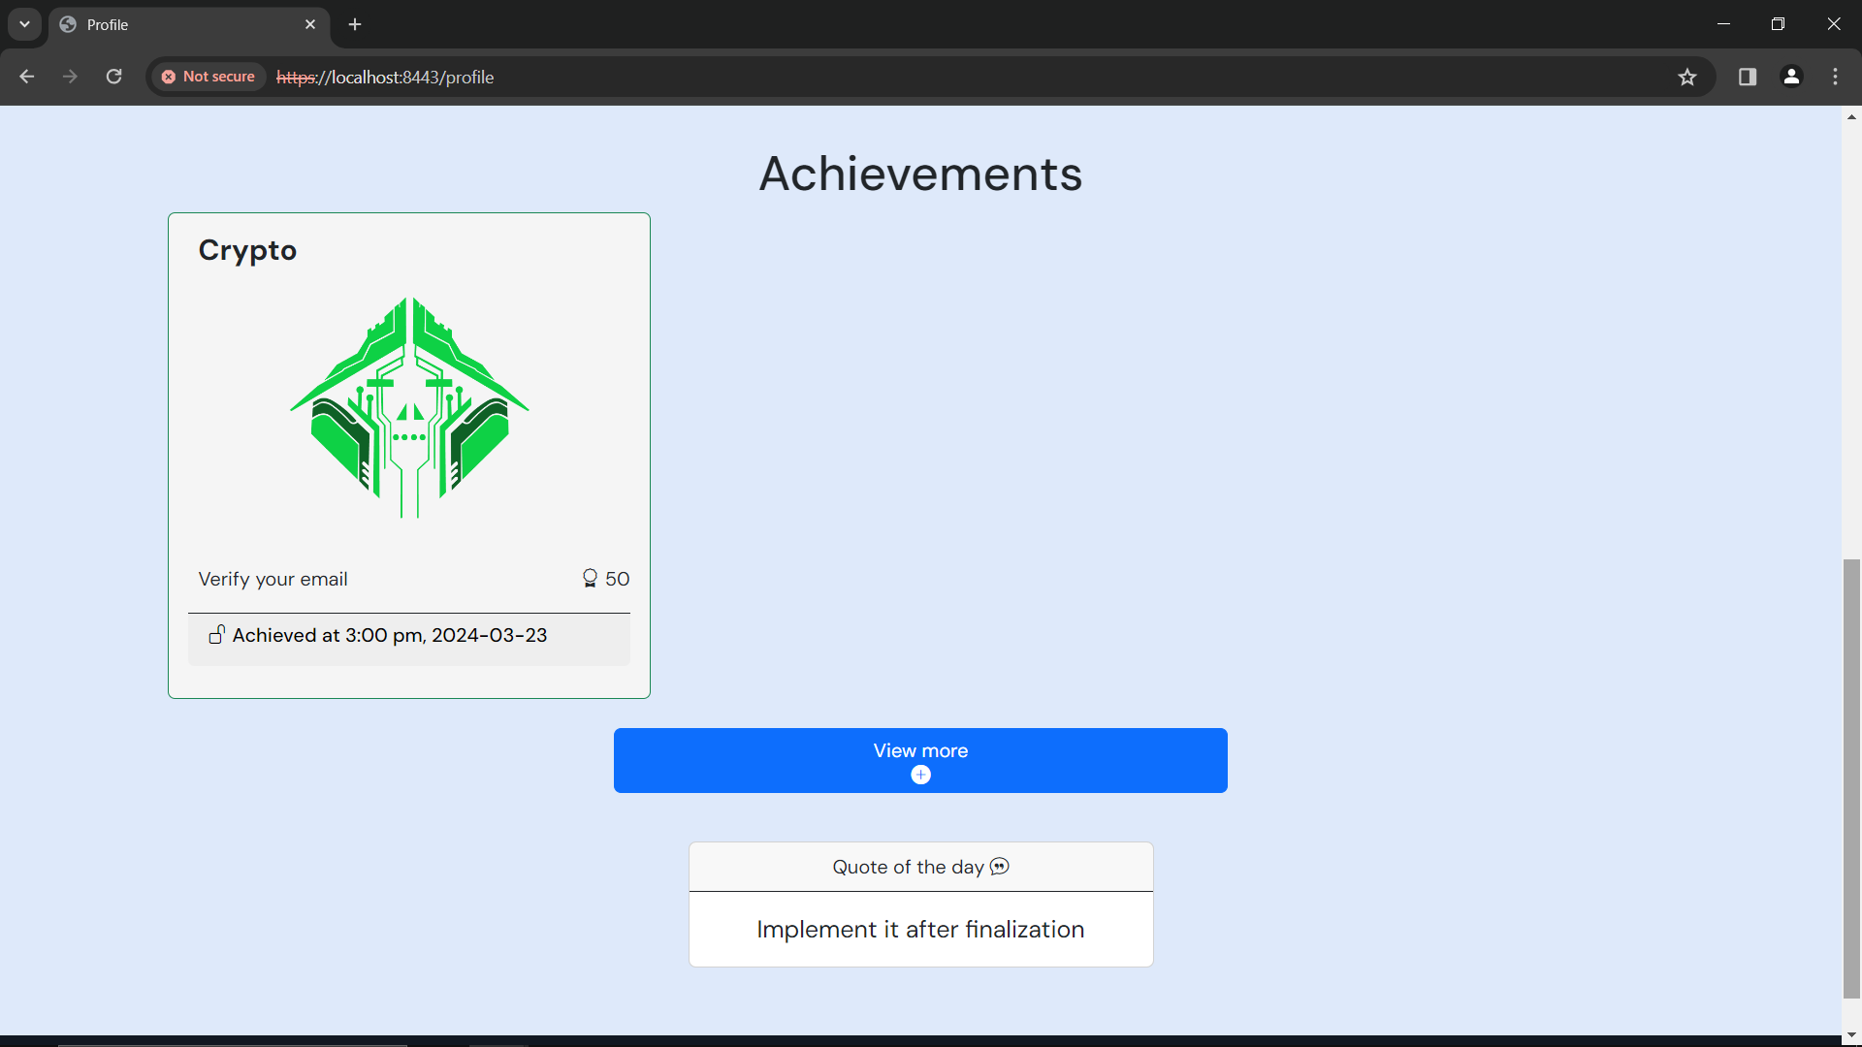

Click ***‘View more’***, to see locked achievements

Figure 64: Profile – Achievements

To see the locked achievements, click ***‘View more’***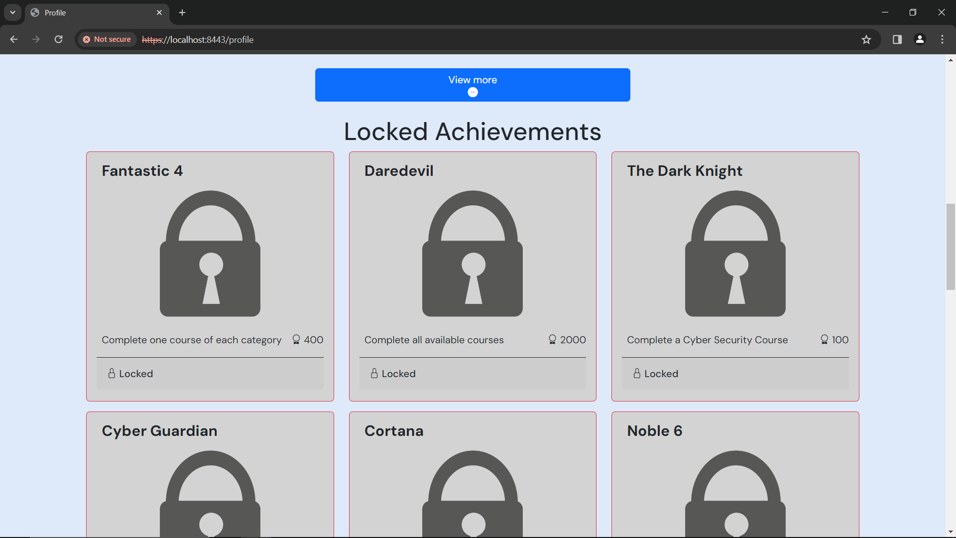

Figure 65: Profile - Locked Achievements

Each achievement will have a description of what you need to do to achieve it.

Here is a table of all possible achievements, and their respective points you will get:

|  |  |  |
| --- | --- | --- |
| **Title** | **Description** | **Points** |
| **Fantastic 4** | Complete one course of each category | 400 |
| **Daredevil** | Complete all available courses | 2000 |
| **The Dark Knight** | Complete a Cyber Security Course | 100 |
| **Cyber Guardian** | Complete 2 cyber security courses | 500 |
| **Cortana** | Complete an AI course | 100 |
| **Noble 6** | Complete any 6 courses | 800 |
| **The Flash** | Complete a course in 24 hours. | 300 |
| **Data sorcerer** | Complete a Data science course | 150 |
| **Iron Legion** | Complete all AI courses | 1200 |
| **Mirage** | Start 2 courses within 24 hours | 250 |
| **QuickSilver** | Complete 2 courses in 24 hours | 500 |
| **Crypto** | Verify your email | 50 |
| **MrFantastic** | Reach Titanium league | 2500 |
| **HyperLethal** | Reach Elysium league | 3500 |
| **The Chosen One** | Reach Top 3 in the Elysium League | 5000 |
| **Double Trouble** | Add a friend | 500 |
| **Review Conqueror** | Review 5 Courses | 1000 |

# Friends

To access the friends page, use this link: <https://localhost:8443/friends>

On the friends page, you will be able to see your current friends, be able to add friends, see your friend request and search for friends.

If you have not added any friends, you will see this page (shown below)

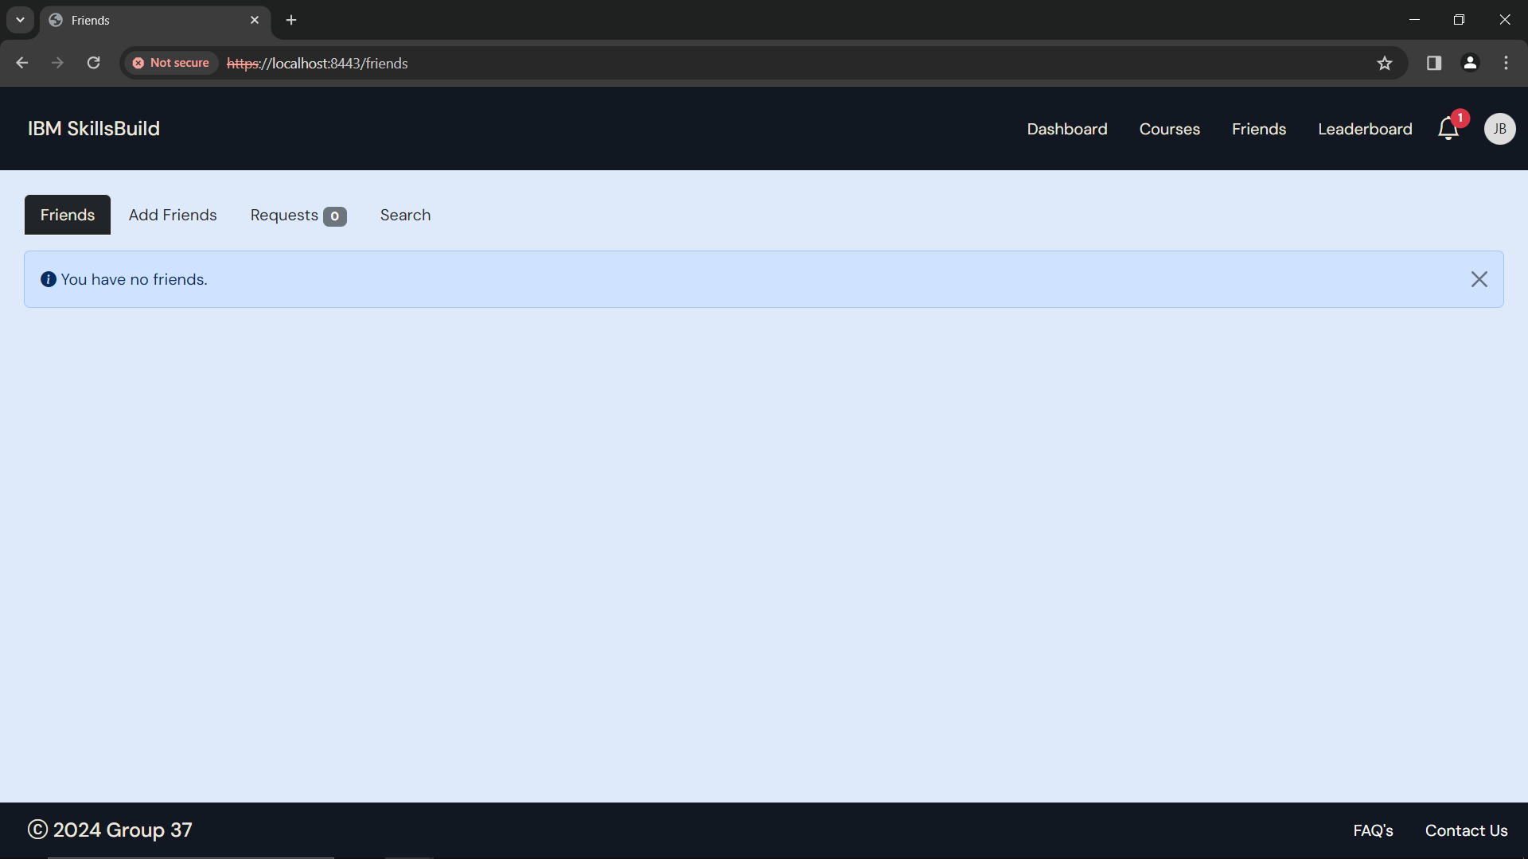

Figure 66: Friends - You have no friends.

If you have friends added, you will see this page (shown below)

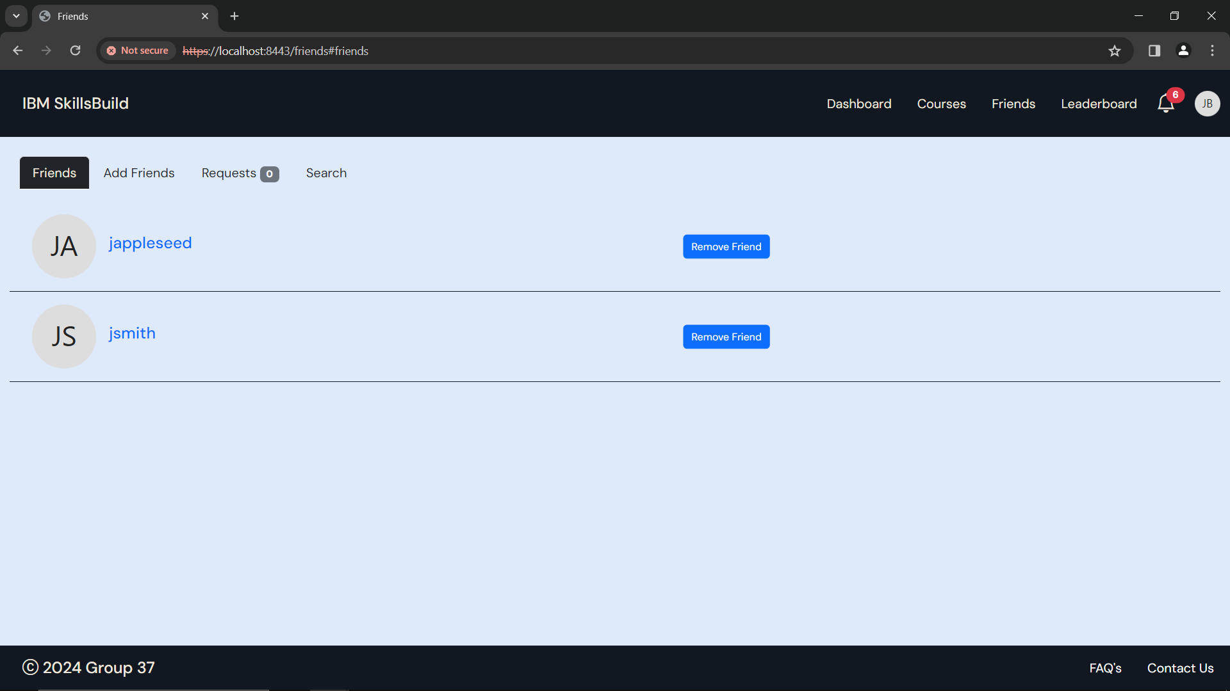

If you want help with adding new friends, head to the **Add Friends** section under **Friends** section of the user manual.

## Add Friends

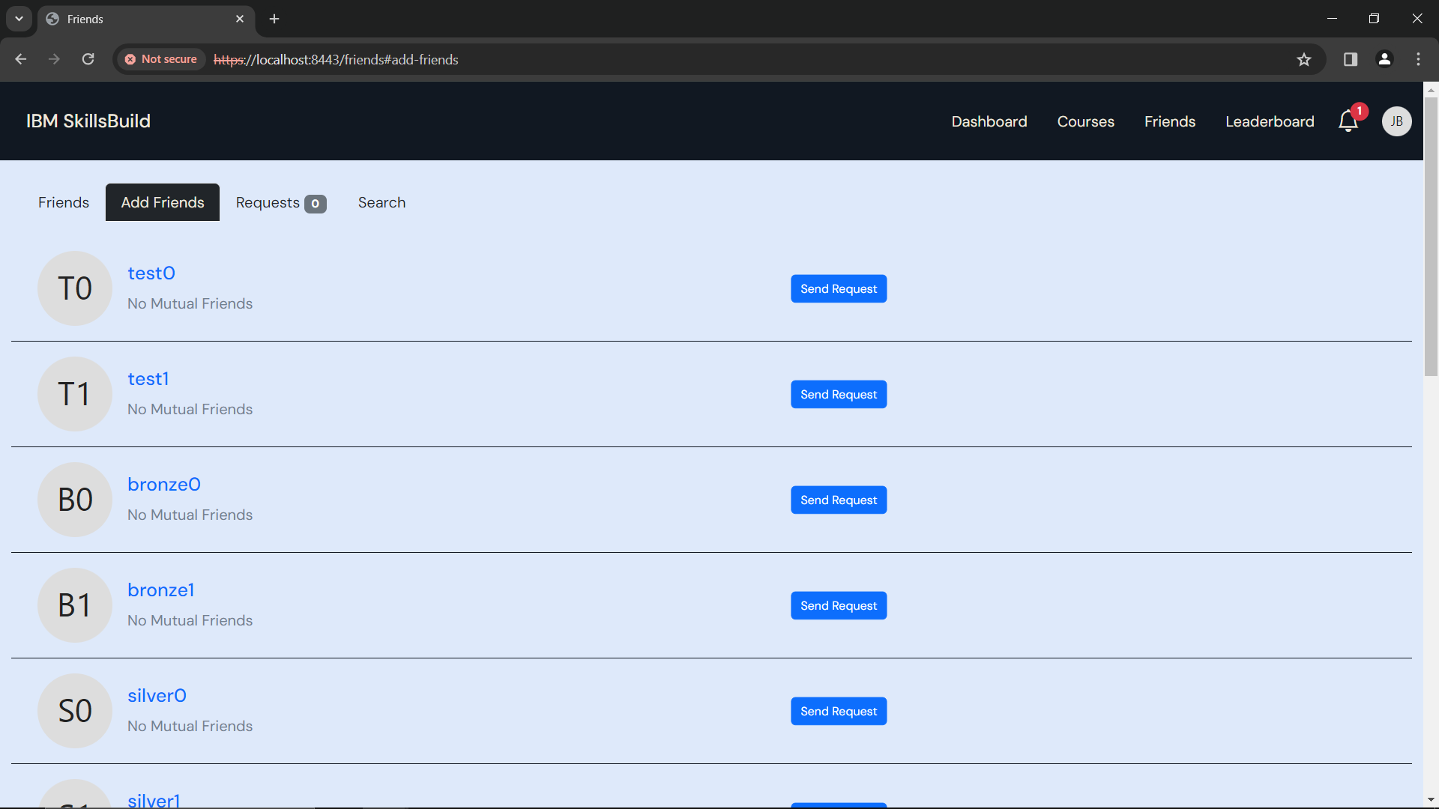

Figure 67: Friends - Add Friends

To add a friend, click ***‘Send Request’***

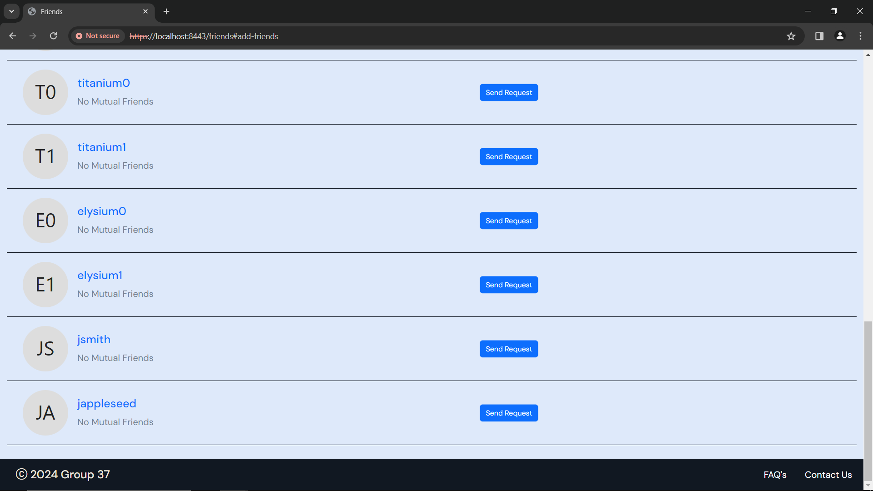

Click ***‘Send Request’***

Figure 68: Friends - Send Request

Once your friend has accepted your request, you will be able to see them in your friends tab

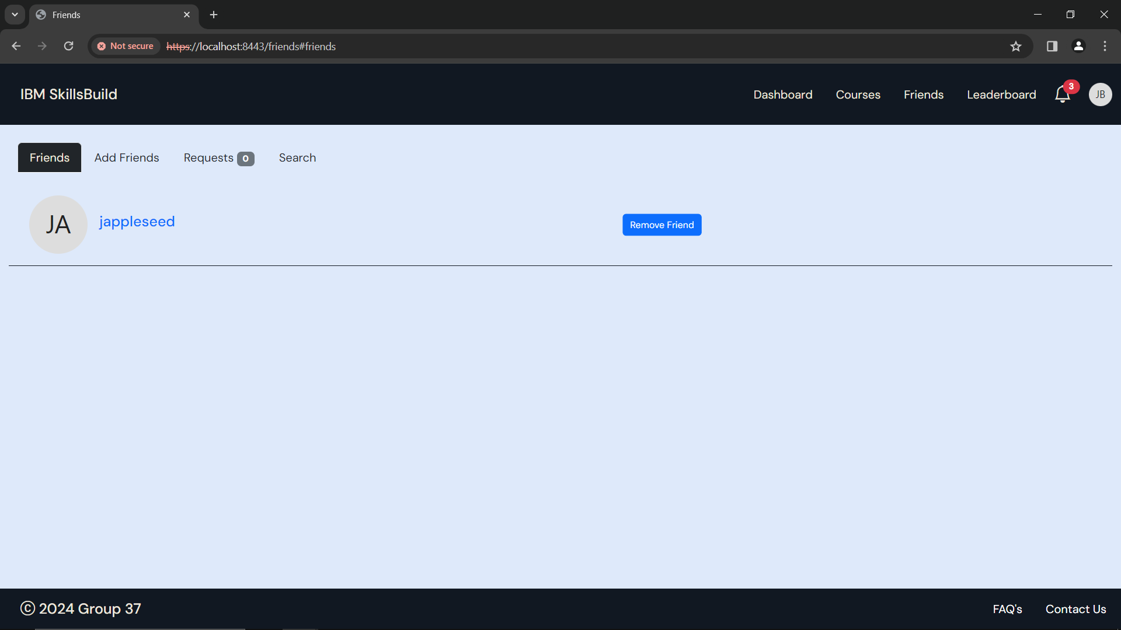

Figure 69: Friends - 1 friend

## View Friends Profile

You can view friends’ profiles (only works if you are friends)



Figure 70: Friends

If you click on your friend’s name, you will be taken to their profile page

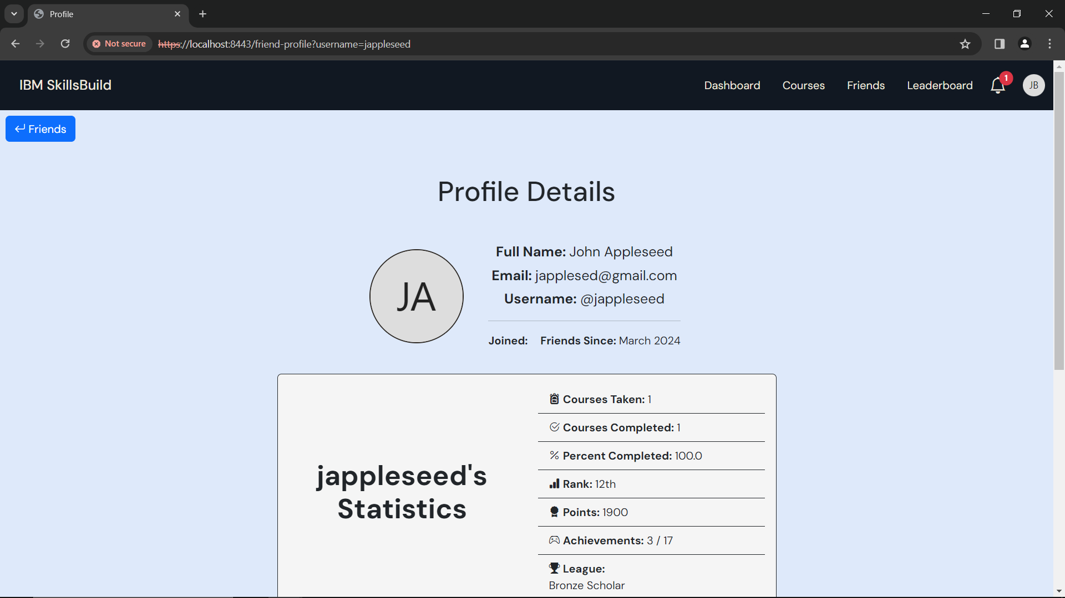

Figure 71: Friend's Profile

Here you will see all your friends details, and their achievements

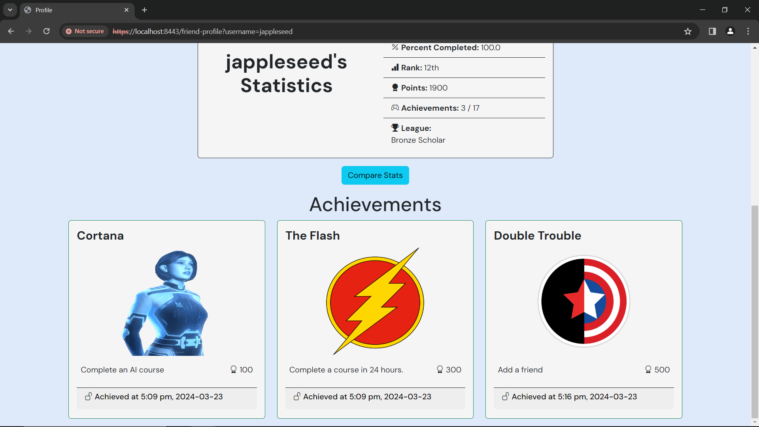

Figure 72: Friend's Achievements

You can also compare your statistics with your friend’s

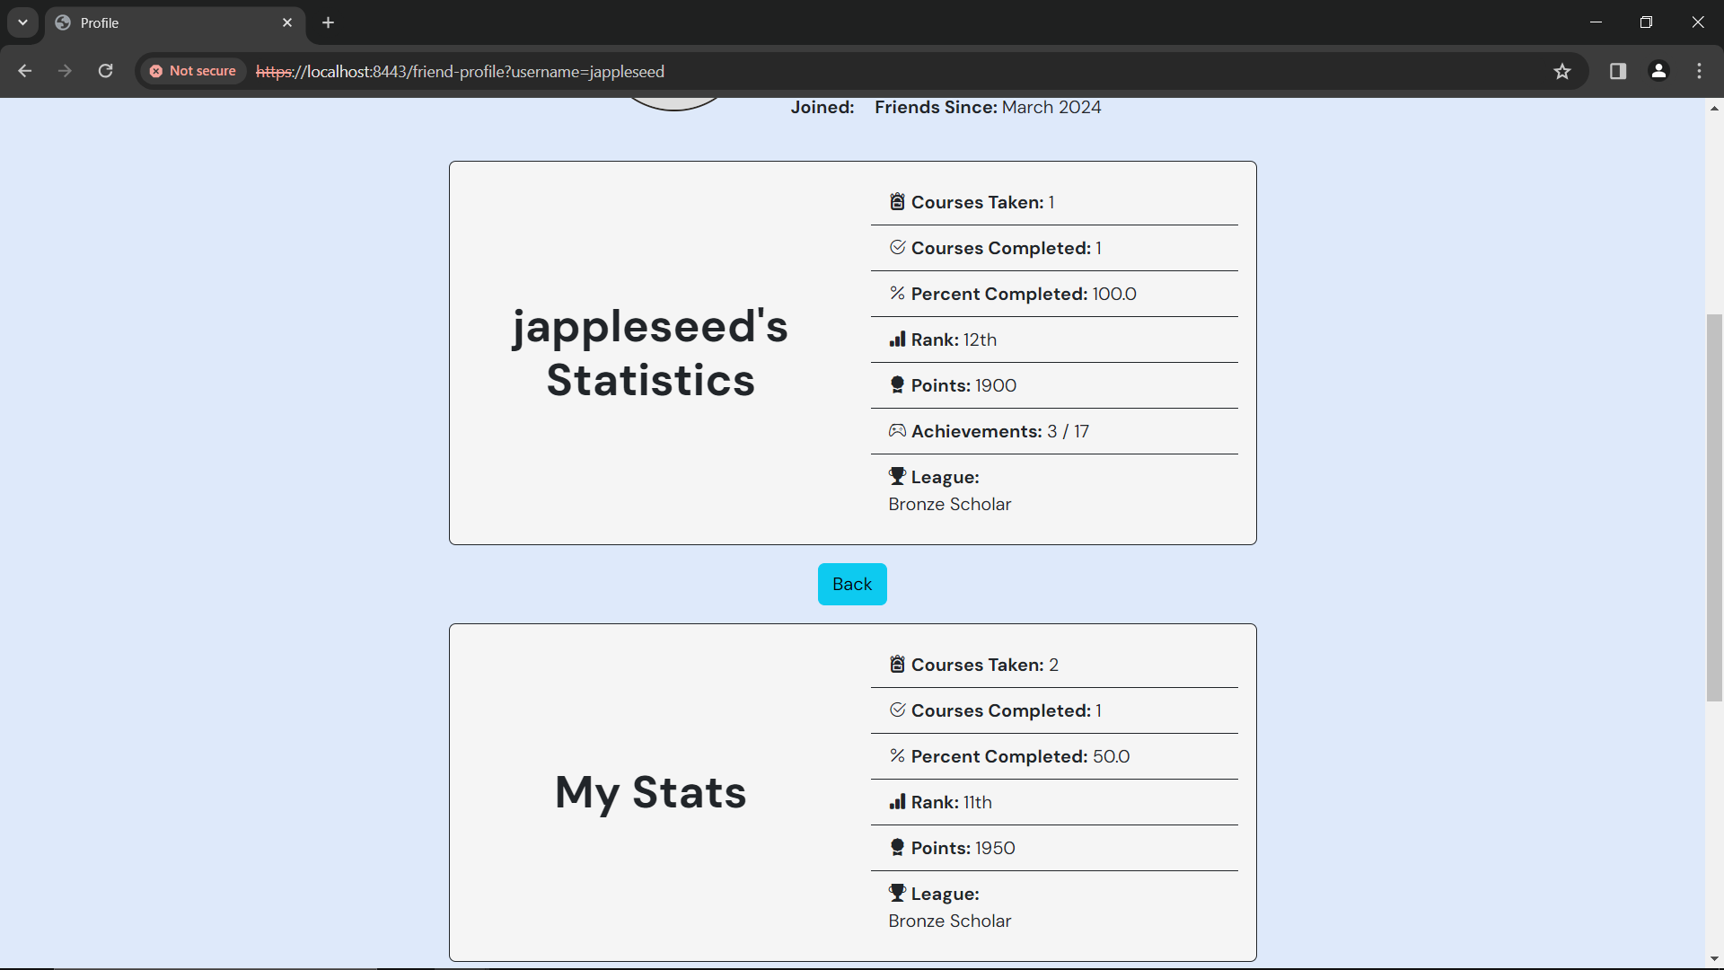

Figure 73: Compare Statistics

To go back to the friends page, click the ***‘Friends’*** button



Click ***‘Friends’***

Figure 74: Return to friends page

## View Friend Requests

You can view you incoming friend requests

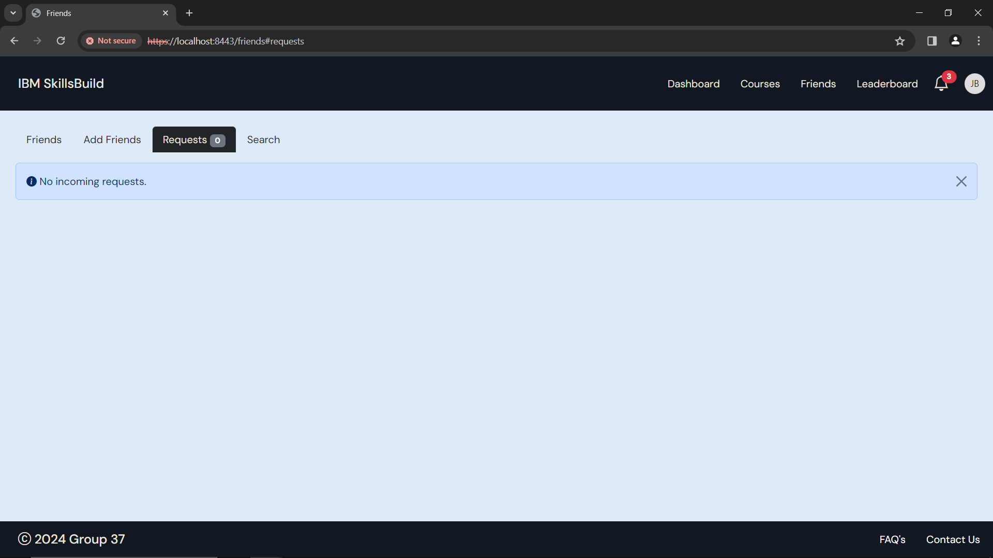

Figure 75: Friend Requests - No incoming requests

If you have no incoming friend requests, you will see the page above

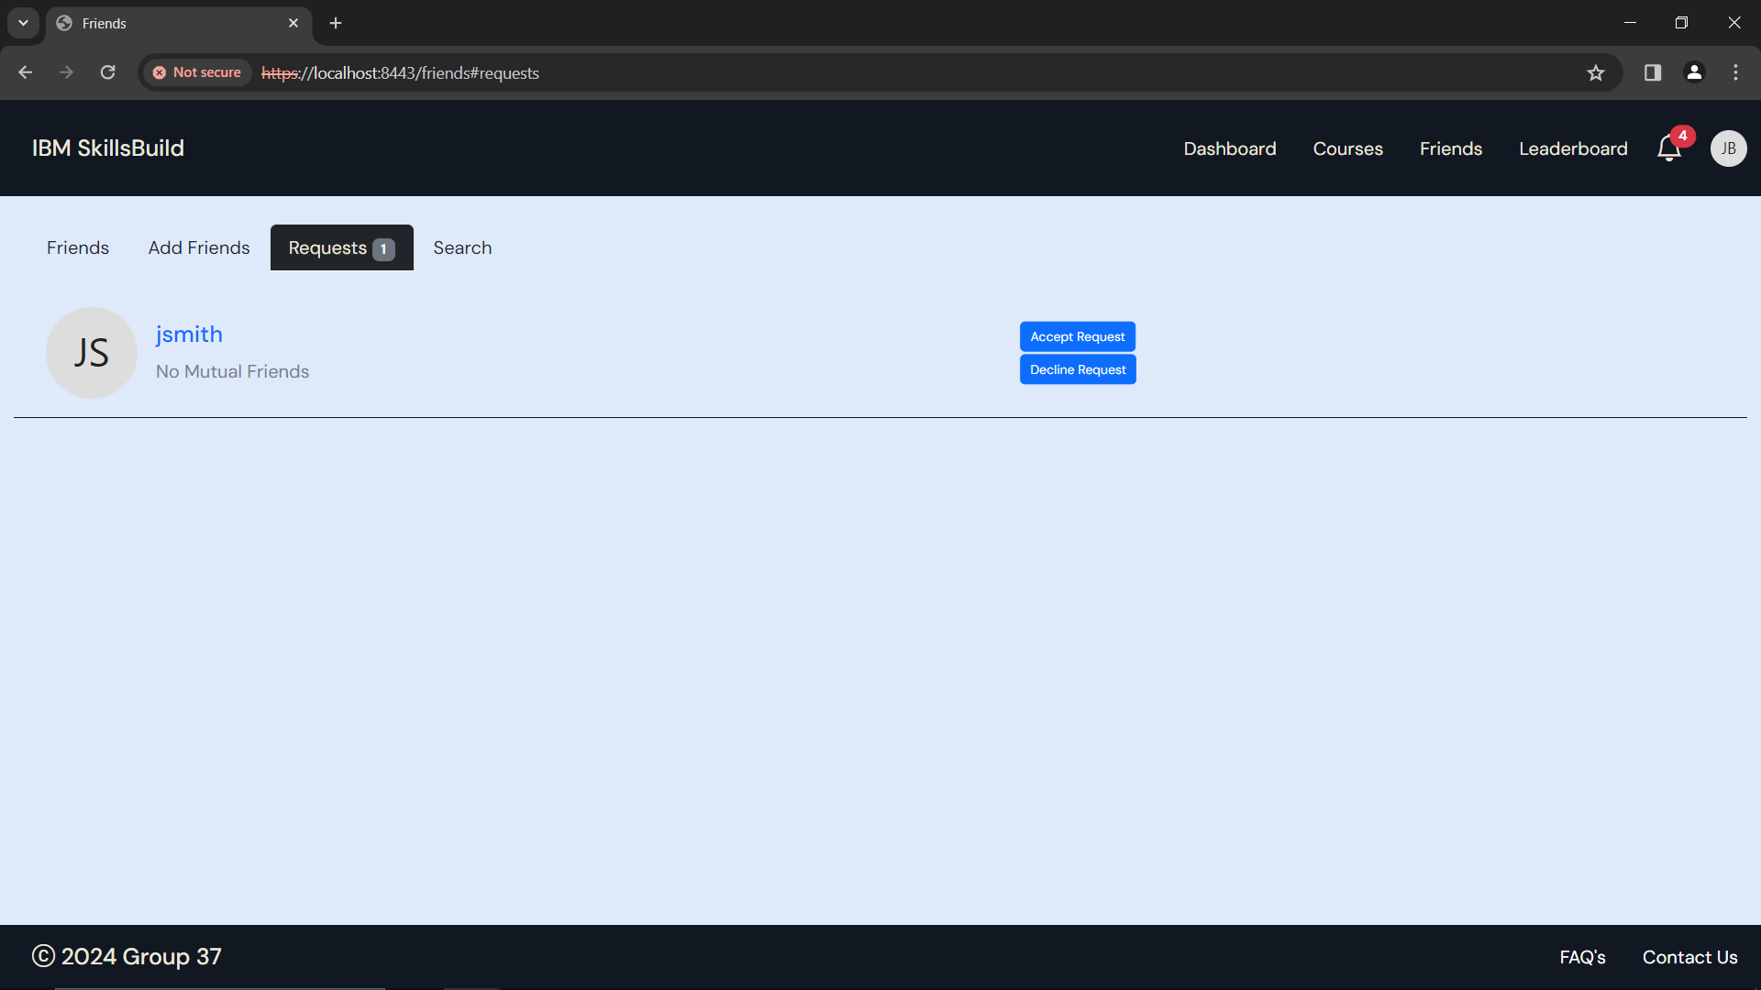

Figure 76: 1 Friend Request

If someone has requested to be your friend, you will be able to see your friend request.

* You can accept the request

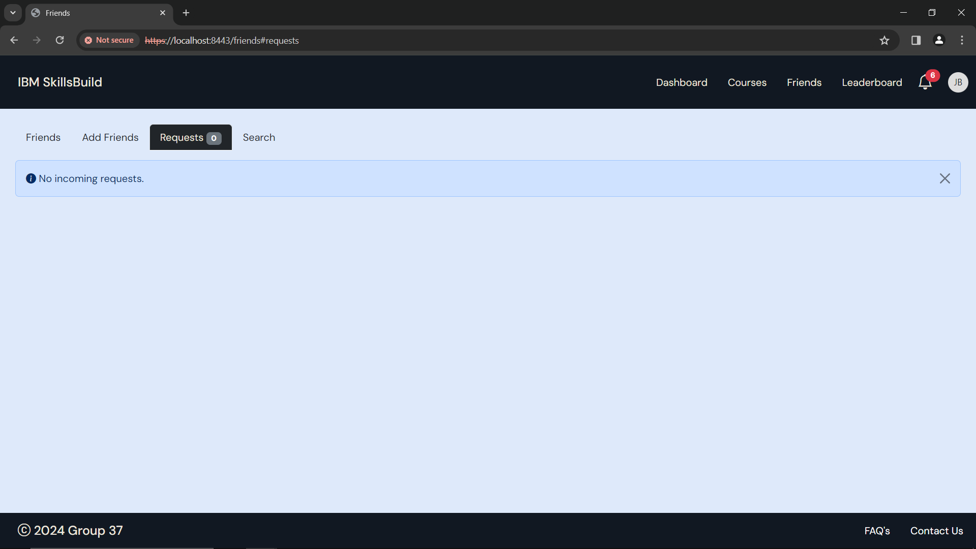

Click ***‘Friends’***

If you accept the request, you will see the page above

If you go to the friends tab, you will see your new friend



* Or decline it

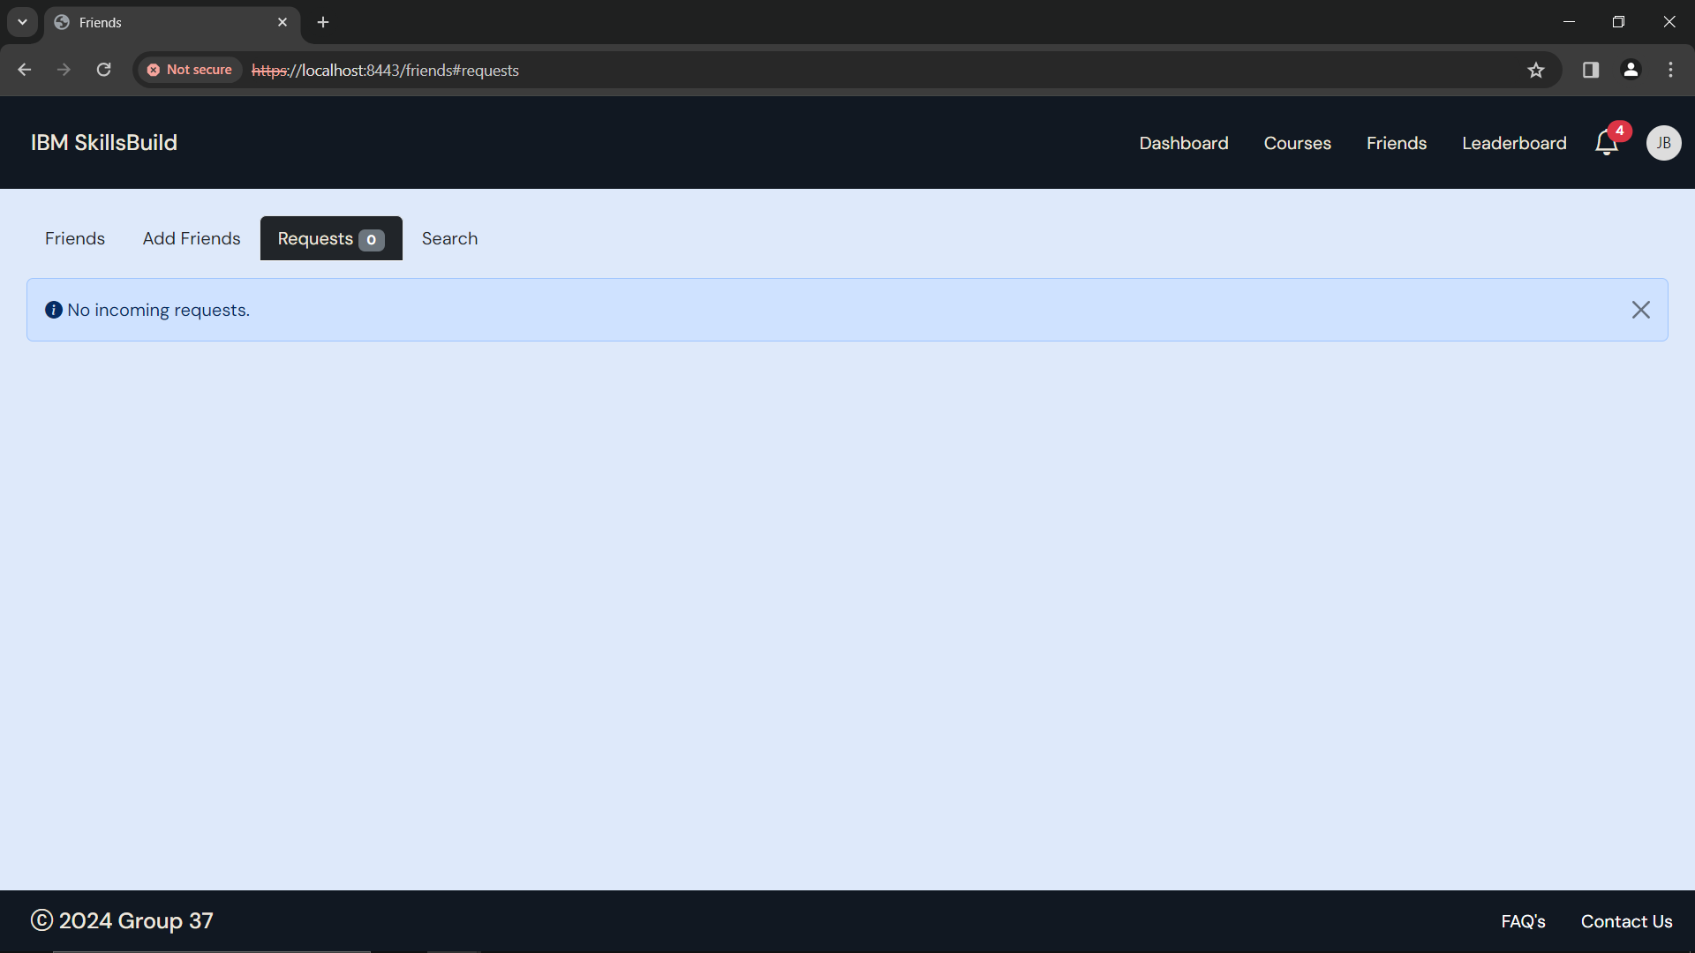

If you decline the request, the request will be deleted, and they will not be your friend

If you wish to remove a friend, head to the **Remove Friend** section under the **Friends** section of the user manual.

## Remove Friend

You can remove a friend if you no longer wish to be their friend



Click ***‘Remove Friend’***

Figure 77: Friends

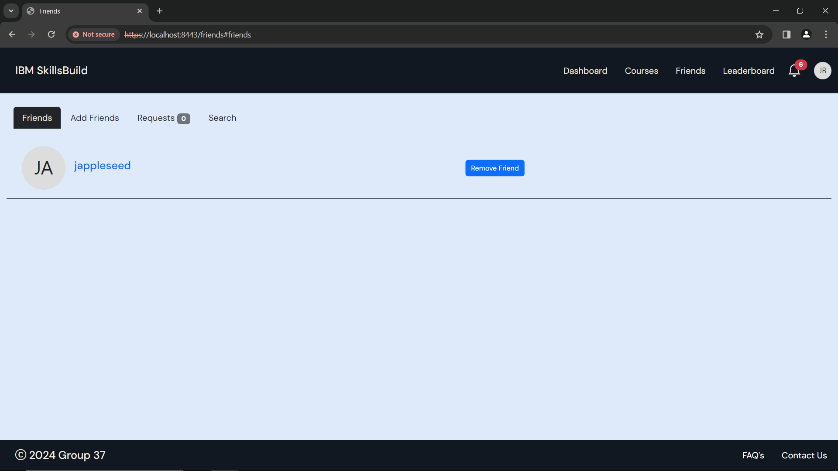

Figure 78: Friend Removed

Once you have removed your friend, they will be removed from your list of friends, and they will be in the add friends tab.

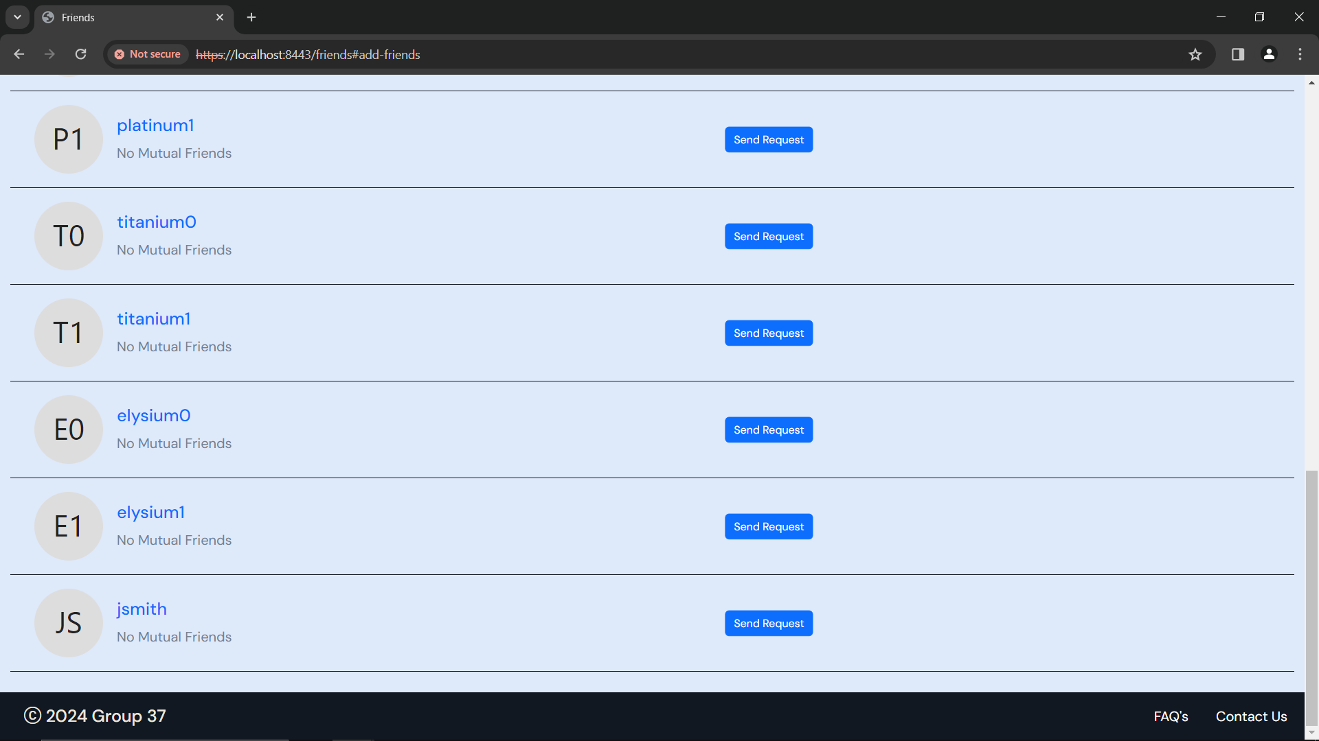

Figure 79: Add friends

If you wish to add them back, head to the **Add Friends** section under the **Friends** section of the user manual.

## Search to Add Friends

If you cannot find a friend to add in the list, you can try to search for them using their username.

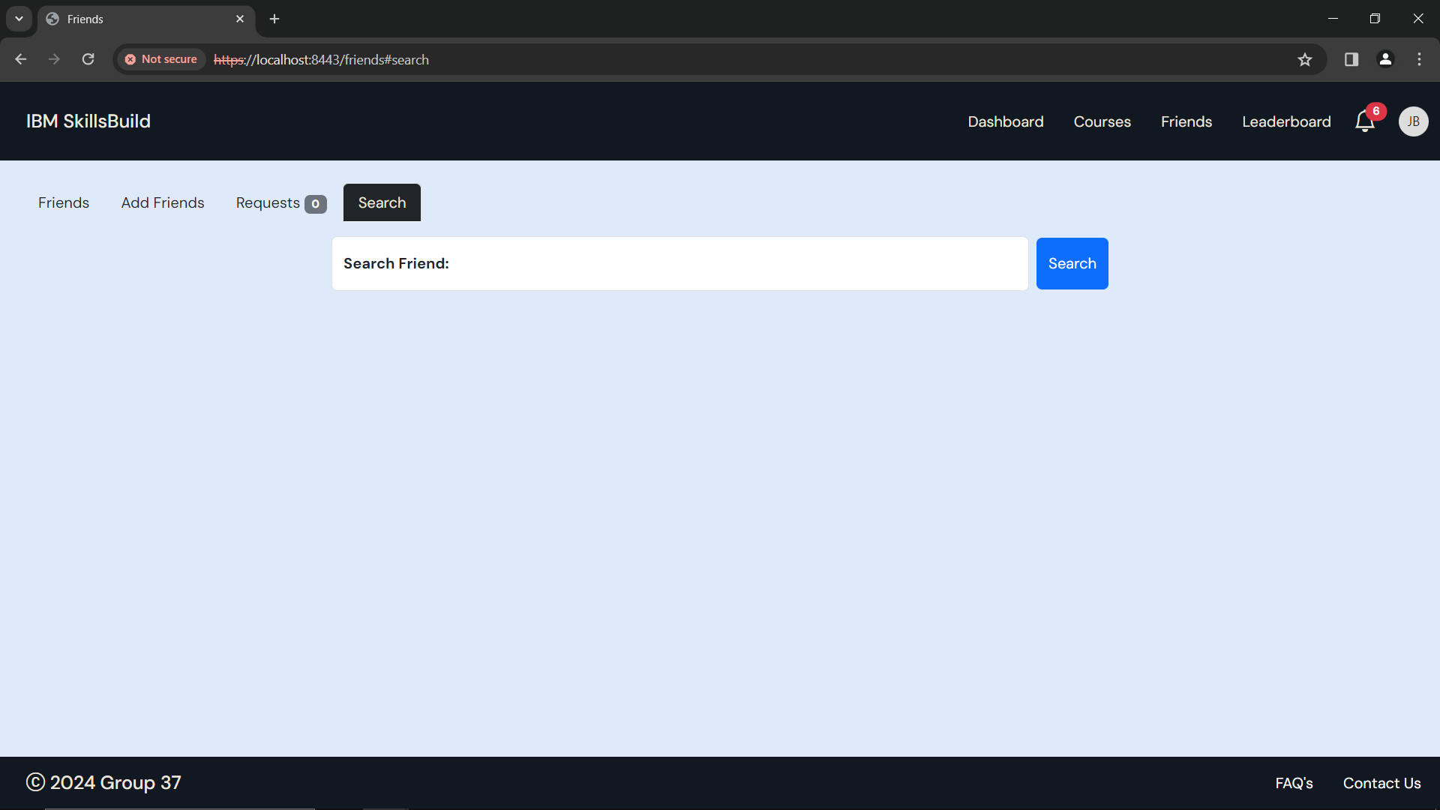

Figure 80: Friends - Search for a friend

Once you start typing in their username, you will see all users with that username.

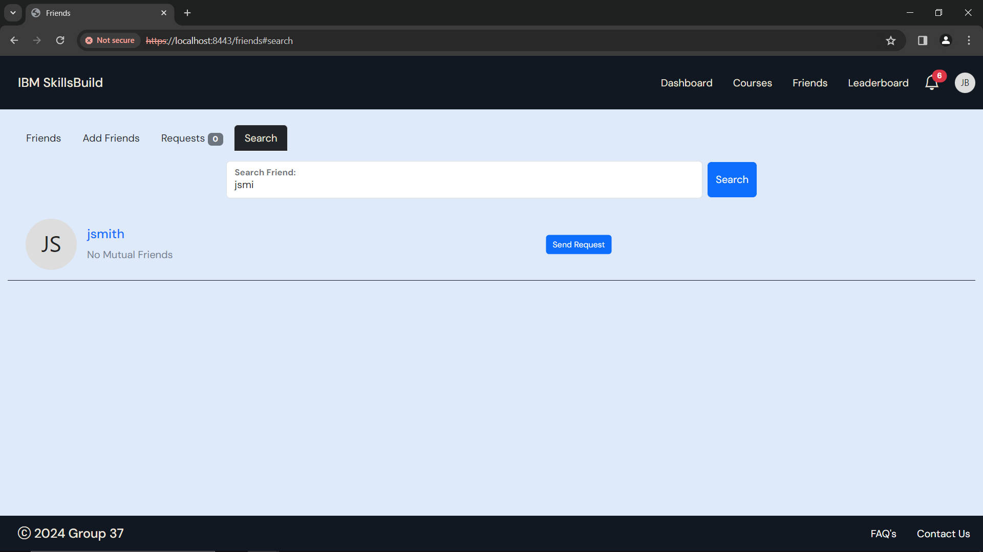

Figure 81: Friends Search - 'jsmi'

From here you can send a request to them.

If you need help with adding a friend, head to the **Add Friends** section under the **Friends** section of the user manual.

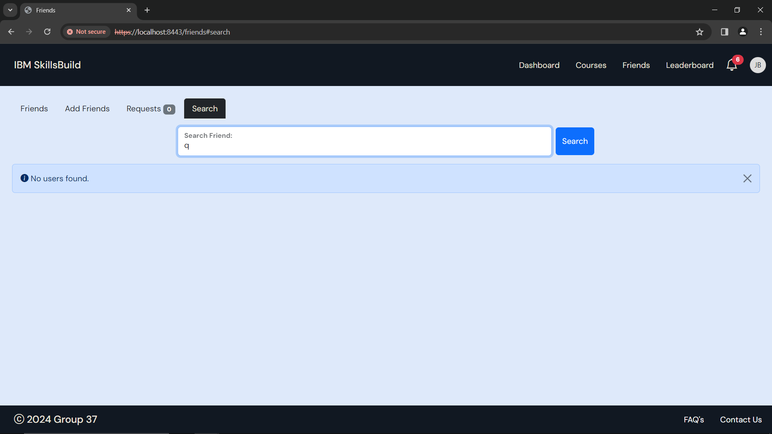

Figure 82: Friends Search - No users found.

If you see the page above, check you are spelling their username correctly, or have a look for them in the ‘Add Friends’ tab.

If you need help with adding a friend, head to the **Add Friends** section under the **Friends** section of the user manual.

# Leaderboard

To access the leaderboard, use this link: <https://localhost:8443/leaderboard>

In the leaderboard page, you will be able to see tabs for different leagues, global, and friends leaderboards.

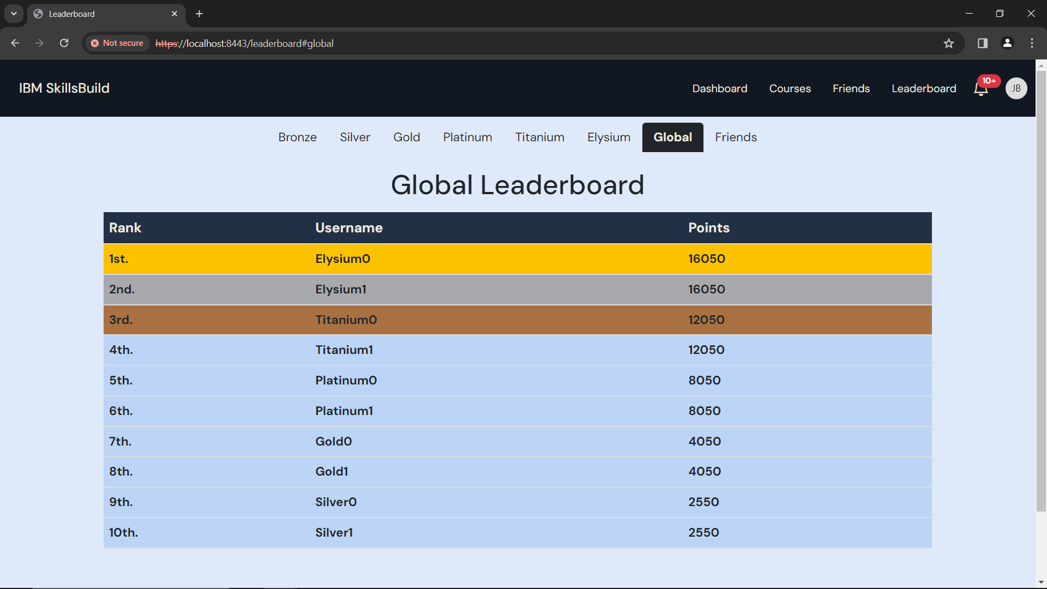

Figure 83: Leaderboard

As you complete courses (after getting at least 80% in the quiz) you will get more points.

* Points are calculated by the duration of the course
  + 1 hour = 100 points
  + 5 hours = 500 points
  + 20 hours = 2000 points

You can also earn points by getting achievements.

To see what achievements there are, and how many points you can get for it, head to the **Achievements** section under the **Profile** section in the user manual

Complete more courses and get achievements, to earn more points and move up the leagues and the leaderboards.

In the global leaderboard, you will be able to see the top 10 users.



Figure 84: Global Leaderboard

In the friends leaderboard, you will be able to see your friends, and their points

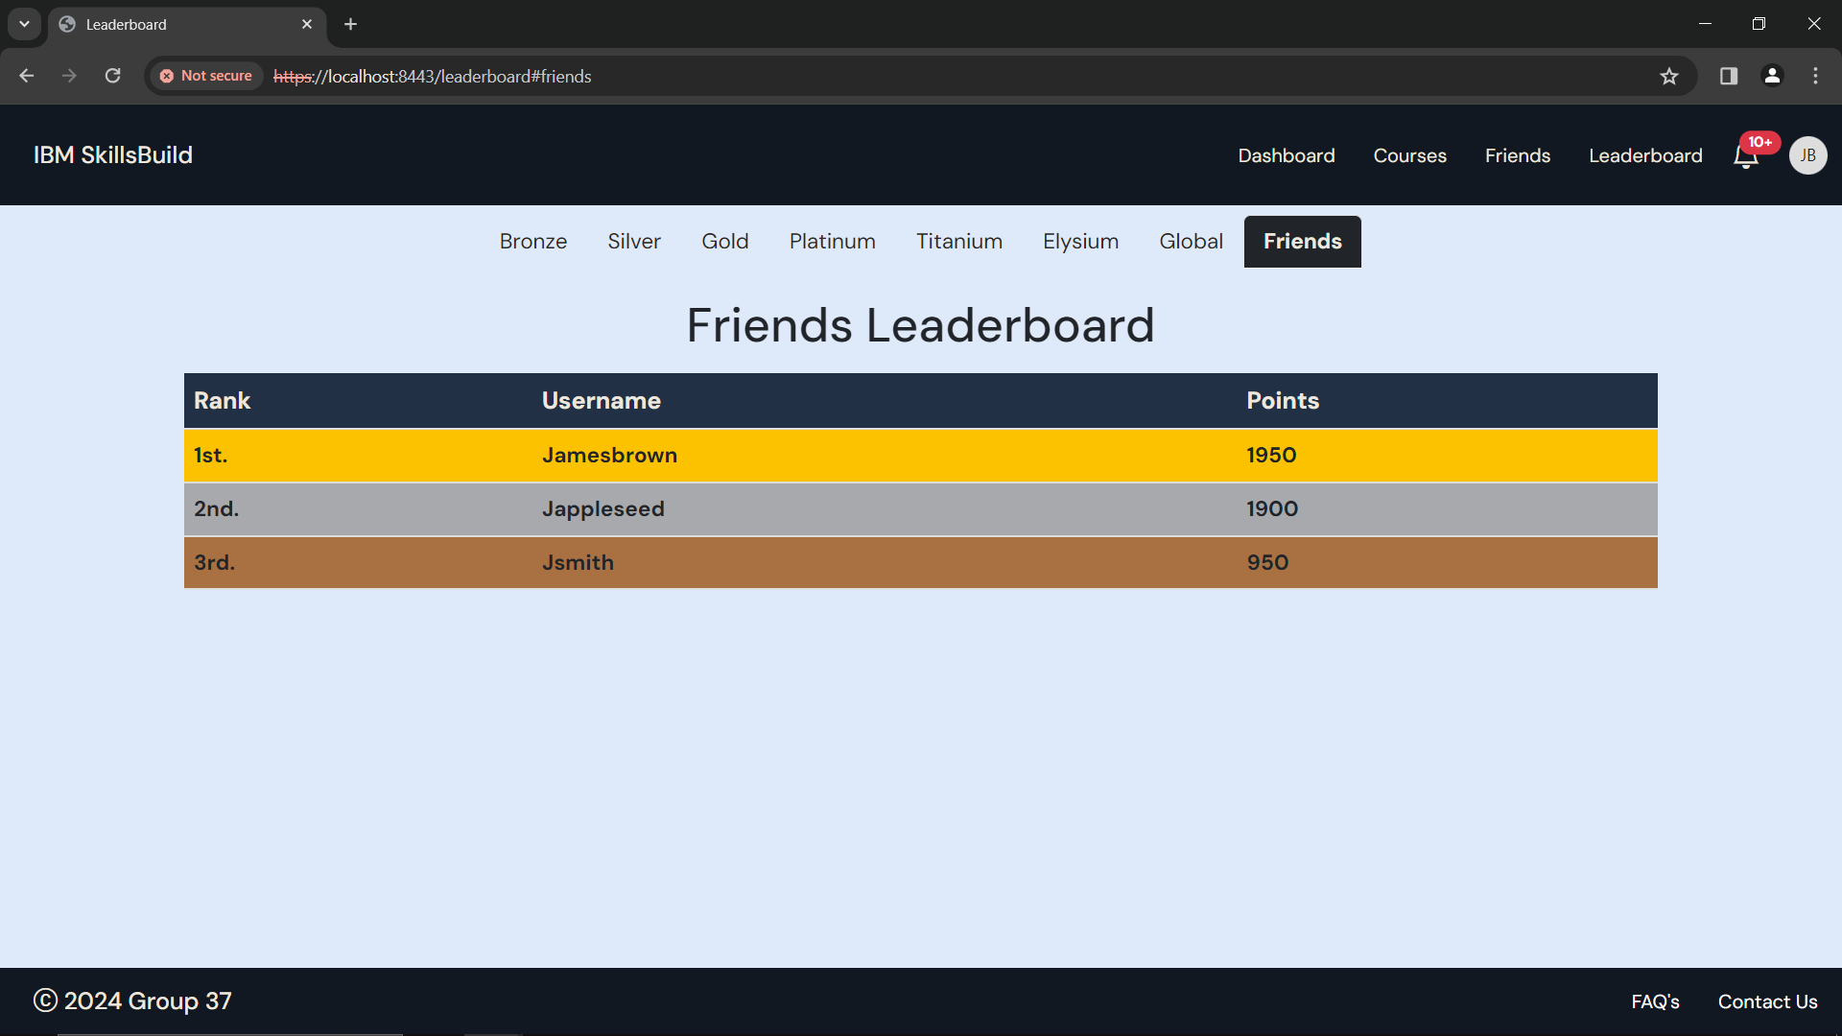

Figure 85: Friends Leaderboard

## Leagues

There are 6 different leagues. Below is a table of the leagues and the minimum points for each league.

|  |  |
| --- | --- |
| **League** | **Points** |
| Bronze Scholar | 1000 |
| Silver Sage | 2500 |
| Gold Guru | 4000 |
| Platinum Prodigy | 8000 |
| Titanium Titan | 12000 |
| Elysium | 16000 |

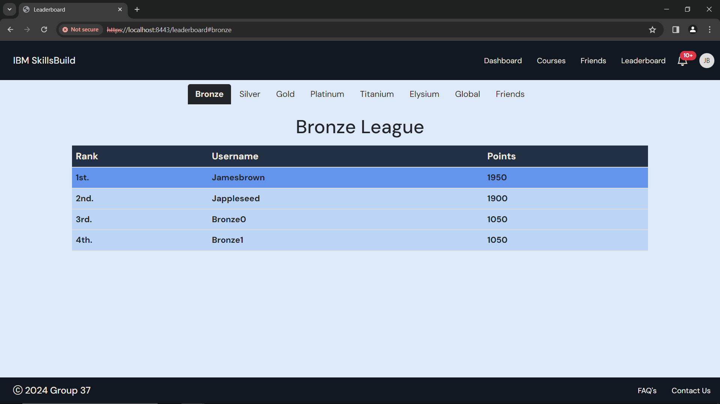

Figure 86: Bronze League Leaderboard

If you have enough points to be in a league, you will be able to see yourself in that respective league’s leaderboard.

*(E.g. User ‘Jamesbrown’ has 1950 points putting him at the top of the bronze league)*

If you do not have the minimum points for the Bronze league, you will be unranked, which can be seen in your profile.



Figure 87: Profile - Unranked League

# Notifications

You will be able to see any notifications in the navigation bar.

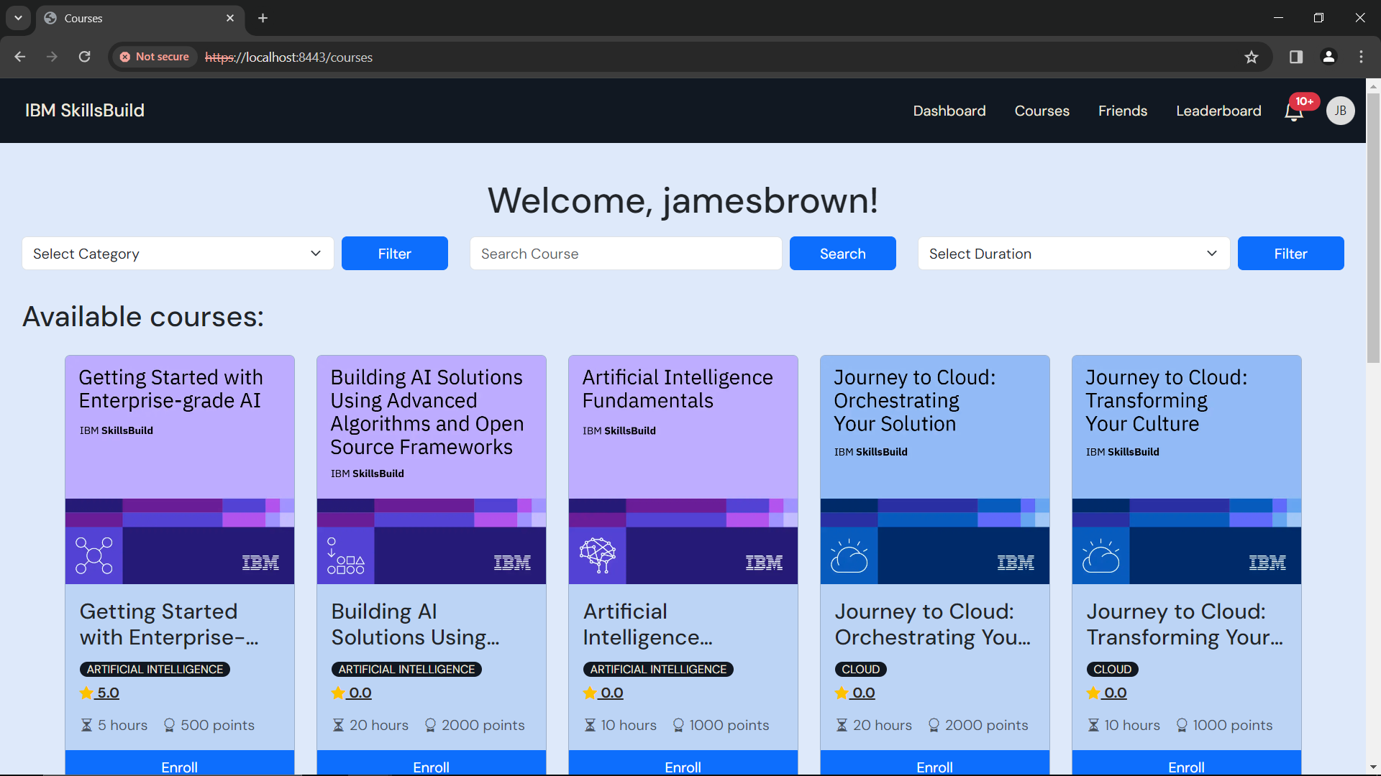

Click the icon to view notifications

Figure 88: Courses - Notifications

You will get notifications for friends requests, adding a new friend, getting an achievement, reaching a new league or top 3 in your current league & global leaderboard or if someone takes your top 3 spot in your current league & global leaderboard.

You will be able to see the number of unread notifications you have. *(E.g. 10+)*

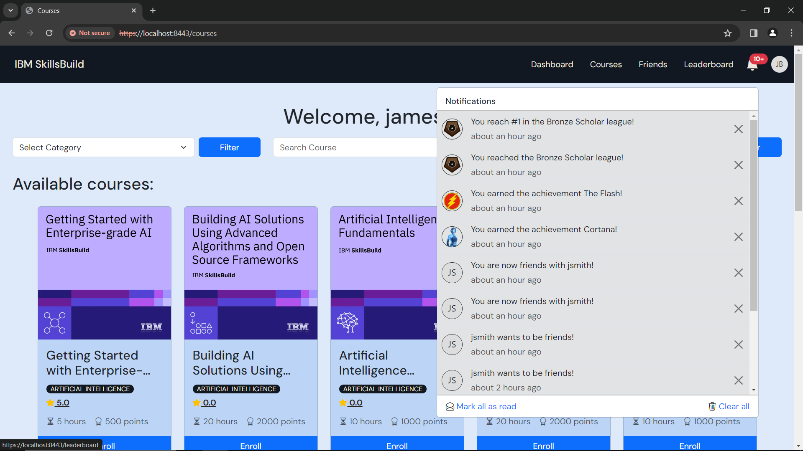

Figure 89: Notifications

To read a notification, you can click on the notification.

This will take you to the relevant page.

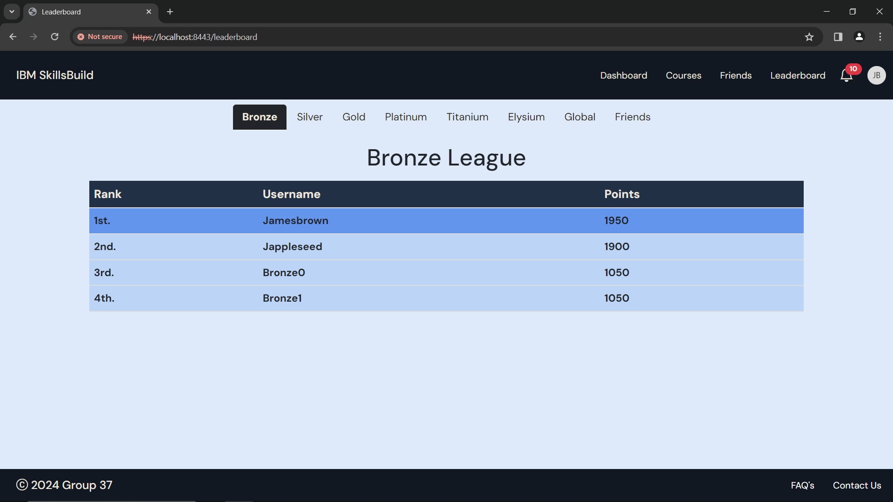

Figure 90: Read notification -> Bronze League Leaderboard

That specific notification will now be shown as read.

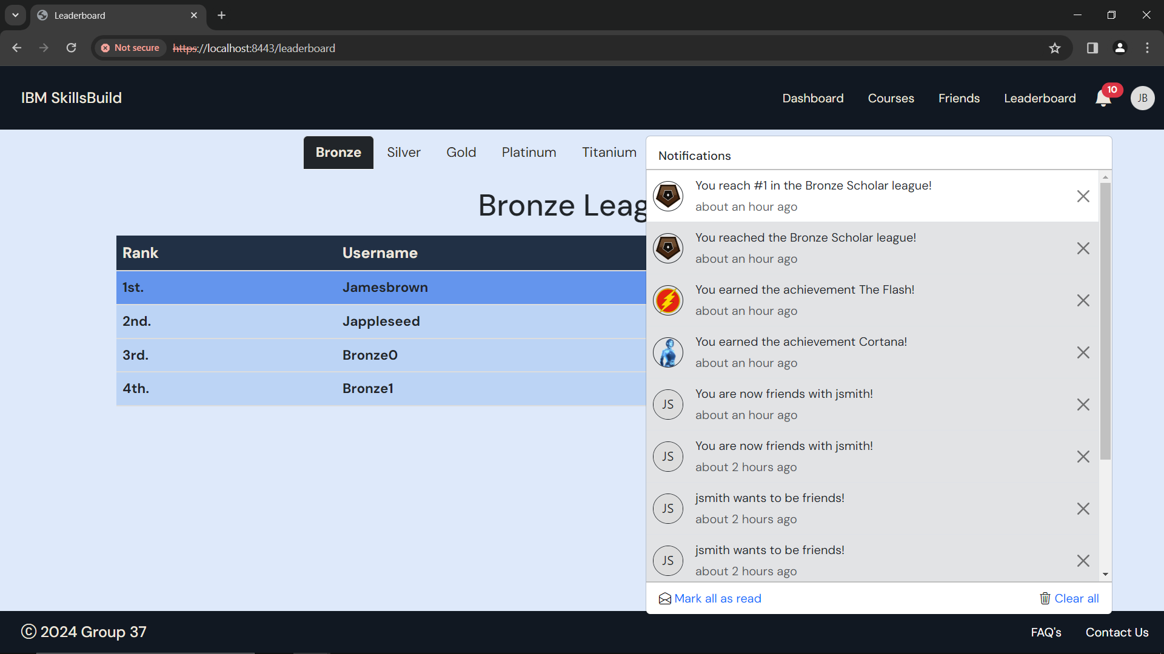

Click ***‘Mark all as read’*** to mark all notifications as read.

To mark all notifications as read, click ***‘Mark all as read’***

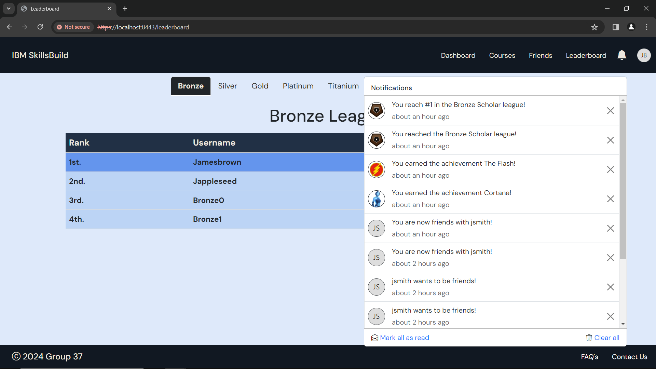

Figure 91: Notifications - all marked as read

You will see that there is no longer a number next to the notification icon in the navigation bar, and all the notifications are read.

To delete a notification, click the X next to the you wish to delete.



That will clear it from the notification list.

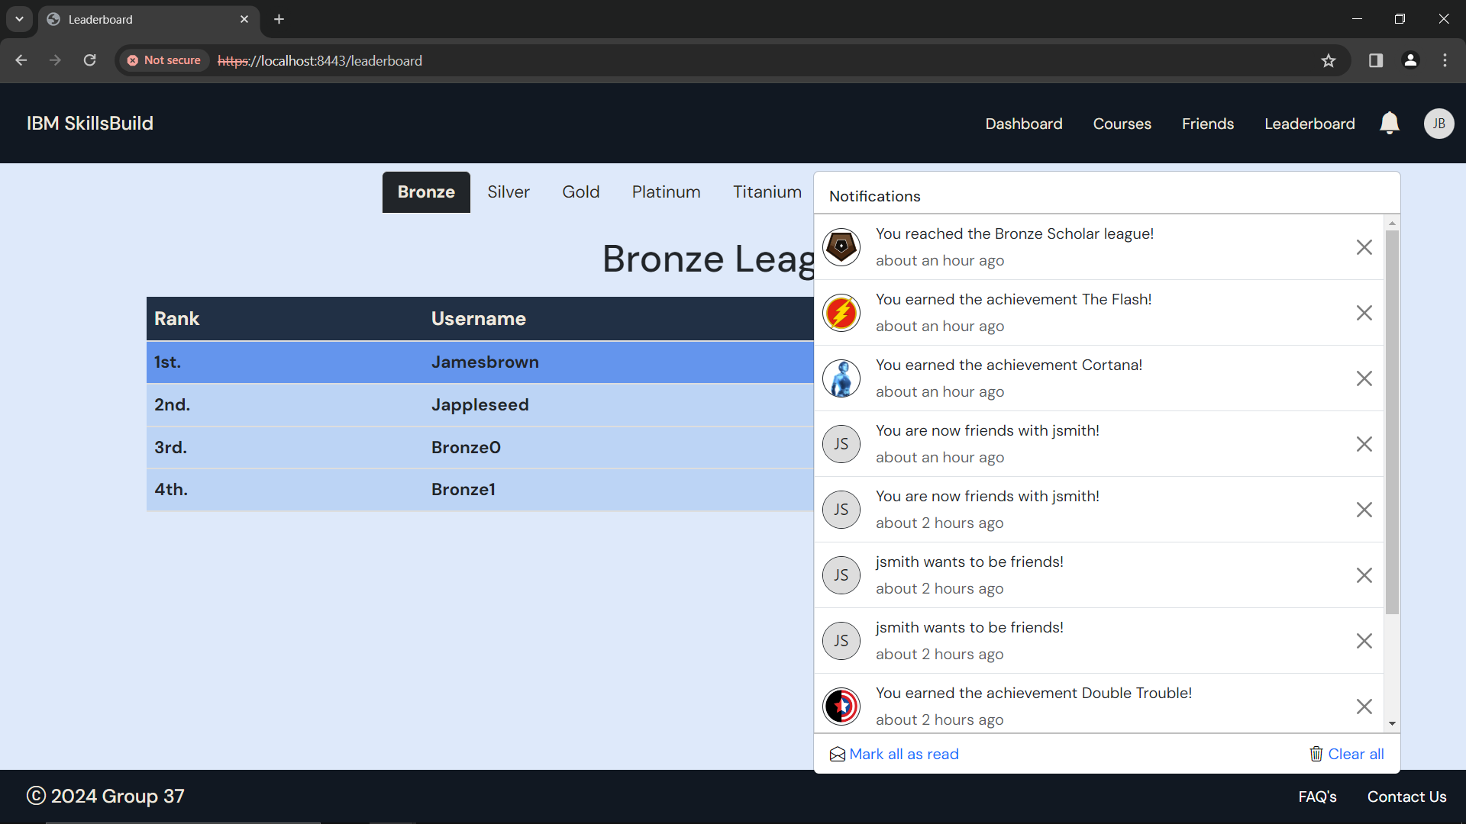

Click ***‘Clear All’*** to delete all notifications

Figure 92: Deleted a notification

To clear all your notifications, click ***‘Clear all’***

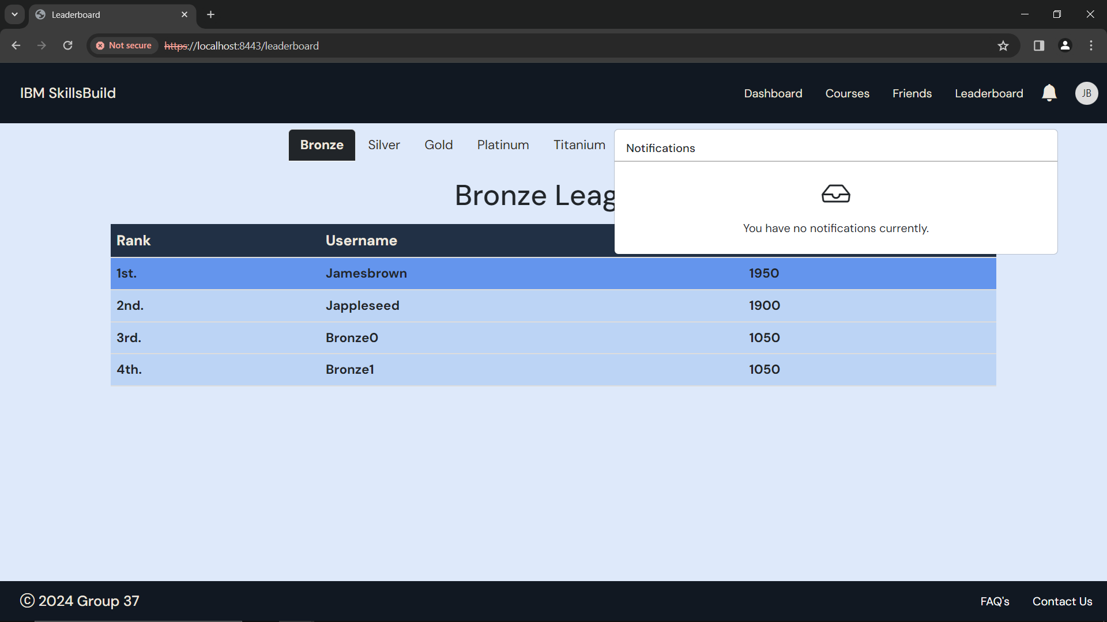

Figure 93: Cleared all notifications

# Logout

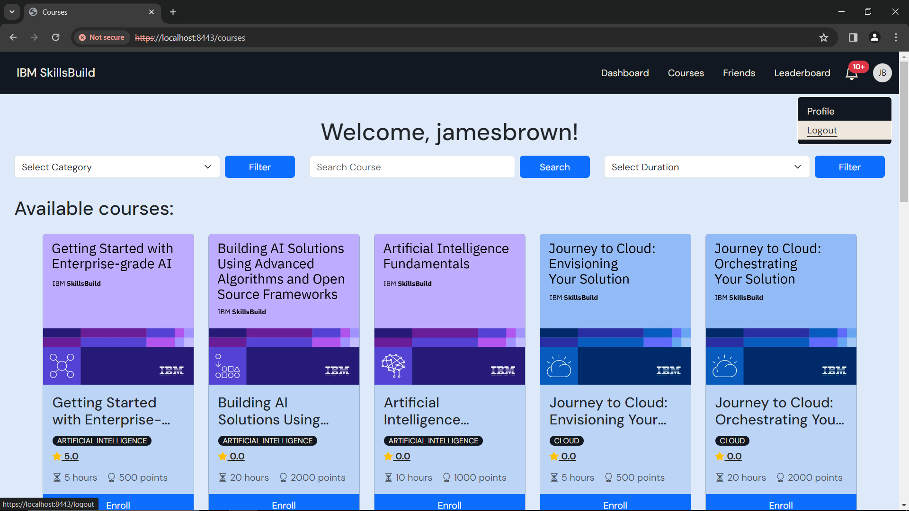

To logout, click **‘*Logout*’**

Figure 94: Courses - Logout

You will be able to see the logout option after clicking your profile picture at the top right of the navigation bar.

After you logout, you will be taken back to the welcome page.



Figure 95: Welcome

# FAQ’s & Contact Us

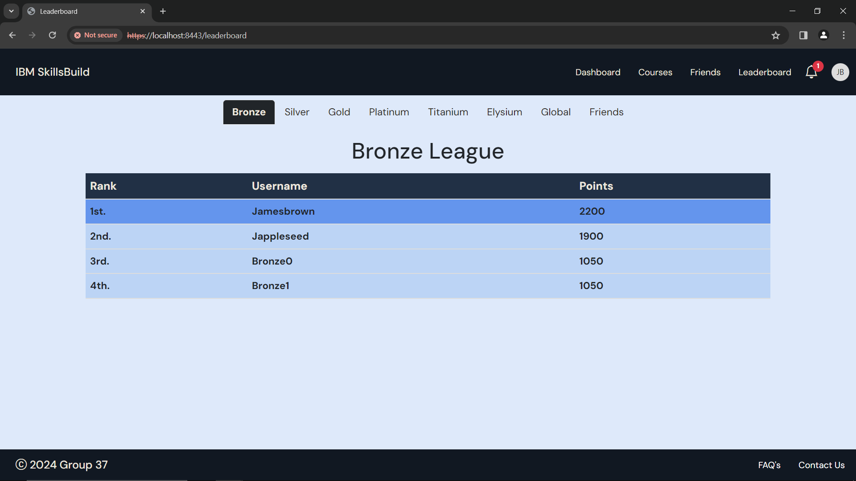

Figure 96 – FAQ’s and Contact Us

At the bottom of every page, you will be able to see FAQ’s, with some frequently asked questions.

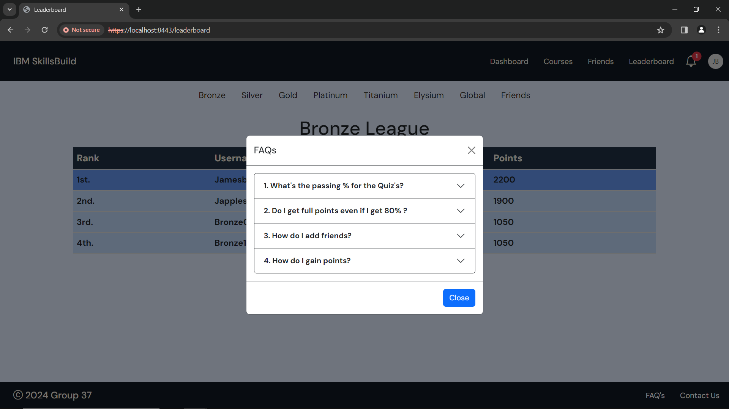

Figure 97 - FAQ's

If you have any further questions, please use the ***‘Contact Us’*** button to email the team.

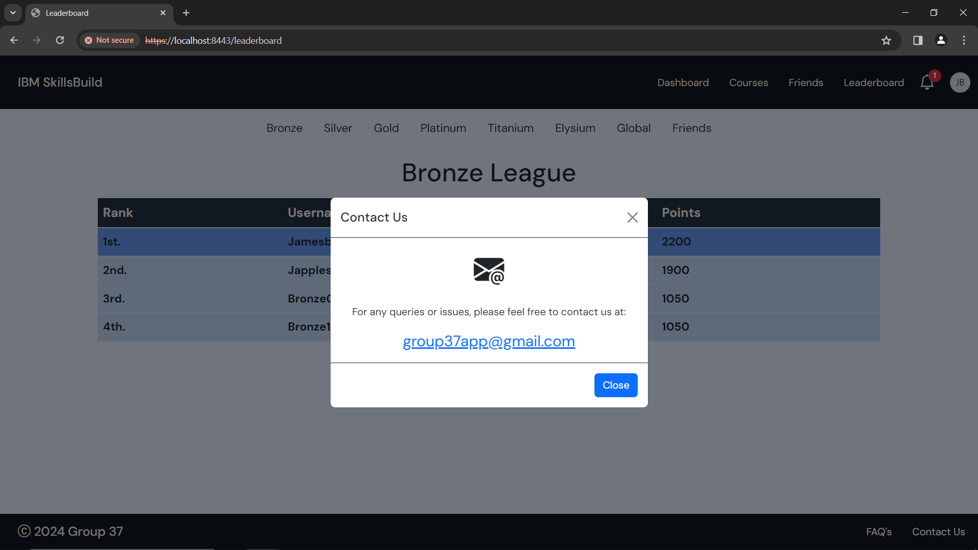

Figure 98 - Contact Us

Or contact the team at [group37app@gmail.com](mailto:group37app@gmail.com)

## FAQs - Frequently Asked Questions

1. What’s the passing % for the Quiz’s?
   1. Passing % for any quiz is 80% for any given course.
2. Do I get full points even if I get 80%
   1. Yes, you get full points if you get 80, 90 or 100% in any quiz.
3. How do I add friends?
   1. You can add friends via the Friends tab in the dashboard.
4. How do I gain points?
   1. You can gain points by completing course & achievements in your Profile section.
5. Why do I keep getting redirected to the dashboard page?
   1. If you try to access a link that is invalid, you will be redirected to 1 of 2 pages. If you are not logged in, you will be redirected to the login page. If you are logged in, you will be redirected to the dashboard page.

If you have any questions, contact the team at [group37app@gmail.com](mailto:group37app@gmail.com)